Personal Details
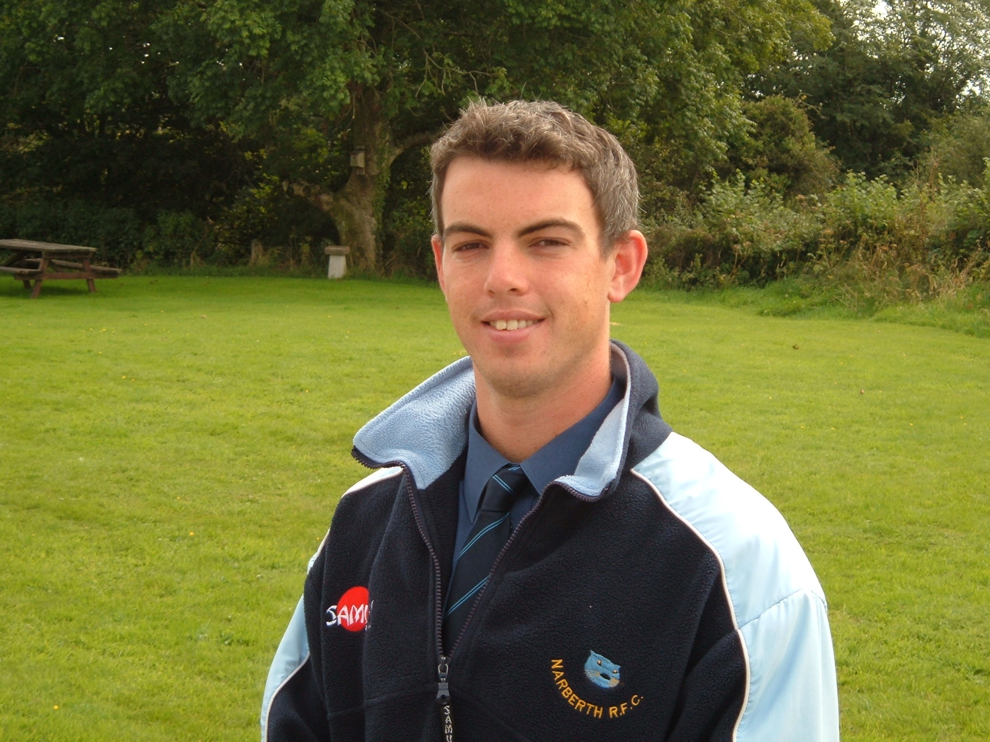
Male
British
DOB - 14 December 1982
Full driving licence since 07/06/2000
Speaks Spanish at a conversational level
E-mail address: ceri_j_davies@hotmail.com

Education
2009 – The International TEFL Corporation – TESOL Certificate. 120 hour course which included 10 hours of observed teaching practice. Achieved 100% in Grammar Exam and observed teaching practice was graded “excellent”.

2005 - Sheffield Hallam University - Achieved a BSC with Honours in Sports Development with Coaching. (Class 2:1)

2001 - Llandovery College – A levels in French, Geography and Physical Education, achieving a grade A in Physical Education.

Other Qualifications
Qualification Date Venue
Level 2 Cricket Coaching Award 20/7/2009 Coed School, Llanelli
Level 2 Athletics Coaching Award 14/6/2009 Acton Stadium, London
First Aid at Work 17/4/2008 St Johns Centre, Baker St.
Level 2 Rugby Coaching Award 20/08/2006 Haverfordwest RFC
Level 2 Swimming Instructors Award 11/12/2004 Chapeltown Swimming Pool
Level 1 Junior Football Coaching Award 15/01/2004 Sheffield Cricket Ground

Recent Employment
Aug 2009 – Nov 2009 – Huashan Middle School
Position – English Teacher
Responsibilities:
- Teach Conversational English to students aged 16/17 of a Lower Intermediate/Intermediate level.
- Teach Reading, Writing, Listening Speaking and Grammar to students aged 15/16 of an Intermediate Level to help prepare them for a study year in Australia.

Nov 2007 – Mar 2009 – Greenhouse Schools Project
Position – Special Education PE Teacher
Responsibilities:
- Work with children with a range of severe learning difficulties, running multi-sport sessions and developing movement skills through hydrotherapy, rebound therapy and co-ordination/agility exercises.
- Co-ordinate holiday activity schemes.

Mar – Aug 2007 – Volunteer work in Peru (see “Recent Volunteer Experience”)

Sep 2005 – Feb 2007 – Narberth RFC
Position – Community Rugby Development Officer (part time)
Responsibilities:
- Create a Development Plan and provide written and verbal reports detailing progress.
- Chairing Junior Meetings and management of the Junior Section of the Club.
- The co-ordination of volunteers within the Junior Section of the club.
- Representing the Junior Section of the Club on Senior Committees.
- Promotion of the club through establishing strong links with local Community Groups.
- Curricular Multi-Sport Coaching in local Primary Schools.
- After School rugby coaching in local Primary Schools.
- Increasing the standard of coaching within the Junior Section of the club and in local Primary Schools through the provision of Coach Education for coaches and teachers.
- The development of an Inter Primary School Competition structure involving the organisation of friendly matches and festivals.

Oct 2005 – Feb 2007
Position – Sports Scheme Co-ordinator (self employed)
Provision of Multi Sport Holiday Schemes for children aged 6-11
Responsibilities:

- Advertising and promotion of the scheme.
- Financial management of the scheme.
- Recruitment and training of coaches.
- Negotiating the use of facilities and specialist coaches by working in partnership with local Sports Clubs, Leisure and Community Centres and SDOs.
- Delivery of the scheme.

May 2005 - Dec 2006 – Pembrokeshire Association of Cricket Coaches
Position – Assistant Cricket Development Officer (part time)
Responsibilities:

- The promotion of Clubs through coaching sessions in local Primary and Secondary Schools.
- The co-ordination and delivery of Inter Primary School KWIK Cricket Festivals.
- The introduction of Under 9s cricket to the County through the development, organisation and delivery of a series of festivals for clubs in the area.
- Disability Cricket Coaching for adult community groups.
- Mentoring newly qualified coaches.
- CPD for Level 1 and 2 coaches through the delivery of Dragon Cricket Courses for children aged 7-11.

Recent Volunteer Experience
Mar – Aug 07 - Worked as a volunteer in an orphanage in Peru
Responsibilities:
- Teaching basic Maths and English
- Coaching and leadership of activities including football, basketball, athletics and volleyball.

April/May 04 - Work placement with Sport Pembrokeshire
Responsibilities:
- The organisation of Primary School Athletics Festivals
- Girls football coaching in Secondary Schools
- Cycling coaching in primary schools
- Assisting in the organisation of Boccia and KWIK Cricket festivals
- Mentoring 6th form sports leaders in primary school coaching sessions

Other Achievements and Interests
Sport - Play rugby and cricket at a local club level, also enjoy swimming, athletics and football
Music - Achieved Grade 4 in Saxophone
Duke of Edinburgh Award Scheme - Achieved Gold Award

Referees
Miss Clare Bolzon
Tutor (The International TEFL Corporation)

Contact Address -
The International TEFL Corporation,
367 / 11 - 12 Yaowarat Road,
Muang,
Phuket 83000,
Thailand

Tel: +66 (0) 76 236 306

E-mail: cbolzon@gmail.com

Miss Eleanor Coaker
SEN Programme Manager (Greenhouse Schools Project)

Contact address -
Greenhouse Schools Project,
G2, Shepherds Studios,
Shepherds Bush
London. W14 1DA

Tel: 07773038437

E-mail - eleanor.coker@greenhouseschools.org

