Chen Lie
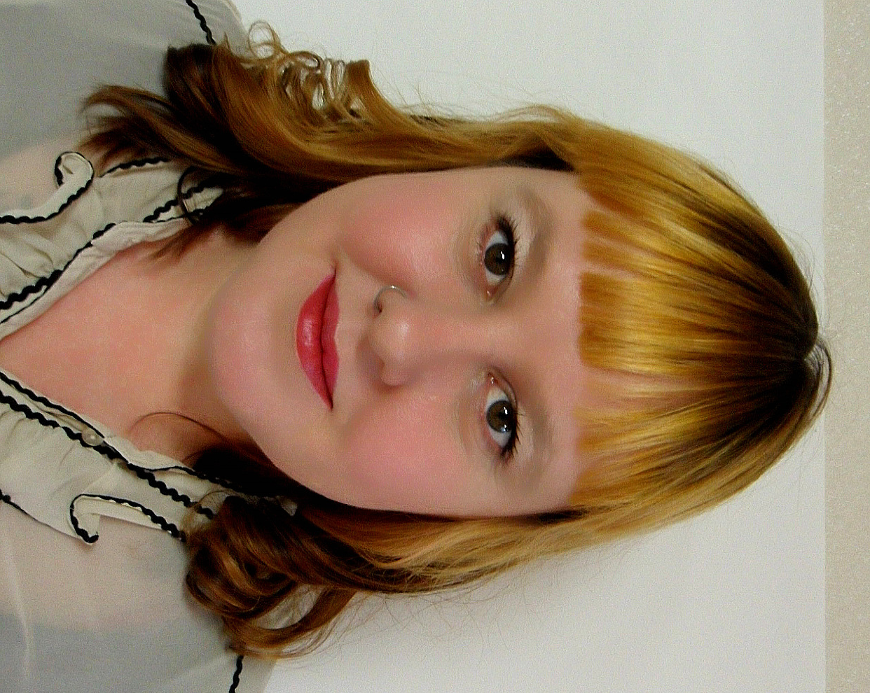
catrabbitslim@gmail.com
Born August 20th 1975

WORK HISTORY

2001-2002 Suwon, South Korea
English Teacher E-English
Taught for 9 Months.
Ages 7-16.
In charge of the student curriculum.
(School closed down in 2002)
2002-2003 Kyongbuk Junior College Yongju, South Korea
Visiting Professor
Taught English for 18 months
College age students
Tourism and Nursing Department
(Left college to pursue further education)
2004-2005 Chiba Language School Pintung Taiwan
English Teacher
Taught for 12 months
Ages 3-14
Summer School Co-coordinator
Wrote own curriculum for 3 and 4 year old class
Directed Drama and Arts activities
(Left to return to South Korea)

2005-2006 Pyongchon High School Pyongchon, South Korea
English Teacher
Taught English for 12 months
Upper High School age students
Science and Art Department
Wrote curriculum for normal classes and Summer and Winter Schools
(Left school due to job offer at Korea Tourism College)
2006-2007 Korea Tourism College Icheon, South Korea
English Professor
Taught English for 2 years
College age students
Tourism Department
Specialised in curriculum and examination writing
(Left college to pursue further education in Australia)

2008-2009 Select Education Melbourne, Australia
Kindergarten Teacher
Taught Kindergarten Part time.

2009-2010 Pangyo Middle School Pangyo, South Korea
English Teacher
One year contract at a Middle School
Wrote own curriculum including Winter and Summer camps.
Helped to set up the new English Classroom.
Currently still teaching here.
EDUCATION

1993-1994 Western Australian Department of Art Western Australia
Associate Diploma of Fine Art Management
1995-2000 The University of Western Australia Western Australia
Bachelor of Fine Arts
2003-2003 TEFL International Banphe, Thailand
TESOL Certificate
120 hour TESOL Certificate course

2008-2008 Monash University Melbourne, Australia
Graduate Diploma Education (Early Childhood)
Teaching certification.

EXTRACURRICULAR ACTIVITIES

Freelance Exhibition Co-coordinator for Group Art exhibitions. Specialising in Photography.
Freelance film maker
Artist involved in the “Eden-Women’s Art Collective “ South Korea
INTERESTS AND ACTIVITIES

History, Art History, Travel, Photography, Film making, Painting, Teaching art to children.

REFERENCES –
Amber Glaskin
Amber_pop@yahoo.com.au
Masters in Linguistics and ESL teacher.

