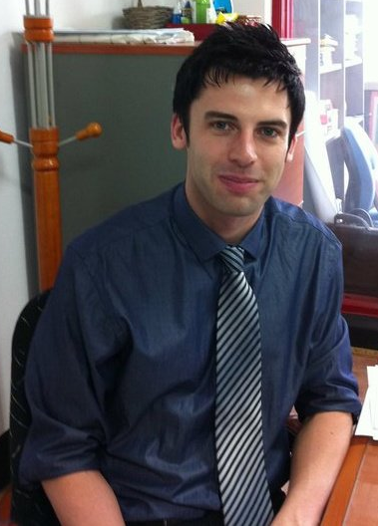
Simon McEnteggart

Address: 경기도 고양시 일산서구 탄현동 1598-8번지 203호 411-320
Gyeongido Goyangsi Ilsan-seo-gu Tanhyundong 1598-8 Apt 203 411-320
Telephone Number: 010) 2426-2588
Email: taggart2010@hotmail.com
Date of Birth: 20/10/1982
Nationality: British

Profile
Dedicated to the education and teaching of others. Able to work individually or as part of a team. An experienced teacher, having taught at a variety of institutions for students of varying ages. A background in film and media compatible with teaching for visual/audio learners.
Experience
Hyeonsan Middle School, Tanhyeon-dong, Gyeonggi-do, South Korea — 2010-2011
Teaching English as a secondary language to middle school students (grades 1 and 3). Responsibilities included teaching English using textbooks and activity books; creating ppt presentations for teaching original English lessons; teaching morning and after school lessons; teaching winter and summer English camps. Additional activities included helping prepare and grade exam papers, proof reading of English newspapers, and helping students during lunchtime English club.
Teacher of English, YBM ECC; Buk Ilsan, Gyeonggi-do, South Korea — 2009-2010
Teaching English as a secondary language to children (ages 5-14). Responsibilities included teaching English speaking, reading, writing and listening using a variety of methods. For example, methods such as role plays, information gaps, questionnaires, problem solving, games and many others were utilized. Assessments were routinely conducted in the form of written, dictation and free writing tests. In addition, phone teaching, preparing students for graduation performances/ceremonies, and creating classroom displays, were conducted.
Teacher of Media Studies, St. Albans Girls‘ School, St. Albans, Hertfordshire, United Kingdom — 2008-2009
Responsibilities included teaching media studies lessons at Key Stage 4 and 5, from Years 10 through to 13 (ages 14-18). Topics covered included audience theories, ideology, representation, documentaries and sitcoms over a range of media such as film, television, advertising, magazines and newspapers. Assessments generally took the form of written essays, which were then marked and deliberated with colleagues. For practical assessments, students were prepared and evaluated for their pre-production/production (moving and still image) coursework.

Associate Lecturer/Academic Tutor, University of Sunderland; Sunderland, United Kingdom — 2005-2008
Module Coordinator on Film Theory and Criticism at Level 2 from September 2007-January 2008. Responsibilities included the assessment of grades for both presentation and written assignments, and undertaking all lectures and seminars throughout the semester. In addition, presided over certain administration responsibilities, including webct and registration. Also worked on the module in other capacities, as Joint Coordinator (2006-2007), and as Seminar Leader (2005-2006).
Seminar Leader on History of Cinema at Level 1 from 2005 – 2008. Responsibilities included the undertaking all seminars, and the assessment of all assignments.
Seminar Leader on select seminars of British Cinema module at Level 2, 2006 – 2007, specifically the section on imperialist ideology. Assessment of assignments on this subject area.
Seminar Leader for Development of Academic Research Skills 2006 – 2007. Responsibilities included the development and preparation of student dissertation proposals, and the assessment of research files.

Education
Yonsei University, Korean Language Institute (Evening Program) - Level 1 (Pass), 2010
Certificate of Educational Studies in TESOL (100 hours) — TESOL Certificate (Distinction) , 2010
University of Sunderland, Sunderland, United Kingdom — Master of Arts, 2006
University of Sunderland, Sunderland, United Kingdom — Bachelor of Arts, 1st Class (hons), 2005
Francis Bacon High School, St. Albans, Hertfordshire, United Kingdom — A-Level, (A) Media Studies, English Literature, (B) General Studies, (D) Art and Design, 2001
Francis Bacon High School, St. Albans, Hertfordshire, United Kingdom — GCSE, (A) English Literature, History, (B) English Language, Mathematics, French, Art, Geography, (C) Science, I.T., Design and Technology

Publications
‘Sequelizing the Superhero: Postmillenial Anxiety and “Cultural Need”’ in Second Takes: Critical Approaches to the Film Sequel, 2010, Carolyn Jess-Cooke and Constantine Verevis (eds.), State University of New York Press, Albany
Awards
University of Sunderland Centre for Research in Media and Cultural Studies Award for Best Dissertation, “The American Superhero as the Embodiment of Religious and Social Crisis”, Sunderland, United Kingdom — 2005
Interests
Learning different cultures, films and film making, history, reading, and traveling.
Referrals
1)
Mrs. Lee Un Jeong, Mrs. Im Un Hyang, Mrs. Park Gyeong Mi, Mrs. Lee Gyeong Hwa, Mrs. Gang Suen E
Hyeonsan Middle School
25-1 Tanhyeon-dong, Ilsan-seo-gu, Goyang-shi, South Korea

2)
Mr. Yeong Seok Kim (Manager of Buk Ilsan ECC) email: k3224m@hanmail.net
YBM ECC, Buk Ilsan
4F, Sejin Bld., 1574-1 Tanhyun-dong, Ilsan-gu, Goyang-shi 411-84, South Korea

