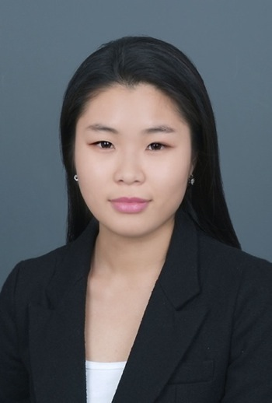
Soh-young Ahn ( Chanel )
F4 visa holder
New Zealand citizenship
010 8527 5642

Dear whom may it concerns
I am pleased to present my resume to you for consideration as an English teacher. Briefly introducing myself, my name is Soh-young Ahn (Chanel). I graduated New Zealand University of Waikato and I studied Bachelor of Computer Graphic Design. I had two TESOL certificates that are advanced 120 hour program and tutoring English specialization. I had teaching and other work experiences in South Korea. The age that I taught English was 4-13 years old students. I am in Korea now so I can start work as soon as possible.
I have qualities that adventure teaching needs in employees. I am open-minded, hard working, adaptable, and responsible. I love children and teaching them because it makes me feel like I am doing something worthwhile with their and my life. My teaching style is full of energetic and active, yet flexible in responding to constantly changing demands.
I believe you will find me to dedicated educator who will qualified to provide the motivation and direction students need to successfully learn.
The enclosed resume will show ability to be a wonderful teacher and providing students with excellence in education.
l would be honored to work for your company and school, and l look forward to hearing from you. If you have any questions, please do not hesitate to contact me as l would be happy to answer them for you.
Thank you for your time and consideration.
Sincerely.
Soh-young Ahn (Chanel)

Soh-young Ahn
New Zealand citizenship
D.O.B: July 11, 1989
Home: 070 8688 3269 Cell: 010 8527 5642
경기도 성남시 분당구 구미동 22 까치마을 건영빌라
Education
Hamilton Peachgrove Intermediate, New Zealand 2001-2002
Hamilton Girls High School, New Zealand 2003-2007
University of Waikato, New Zealand 2008-2010
- Bachelor of computer graphic design

Certifications
- New Zealand Foundation Global TESOL, December 2010
- New Zealand Advanced Global TESOL, January 2012
- New Zealand Specialization Global TESOL, Tutoring English, January 2012

Teaching Experience
Kidz Art, Yong-In, February 2011 – March 2012
- English and art hakwon
- Taught English and creative art for 4~13 years old kids
- Developed art, music, movie and English lesson plans for each class
- Counselled students and parents

Jes Island, Jam-sil, January 2013- April 2013

- English Kindergarten
- Native English teacher for 4 years old kindergarten kids in first year
- Taught phonics and grammar for 8~10 years old elementary kids

Additional experience
Toytron, Seo-cho dong, March-May 2012
- Part-time marketing assistant
- Arranging promotional events
- Displaying new toys
The T-shirt museum, Nong-hyun dong, May- December 2012
- Web designer / customer service representative
- Managing overall website contents and technical problem
- Releasing new products
- Answer phones and respond to customer requests

Volunteer experience
- Hamilton Multi Culture Music festival MC, New Zealand 2009
- WAKS (Waikato association of Korean students) director of marketing,
New Zealand 2009-2010

