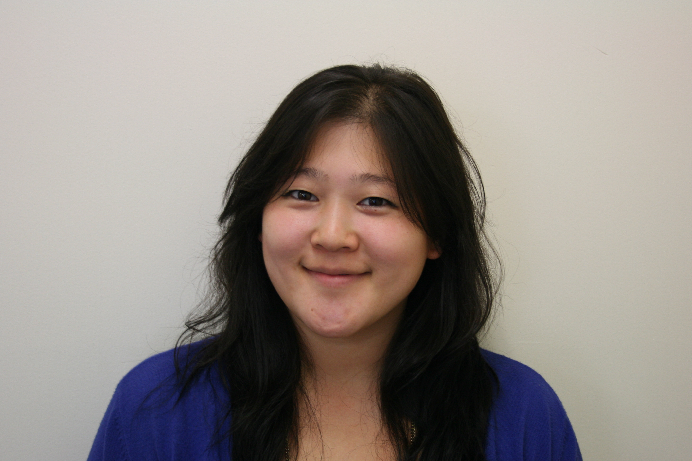

Curriculum Vitae
Grace Kwon – 114 Surrey Crescent
Mob: 0210 228 4207
Email: ottergrace@hotmail.co.uk

Career Objectives
Over the years, I’ve worked in various occupations and I have learned that even the most negative experience can become a stepping stone for growth and character development. I have many creative talents, and I enjoy being around people. I am bubbly, assertive, energetic and confident. As a team player, I am a great communicator, and I love to see results. One of my character strengths is that I’m very teachable. I’m always open to improvement and adjusting to suit any environment that I may find myself in.

Education/Qualifications
TESOL Certificate III (2010) ACG Building, Level Four, 345 Queen Street
Certificate in Applied Christian Ministry NZQA Level 4 (2009/2010)
Equippers Bible College, Auckland
Hongik Univeristy (Seoul, Korea)
I was accepted in 2001 at the English Education Department with a full scholarship. However, after three years, I decided to pursue my passion in travel and world missions.
Sang Dang High School (Cheong ju, Korea) Graduated in 1999

Employment History
The Langham Hotel, Auckland (Sept 19 2008 – December 2008) employed as a call centre operator (telephonist)
Responsibilites and achievements, skills I attained through this period of employment
- Time management and prioritizing task list, programming computer wake up calls
- Logging down tasks and paging housekeeping with hotel services. I.e) towels, guest amenities, limo bookings, turn down service, laundry pick up etc. also guest servive.
- Taking down phone messages, both written and verbal; ensuring they get to the appropriate guest or staff member
- Mentoring new colleagues.
Alternatively, I covered shifts in our club lounge as a food and beverage attendant, and some banquets shifts as a beverage floater and waitress.

Mt Eden Fish Shop – shop assistant (May 2008- august 2008)
Responsibilities and achievements
- Set up shop in the morning
- Was responsible for various cooking and food preparation roles
- Developed my customer service skills
- Cash handling
Youth With a Mission : Crystal Springs – Youth Mentor (August 2007- February 2008 )
Responsibilities and achievements
- This is a 5 month bible study and mentorship program and a live in staffing position.
- I was in a group of 12 staff who mentored a group of 45 young adults
- My role was also as a personal assistant to the school leader. I was responsible for the office admin work
  - Developed my secretarial skills such as filing documents, developing phone manner, photocopying and typing
  - Organized travel arrangements for missions trips
  - Responsible for school photography
  - Created orientation booklets for the students
YWAM Family Ministries – Home school teacher February 2007- April 2007
Responsibilities and achievements
- I was assigned to teach a small international group of students to assist them with their homeschooling
- I was working with another teacher and we gave them daily assignments and were in charge of going through their home school curriculum with them
Bar “O” September 2003 – August 2004
Responsibilities and achievements
- Began working as food and beverage attendant and was promoted to assistant manager after two months
- Was responsible for opening the shop
- Was in charge for ordering bar supplies: liquor, fruit etc
Western Bar & Grill February 2002 - September 2003
Responsibilities and achievements
- Was responsible for opening and closing of the bar
- Assisted with food preparation and cooking for the pub food
- Worked during the 2002 Soccer World cup that was held at the stadium next to the bar which enabled me to develop my efficiency skills during this busy time

Skill Summary
Non Technical Skills:
- Communication skills
- Cooking
- Party Planning
- Nannying
- Baking
- Making basic cocktails
- Wait services
- Art
- Acoustic Guitar
- Jazz singing
- Piano
- Cello
Computer Skills:
Adobe Illustrator; Beginner
MS Excel; Beginner
MS Word; Beginner
Macintosh; Beginner

Languages
Fluent English and Korean
World Missions, Travel
Hospitality
Fine Dining
Creative Writing
Illustration and Graphic Design
Music, Photography
Linguistics , Literature, and Foreign Languages,
People, Typography, Cinema

Character references

Dongsun Kim
Supervisor of Private Language School
Ph +0082 – 19-9663-0816

The Langham Hotel
Sheryl Geraghty – senior call centre operator
Ph +64-9-298-4042

Youth With A Mission : Family Ministries NZ Directors
Ross and Sheryll Watkins
Ph: +64-7-888-5687

