Jambal Khishigjargal |  | 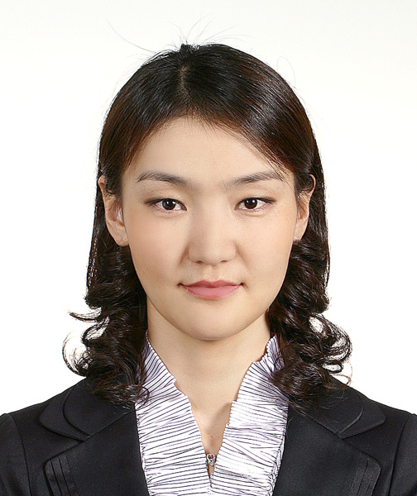
서울시 송파구 송파동 21-1 다원 빌딩 7층, S.Korea
▪ Mobile: (+82)10-5801-1085 ▪ Email: khishgeed@gmail.com
PERSONAL INFORMATION
▪ Nationality: Mongolian ▪ Citizenship: Mongolia
▪ DOB: 31 December 1979 ▪ Civil Status: Single
EDUCATION
Aug. 2006-  Feb. 2009  Sept. 1999-  June 2003  Oct. 1998-  June 1999  Sept. 1997-  June 1998  Sept. 1995-  Jan. 1997  Sept.1987-  June 1995 /  - June 1997 | KAIST Graduate School of Finance Seoul, Korea  Finance MBA: GPA 3.56/4.3  ▪ Courses of focus: Corporate Finance, Investment Banking, Asset Management, Valuations,  Fin.Statement Analysis, Mergers & Acquisitions, Investments, Governance  ▪ Thesis work: “ Reverse Takeovers and Corporate Governance”  – examining reverse merger successes depending on governance characteristics  ▪ All classes were in English  GAZI University, School of Economics and Administrative Sciences Ankara, Turkey  Bachelor of Business Administration: GPA 3.15/4.0  ▪ Courses of focus: Accounting, Financial Statement Analysis, Financial Management,  Strategic Planning, Project Evaluation&Financing, Management, Marketing  ▪ 50% of classes were in English  Ankara University, Turkish Language Training Center Izmir, Turkey  Turkish language training  National University of Mongolia, School of Economic Studies Ulaanbaatar, Mongolia  ▪ Economics major: (Won the Turkish Government Scholarship in the 1st year)  Mongolian-Turkish Advanced Training Secondary School Ulaanbaatar, Mongolia  High school education  ▪ Core courses: Advanced Mathematics, Intensive English and Turkish  #1 Ten-year Secondary School of Mandalgobi City Dundgobi, Mongolia  Secondary and high school education  ▪ Special concentration: Mathematics and Geometrics, Olympiad training
WORK EXPERIENCE
March 2009 - Present  July. 2008-  Aug. 2008  July. 2007-  Aug. 2007  Sept. 2003-  Aug.2006  July. 2003-  Aug.2003  May 2003-  June 2003 | Hawoorim - Business Consulting and Law Firm Seoul, Korea  Intern  ▪ Help setting up business connections in Mongolia and Turkey  ▪ Expand client base within and outside of Korea especially from Mongolia and Turkey  Good Morning Shinhan Securities Seoul, Korea  Intern, International Business Division, International Sales Department  ▪ Tracked news and performance of the Korean stock market and other global stock exchanges  ▪ Studied IPO issues, government policies related to interest rate change and mortgage rates  ▪ Worked with several financial analysts, and developed a broad understanding of their work  SK Group, SK Networks Seoul, Korea  Intern, Network Business Strategy and Planning Division, Business Supporting Team  ▪ Researched market sectors of the ICT industry of Mongolia  ▪ Performed presentations on country introduction and business opportunities in Mongolia  Mongolian Academy of Sciences, Headquarters Ulaanbaatar, Mongolia  Manager, International Relations Department  ▪ Overall coordination of international activities of the Headquarter & the 16 institutes of MAS  - Organized incoming and outgoing scientific exchange visits  - Assisted setting up collaboration of the joint and field research projects  - Conducted / coordinated international workshops, forums and seminars  - Organized business visits and meetings  ▪ Drew up annual budget reports for the int.l activities such as workshops, exchange visits etc.  ▪ Reference: Acad. Duger Regdel, Secretary General, regdel@mas.ac.mn Tel: (976)-11-261993  Agricultural Bank of Turkey (Ziraat Bankasi) Ankara, Turkey Intern, Kizilay Branch  Ankara Chamber of Commerce Ankara, Turkey Intern, Accounting and Finance Department
HONORS AND AWARDS
2006  1998  1996  1995, 1997 | Korean Government Scholarship  Turkish Government Scholarship  Top student of the Mongolian-Turkish Secondary School  ▪ Participated in the Mathematics Olympiad of Ulaanbaatar City.  First place in the provincial level of the State Mathematics Olympiad twice  ▪ Participated in the 31st (in Arkhangai) and 33rd (in Hujirt) State Mathematics Olympiads.
OTHERS
Languages:  Computer:  Interests: | ▪ Mongolian (Native) , English (Fluent), Turkish (Fluent),  Russian (Intermediate), Korean (Intermediate)  ▪ MS Office, Outlook, SPSS (proficient user); MATLAB, SAS (moderate user)  ▪ Foreign languages and cultures; traveling in natural parks;  Sports - swimming, tennis, volleyball; Music, arts

