Jambal Khishig jargal (히시캐) |  | 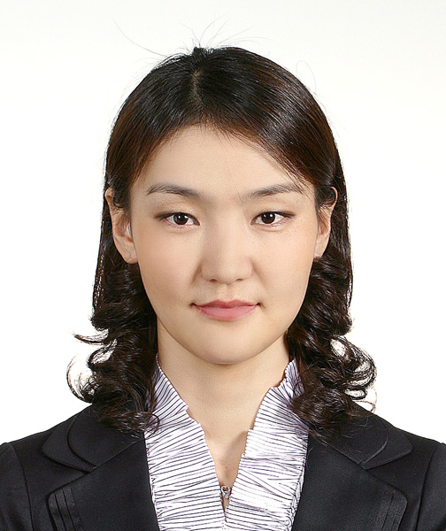
서울시 송파구 송파동 21-1 다원 빌딩 7층, S.Korea
▪ Mobile: (+82)10-5801-1085 ▪ Email: khishgeed@gmail.com
▪ DOB: 31 December 1979 ▪ Nationality: Mongolian
EDUCATION
Aug. 2006-  Feb. 2009  Sept. 1999-  June 2003  Oct. 1998-  June 1999  Sept. 1997-  June 1998  Sept. 1995-  Jan. 1997 | KAIST Graduate School of Finance Seoul, Korea  Finance MBA  ▪ All classes were in English (October 2008 -TOEIC 990)  GAZI University, School of Economics and Administrative Sciences Ankara, Turkey  Bachelor of Business Administration  ▪ 50% of classes were in English  Ankara University, Turkish Language Training Center Izmir, Turkey  Turkish language training  National University of Mongolia, School of Economic Studies Ulaanbaatar, Mongolia  Economics major, won a scholarship to study abroad in 1st year of study.  Mongolian-Turkish Advanced Training Secondary School Ulaanbaatar, Mongolia  High school education in English
WORK EXPERIENCE
March 2009 - Present  July. 2008-  Aug. 2008  July. 2007-  Aug. 2007  Sept. 2003-  Aug.2006 | Hawoorim - Business Consulting and Law Firm Seoul, Korea  Intern  Good Morning Shinhan Securities Seoul, Korea  Intern, International Business Division, International Sales Department  SK Group, SK Networks Seoul, Korea  Intern, Network Business Strategy and Planning Division, Business Supporting Team  Mongolian Academy of Sciences, Headquarters Ulaanbaatar, Mongolia  Manager, International Relations Department  ▪ Overall coordination of international activities of the Headquarter & the 16 institutes of MAS  ▪ Drew up annual budget reports for the int.l activities such as workshops, exchange visits etc.
HONORS AND AWARDS
2006  1998  1996  1995, 1997 | Korean Government Scholarship  Turkish Government Scholarship  Top student of the Mongolian-Turkish Secondary School  ▪ Participated in the Mathematics Olympiad of Ulaanbaatar City.  First place in the provincial level of the State Mathematics Olympiad twice  ▪ Participated in the 31st and 33rd State Mathematics Olympiads.
OTHERS
Languages:  Computer:  Interests: | ▪ Mongolian (Native) , English (Fluent), Turkish (Fluent), Russian (Intermediate), Korean (Interm.)  ▪ MS Office, Outlook, SPSS (proficient user); MATLAB, SAS (moderate user)  ▪ Foreign languages and cultures; traveling in natural parks; Sports - swimming, tennis, volleyball; Musics – can play some instruments like guitar, arts

