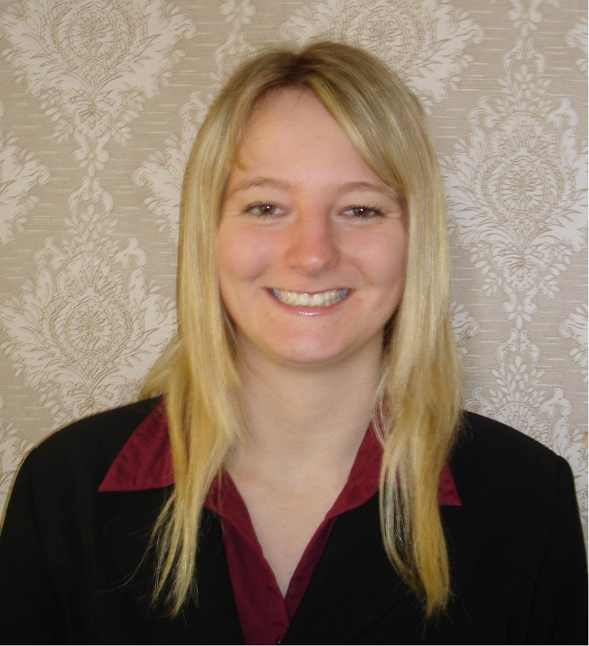
35 Marlborough Street  Mount Eden  Auckland 1024  New Zealand | Tel: 00 64 (0)9 623 3048  Mobile: 00 64 (0)21 147 2998  Email: roz_leman@hotmail.com  D.O.B.: 25.10.1985  Place of birth: Keighley, UK  Nationality: British  Marital status: single
Rosalind Leman
Objective

- To apply the skills I have gained from my teaching experience and my TEFL qualification to obtain a position as an English teacher.
Education and Training
Feb-Jun 2009 International TEFL Corporation
ITTT TEFL Certificate
- Internationally recognized 100-hour online TEFL certificate course
- Covered teaching skills, language awareness, phonology and classroom management
2004-2007 The University of Nottingham Nottingham, UK
Bachelor of Arts (Honours): Music and Philosophy
2:1
Employment History
May-Nov 2008 Anuban Prachuap Khiri Khan School Prachuap Khiri Khan, Thailand
English Teacher (Voluntary)
- Taught English as a foreign language to children aged 9-12 in classes of 40
- Completed a teaching skills course
- Gave explanations and instructions using simple vocabulary, gestures and visual cues
- Wrote detailed lesson plans
- Planned topics for semester
- Organised student-centred activities to develop students’ spoken English
- Created teaching materials using minimal resources
- Assisted with school ceremonies and extracurricular activities
Languages

- French: intermediate
- German: intermediate
- Thai: basic
Skills

IT
- Microsoft Windows and Office programs
- Typing - 65wpm

Driving
- Full, clean driving license
Hobbies and Interests

- Playing the flute, piano and guitar
- Composing and listening to music
- Writing short stories and dialogues
- Reading classic and contemporary literature
- Reading newspapers and political non-fiction
- Appreciating art and visiting art galleries
- Travelling around the world
Referees

Clare Jackson
Recruitment Consultant
Kelly Services
Level 9
Gen-i Tower
66 Wyndham Street
Auckland 1001
Tel: +64 9 303 3122
Email: clare_jackson@kellyservices.com

Suchada Pimsorn
Head of English Dept.
Anuban Prachuap Khiri Khan School
Salacheap Road
Prachuap Khiri Khan
Mueng District
Thailand
77000
Tel: +66 89 614 1369
Email: krusuchada@hotmail.com

Mark Crocker
ITTT TEFL Course Tutor
mark@tesol-tefl.com

