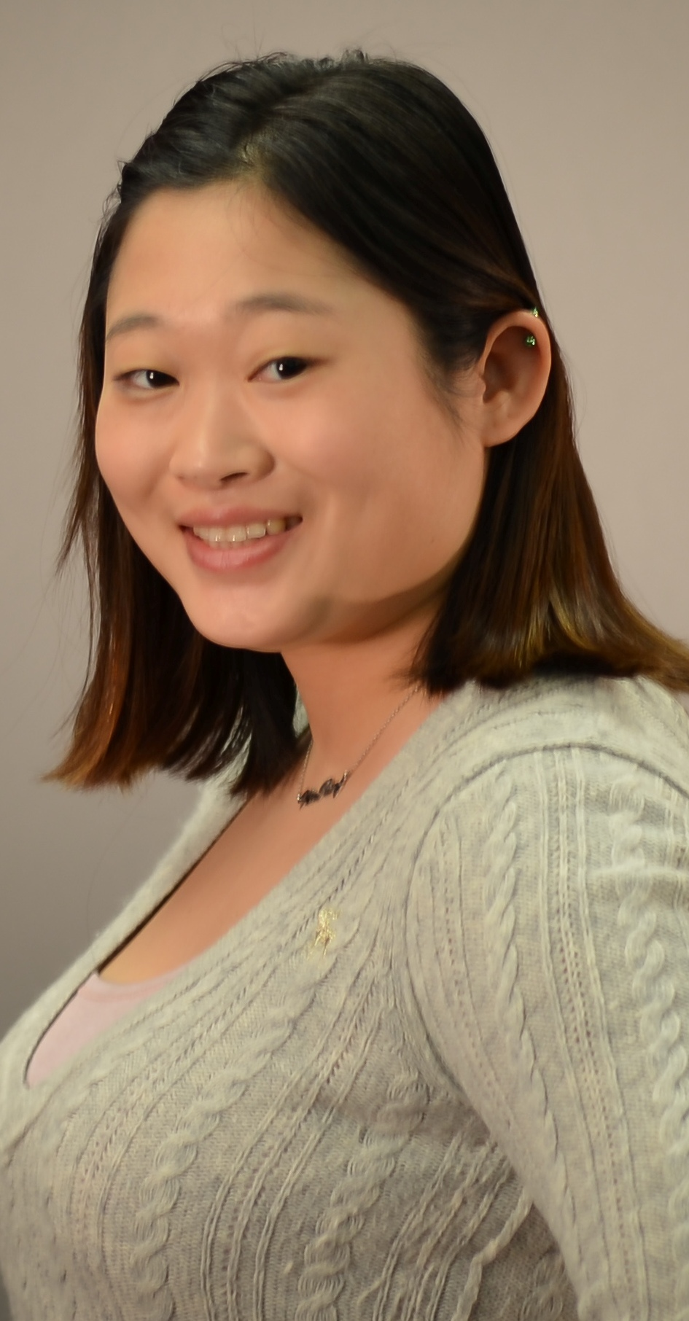

CARLA J. MCBRIDE
D.O.B 20/10/86

EDUCATION
The University of Kansas, Lawrence, KS, May 2013
Bachelor of Fine Arts in Art History with Fine Arts Emphasis
Minors: Sociology and Korean

STUDY ABROAD
South Korea: Seoul Summer and Fall Semester 2011 Ewha Woman’s University 이화여자대학교
- Learned about Korean culture, language, North Korea, art
- Received a scholarship to study in Korea
- Trip photographs won KU award
Greece: Athens January 2006 through Augustana College, South Dakota
- Attended with students from other Midwest private colleges, only Freshman and student representing my college
- Studied Lord Byron and his travel through Greece
- Learned about Greek modern history and ancient architecture

STUDENT INVOLVEMENT
Board of Class Officers: Senior Class Representative Fall 2012-2013
- Brainstormed ideas for the graduating class motto, senior gift
- Helped with PR of senior class events
- Promoted class unity on campus with class “percentage discount night” with local businesses
Global Partners: Participant Fall 2010-2013
- Help international students adjust to life on campus and American culture/customs
- Made new friends and learned about different countries’ people
- Attend cultural sponsored events/lectures on campus part of GAP program
- Global Awareness Program Certificate with Distinction
- Relay for Life: Public Relations Committee Fall 2010-Present
- Chalk sidewalks around campus promoting Relay events
- Contact media outlets such as the newspaper, radio and other school organizations
- Make posters/fliers and distributed to Lawrence community
- Work Relay For Life annual spring event on campus, security
Student Activities Board: Member of SAB Dole Institute of Politics Fall 2010-2011
- Helped with Q&A at Dole Institute lecture series
- Attended student conference about the American political process
- Research Experience Program Certificate

EXTRA-CURRICULAR ACTIVITES
East Coast Asian American Student Union (ECAASU) Feb. 2008-2013
- Discuss issues in the Asian American community and promote activism
- Attend the annual conference at hosting university
University of Kansas Symphonic Band: Fall 2010-2012 play the flute
- Members selected through blind audition

July 9, 2013

Seoul, Korea

Dear Sir or Madam

I am applying for the position of English teacher Korea for Summer/Fall 2013. I learned of the position from the koreajobfinder.com website. I recently graduated from the University of Kansas this May with a degree in art history and minors in sociology and Korean. I would like to work in Korea to help earn money to pay for graduate school. I plan on studying in Seoul.

I have no formal teaching experience in Korea, however I was tutoring a Masters student from Korea and her nine-year-old daughter who attended my university. The mother I helped with proofreading her research papers and worked on her English speaking and pronunciation. Her daughter I helped translate her journal from Korea to English. I helped her with making sure she used capital letters where appropriate as well as using the correct punctuation and grammar. It was helpful knowing a little of both languages to help them understand some concepts better since I knew what things were similar and different between the two languages. I enjoy helping international students with American English and learning about the cultural differences between my culture and theirs.

I look forward to hearing from you.

Sincerely,

Carla McBride

