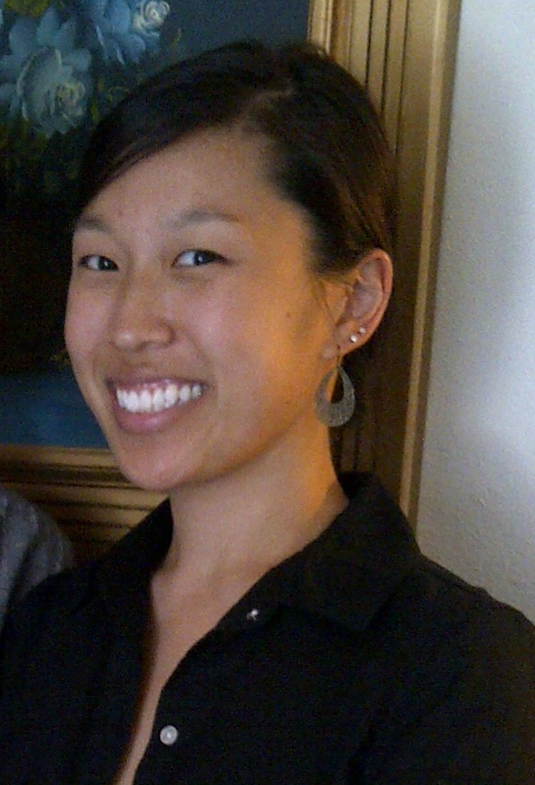

Casey M. Seeling
________________________________________________________________________________________________________

Objective To obtain a position where I can teach children.

Education Winona State University, Winona, MN
Candidate for Bachelor of Science Degree – Graduation Date: December 10, 2010
Major: Elementary Education: Early Childhood – Birth through Grade 6
GPA: 3.6 on 4.0 scale Dean’s List

Chung-Ang University, Seoul, South Korea – Study Abroad, Spring semester 2008

Experience Community School of Excellence Saint Paul, Minnesota
Kindergarten School Teacher Fall 2011 – present
- Develop reading skills through Guided Reading
- Strengthen cultural awareness through the IB – PYP program
- Gain global knowledge by teaching IB – PYP related lesson plans

Community School of Excellence Saint Paul, Minnesota
Kindergarten Summer School Teacher Summer 2011, 2012
- Enrich the students with literacy lessons to develop their DRA
- Teach mathematic, spelling, and writing lessons to increase their skills

South St. Paul Public School District South Saint Paul, Minnesota
Substitute Teacher – Kindergarten through 6th grade January 2011
- Teach daily lesson plans for each class
- Ensure students comprehend assignments

Ames Elementary School Saint Paul, Minnesota
Student Teacher – Kindergarten: Mrs. Weestrand Fall 2010
- Assist cooperating teacher with daily tasks
- Create math, writing, and reading lesson plans
- Work in large and small groups on developing literacy skills

KinderCare Learning Center Maplewood, Minnesota
Substitute Teacher January 2011
Pre-School Teacher Summer 2010
- Work on developing fine motor skills during small group time
- Help develop gross motor skills during large group time
- Assist on art, science, and language/literacy projects

Chung-Ang University Seoul, South Korea
English Teacher – English Lounge 2008
- Taught college aged Koreans English by pronouncing words phonetically
- Discussed different cultural lifestyles – Westernized and Traditional
- Strengthened communication skills by learning to speak slower

Maxwell Children’s Care Center Winona, Minnesota
Teacher’s Aide – Preschool Room: Angie Lepsch Fall 2009
Teacher’s Aide – Toddler Room: Jill Anderson Spring 2009
- Planned and implemented lessons
- Assisted in daily routines
- Facilitated toddler interactions during play time

Partners In Progress (PIP) Program Winona, Minnesota
Tutor –Washington-Kosciusko Elementary School Fall 2008
- Conducted math and reading assignments for children to practice and improve their skills
- Organized projects and games for the children
- Created lesson plans to help children increase their knowledge

Other Minnesota Children’s Museum Saint Paul, Minnesota
Experience Volunteer – Curiosity Center Summer 2010
- Offer help in the creative arts or sensory activities
- Facilitate the art programs with the children and their parents
- Allow the children to explore their creativity

Woodbury Figure Skating Club 2010 – present
Winona Figure Skating Club 2008 – 2010
Duluth Figure Skating Club 2003 – 2006
Figure Skating Coach, Learn to Skate – Basic Skills Program & Private Lesson Coach
- Prepare lessons from Snowplow Sam to Freestyle level skaters – Basic Skills and ISI
- Work with groups of skaters to achieve skills to pass each level
- Help skaters improve their technical and presentation skills

People Serving People Minneapolis, Minnesota
Meal Server – Volunteer May 2011 – present
- Serve meals to the homeless families

Fairview Hospice Twin Cities, Minnesota
Hospice Volunteer June 2010 – 2011
- Assist patient with various tasks: care giving, light housekeeping, respite

Activities Asian American Club President (Senior Year) / Vice President (Junior Year) / Secretary (Sophomore Year)
Global Studies Student Association President (Senior Year) / Vice President (Junior Year)
Hmong American Student Association Public Relations (Junior Year) / Secretary (Sophomore Year)
Education Minnesota Student Program (Sophomore – Senior Year)
Students Impacting Lives on Campus and in the Community External Mentor / Peer Mentor

