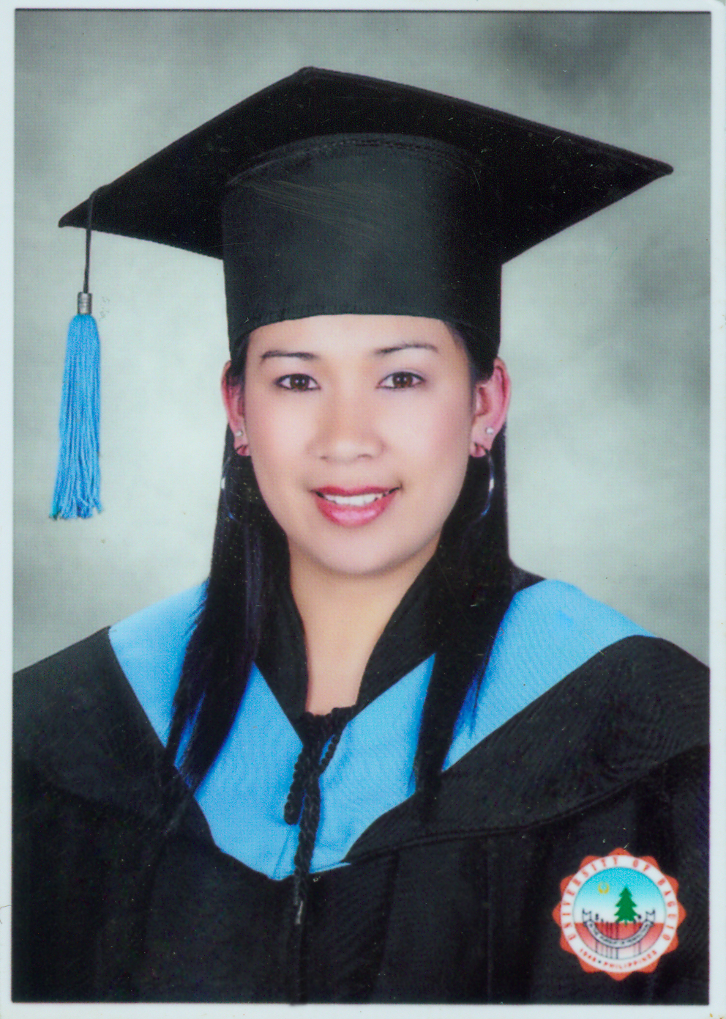
Catherine Clemente Say-ao
Antamok Tram Ucab,Itogon
C.A.R., Philippines
Current Location: Beijing,China
Phone No.: 15300220863
Email Add: cc.sayao@gmail.com

PERSONAL DATA
Age: | 25
Date of Birth: | Nov 13, 1982
Gender: | Female
Civil Status: | Married
Height: | 160.06 cm
Weight: | 58 kg
Nationality: | Filipino
Religion: | Christianity – Catholic
Permanent Address: | Antamok Tram Ucab Itogon Benguet Philippines 2604  Present Address: BaoXing Yuen, Wang Jing Xi Yuen, Beijing China

EDUCATION
 | Highest Education | Second Highest Education
Education Level: | Bachelor's Degree / College Graduate | Vocational Diploma / Short Course Certificate
Education Field: | Education/Teaching/Training | Others
Course: | Bachelor of Science in Teacher Education | CAREGIVING
School/University: | University Of Baguio | Baguio Overseas Learning And Training Center
Location: | Baguio City | La Trinidad Benguet
Date: | Apr 1999 - Oct 2007 | Mar 2005 - Aug 2005

WORK EXPERIENCED
1. | Position: | Private Tutor for Koreans residing in Baguio City Philippines
1. | Duration: | Mar 20, 2006 - Mar 25, 2007(1 yr)
1. | Company: | Private-Home Based Tutorials
1. | Company Industry: | Others
1. | Location | Monteraza Village Tuding Itogon Benguet
1. | Department:
1. | Job Description: | I was hired as a private tutor in English by a Korean family residing in Monteraza Tuding Itogon Benguet Philippines. I taught 2 kids ages 9 and 12.This was my first job as a private tutor in English for Koreans. I finished my job for a year to continue my studies in college.
2. Online Teacher
Duration: January 5, 2008-April 5, 2008
Company: World Communications (South Korea)
Location: Home based teaching online
Job Description: I was hired as an online teacher for Koreans who lives in South Korea. I have been teaching 10 Koreans through skype for 4 months.

3. Volunteer Teacher
Duration: September 2007- December 2007
Location: Itogon Benguet Philippines
Job Description: I volunteered as a kindergarten teacher in Antamok Day Care Center, Philippines for 3 months. I have been teaching children ages 3-5 years old.
4. Private Tutor/ESL teacher at present (Beijing, China)

REFERENCES
Imelda Pacalso Clemente --mother-- mobile number:639197763684
Euanne Bartolome --co-teacher-- mobile number:13366465914
Cristina --chinese friend mobile number:13141201796

WORK AVAILABILITY
I can start for work as soon as possible。

