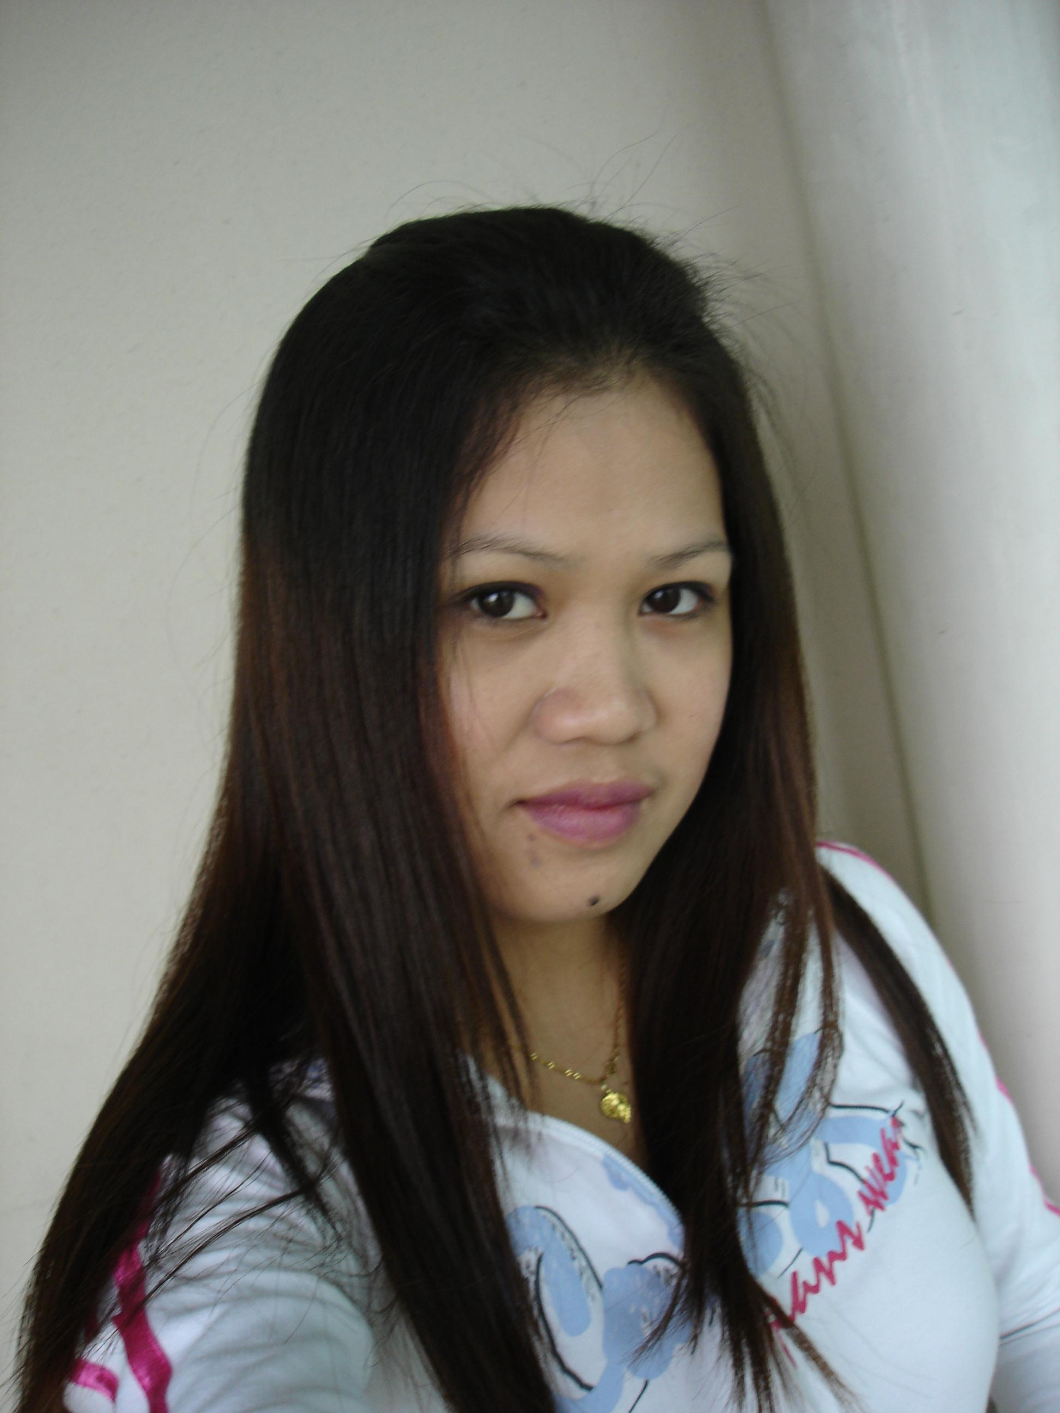

Catherine M. Leyros

No. 610 Samdoo Apt. 2-3bunji, Singil 1-dong, Yeongdeungpo-gu, Seoul
E-mail:Khazier_18@yahoo.com
Phone No. 010-8700-5518
Birthday • December, 20, 1986
Marital Status • Married
Nationality • Filipino

Objective

.To teach elementary and/or middle school aged students in Seoul Korea
where I can develop my skills and knowledge as a teacher and explore an amazing country.

Education

2004 - 2006
Universal College of Computer in Quezon City, Philippines)

Teaching Related Experience

May 2006 - Jan. 2007
Child’s Dream Pre-School in Q.C Philippines

•Its one by one student, one by one teaching in a class..

1/2
Work Experience

Feb. 2007 – Oct. 2007
United Container Corporation , Secretary
Make reports / documents etc.

Awards/Certificates Received

November 09, 2008
•Participation in Academic Teacher Training Sessions held by Cambridge University Press ELT.

December 01, 2008
• Honor prize in Korean language program..
• Perfect Attendance in Korean language program..
• A certificate in completion my Korean course..

Language Skills

• Fluent Tagalog
• Basic Korean
• Intermediate English

Hobbies and Interest

• Reading any kind of books

References

Available upon request

2/2

