Charles White

NATIVE ENGLISH SPEAKER
CITIZENSHIP: USA
D.O.B: AUGUST 5, 1989
GENDER:Male

PROFILE:

I am a TEFL certified instructor with a bachelor’s degree in history from Purdue University. I competed for Purdue University’s varsity cross-country and track & field teams while also being a full time student; this allowed me to strengthen my time management skills. I also have experience with one on one English tutoring and group tutoring, both with non-native English speakers.

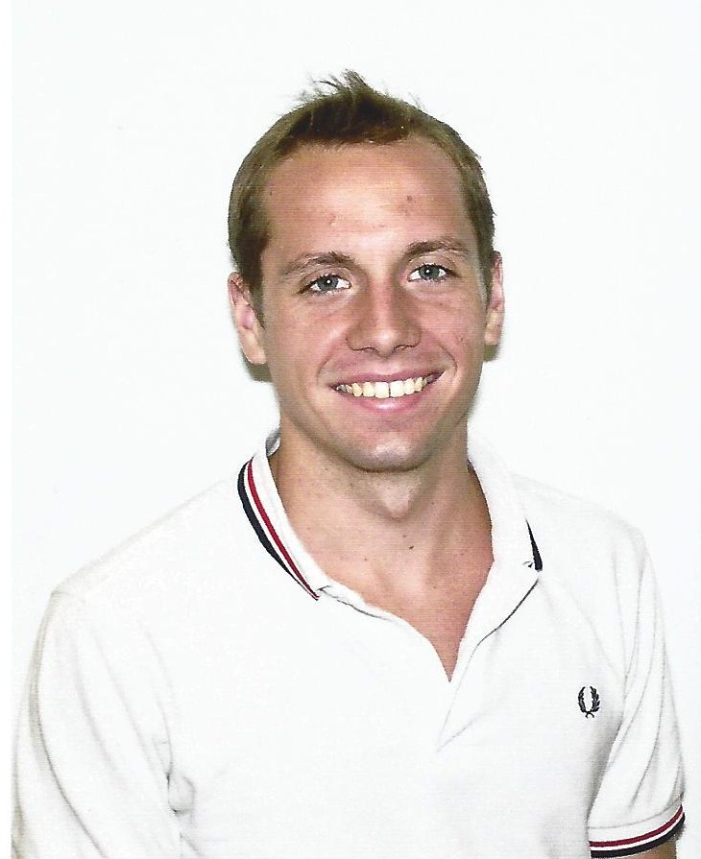
Since the February of 2013 I have been working full-time as an English instructor for Tianjin Oriental Babycare Consulting Co. While employed at Tianjin Oriental Babycare Consulting Co. I worked with children from the ages of four to ten on numerous aspects of the English language, including; conversational English, grammar and pronunciation.

EDUCATION:

TEFL CERTIFIED September 2012
TEFL Institute Online
- 100 hours of training with 20 hours of student teaching

B.A. IN HISTORY December 2012
Purdue University, West Lafayette, IN USA
- Also attended Abilene Christian University from Fall of 2008 to Spring of 2009

RELATED WORK EXPERIENCE

English teacher at Tianjin Oriental Babycare Consulting Co.,Ltd
- I have been with Tianjin Oriental Babycare Consulting Co. since February 2013 and in that time I have helped children from the ages of five to ten with their English verbal, grammar and handwriting skills.

CONVERSATION PARTNER FOR NON-NATIVE ENGLISH SPEAKERS

- Worked one on one with non-native speakers, specifically from South Korea, to help them to speak the English language more efficiently.

ADDITIONAL WORK EXPERIENCE

ASSISTANT SUPERVISOR TO WHITE FAMILY TIMBER 2009-2011
- White Family Timber, Mississippi & Georgia USA.
- Responsible for the planting of seedlings, spraying of herbicide and the clearing of brush.

OTHER AWARDS, SKILLS, AND INTERESTS

- Purdue Academic Honor Roll member 2012
- Kneale Award Recipient for Literary Excellence 2011
- Member of the Phi Eta Sigma Freshman Honor Society 2009-2012
- Member of the Phi Alpha Theta Historical Honor Society 2010-2012
- Member of Purdue Varsity Cross Country & Track Teams 2009-2012
- Member of Abilene Christian University Cross Country Team 2008

