Charmaine Scollins
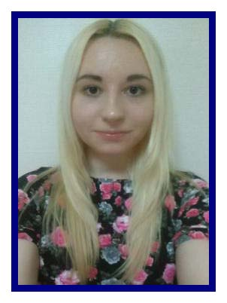
305 Pink Ville
Anjung, Pyeongtaek
Gyeonggi-do
South Korea

D.O.B: 7 / 16 / 91

Personal aim:
Experienced and dedicated English teacher seeking new after school job opportunities in an Elementary school.

Education:
BA Honours degree English language and linguistics with Journalism Grade 2:1
Relevant modules including:
-Child acquisition
-Language and gender
-Intercultural communication

Employment:
TaLK English Teacher Kujwajungang Elementary School Feb 2013- Jan 2015
-Taught three classes per day with grades 1-6.
-Focussed on areas such as phonics and conversational English.
-Planned and prepared all materials including PowerPoint’s and worksheets.
-Planned and taught camp classes with grades 3-6.
-Focused on improving student’s grammar, listening, speaking and writing skills.

GEPIK English Teacher Anjung Elementary School March 2015- Feb 2016
-Taught up to 21 hours per week with grades 3-6.
-Focussed on curriculum textbook with additional self made materials.
-Planned and prepared lessons with a co-teacher.
-Co-planned and taught camp classes with grades 3-6.

Training:
TaLK Orientation Elementary after-school training Feb 2013
-Three weeks intensive training with lectures on classroom management, teaching methods and lesson planning. Certificate of completion.
-Practicum’s on solo and co-teaching.
-15 units of in service online training.

GEPIK Orientation Curriculum training April 2015
-Three days training with lectures on co-teaching methods and lesson planning. Certificate of completion.

Referees:
-Referees available upon request.

