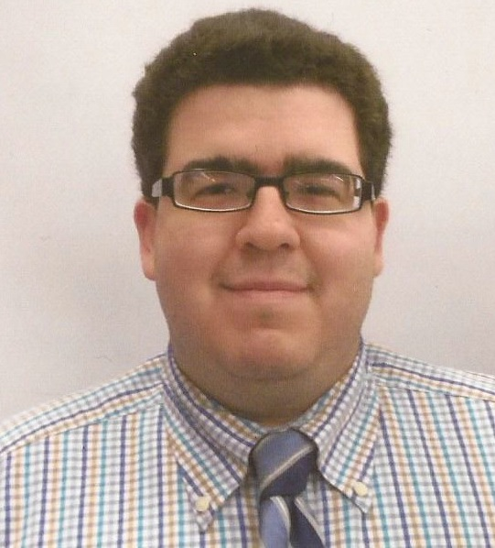
Christian Francisco Howard

EDUCATION

UNIVERSITY OF CALIFORNIA, LOS ANGELES, Los Angeles, California
Bachelor’s Degree in Sociology, 2010
- Courses taken include Statistics in Social Research, Social Psychology, Sociology of Family and Work
- Recipient of Cal B grant, while attending UCLA.
- Will pursue TESOL certification (2014)

PROFESSIONAL EXPERIENCE
CANTRELL, HARRIS AND ASSOCIATES, San Francisco, California 2012 to Present
Staff Accountant
- Managed accounts payable for 25 commercial and residential properties and oversaw more than 2000+ A/P and A/R accounts and reported directly to the CFO
- Analyzed account balances and financial reports and prepared expense and flexible budget reports to help streamline the property owner’s financial goals
- Responded to data requests from auditors, property owners, vendors, managers

CANTRELL, HARRIS & ASSC/LARAMAR, San Francisco, California 2010 to Present
Building Concierge
- Assisted in leasing 4 residential units within the last 6 months.
- Delegated various maintenance responsibilities to both in-house building engineers as well as third party specialists
- Handled logistics and conflict resolution at a multi-storied luxury commercial and residential complex which houses the Yemeni, Vietnamese and Egyptian Consulate
- Handled logistics of 5 level commercial garages

LEARNING ASSISTANCE CENTER, San Francisco, California 2004 to 2012

Tutor

- Instructed students on Sociology, Psychology, English and Mathematics coursework
- Organized lectured materials and implemented creative learning techniques to assist students in comprehending complex subject matter
- Developed multiple choice questions to make students more aware of the lecture material

LUVALLE COMMONS (UCLA), Los Angeles, California 2009 to 2010
Cashier
- Responsible for greeting customers, taking orders in a timely and accurate manner and handing over daily cash receipts to respective managers.
- Additionally multitasked as a food preparer when understaffed. Duties included organizing kitchen and serving area

Sociology Department, San Francisco, California 2006 to 2008
Teacher Assistant
- Graded exams for accuracy and content.
- Collaborated with professor to create mock quizzes and exams to identify troubling spots for students.

ADDITIONAL SKILLS

- Multilingual with written proficiency and verbal proficiency in Spanish
- Proficient at SPSS, Yardi, C++, Java, Microsoft Excel and Word

