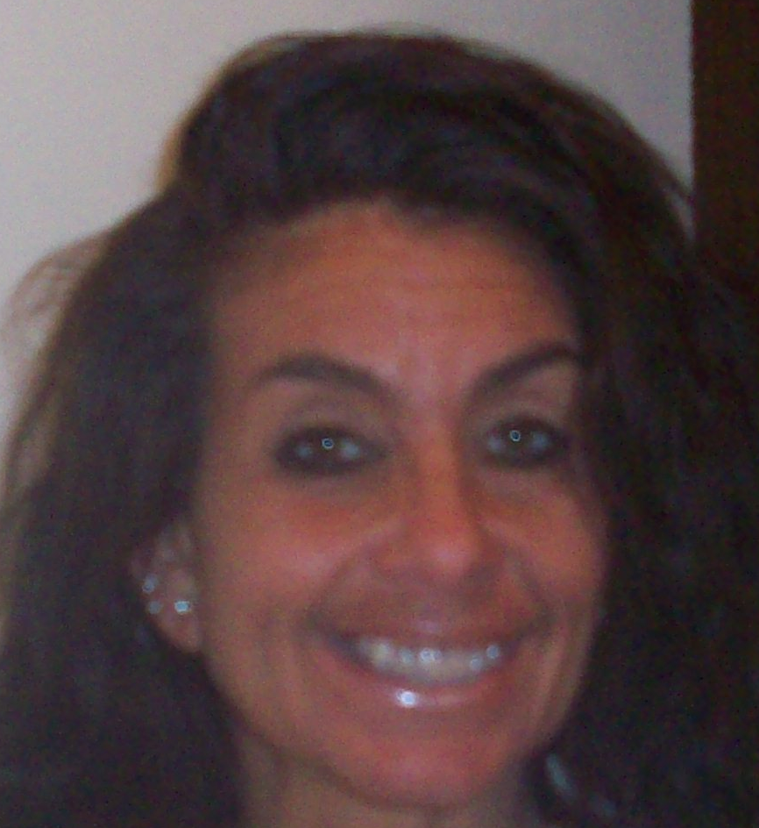

Christine A. Norwood
928 Merrimac St
Cary, IL 60013 USA
+1 847-651-5775
christineanorwood@gmail.com

PERSONAL INFORMATION

English Fluency: Native English Speaker

Citizenship: United States

Profile: A dedicated and eager facilitator with an eagerness and devotion to teach the English language.

Personal: Fast learner and dedicated employee

Education: 1986 Graduate Loyola University of Chicago Chicago, IL Baccalaureate of Science. Major: Communications

Objective: To secure a rewarding and challenging position as an ESL instructor in Asia which would allow me to combine my desire to teach the English language with my desire to teach children.

WORK EXPERIENCE:
June 2004-March 2008 SJ Transcriptions, Inc Wonder Lake IL
Title: Medical Transcriptionist

Job duties: Dictation of Internal medicine family practice, acute care center, chiropractic, pediatrics and psychiatry focus groups notes
Typing speed 80-100 wpm

Sept 2000-May 2004 AP Temps, Inc Barrington, IL
Title: Recruiter

Job duties: ESL Instruction for Spanish speaking employees
Instruction and coaching of non-English speaking employees in basic phrases in the English language and understanding of basic phrases to allow them to gain employment.

1984-1987 Tiny Tot Preschool and Kindergarten Skokie, IL
Title: Classroom Teacher’s Assistant

Facilitated aide to teachers in preschool and kindergarten classrooms ages 2-5
Assisted in lesson preparation
Assisted in creating art projects
Assisted the teacher in preparation of the day’s activities
Assisted in creating cohesion in the classroom amongst the students

References

Kimberly Becker kalb64@sbcglobal.net
Recruiter AP Temps/Home Instead Senior Care +1 847-826-1628

Susan Jewaskinki sjtrans@comcast.net
Owner SJ Transcriptions, Inc +1 815-728-7199

Bonnie Shannahan bonnie@tinytotskokie.com +1 847-675-6619
Owner Tiny Tot Preschool

David Butts mccbutts@yahoo.com
HR Executive +1 847-639-6692

Christine A. Norwood 928 Merrimac Street/Cary/Ilinois 60013/USA
+1 847-651-5775 christineanorwood@gmail.com
Page 2 Resume

