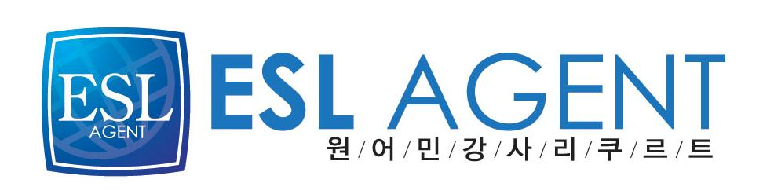
이에스엘 에이전트
최진영(Cassie)
02-2675-0582

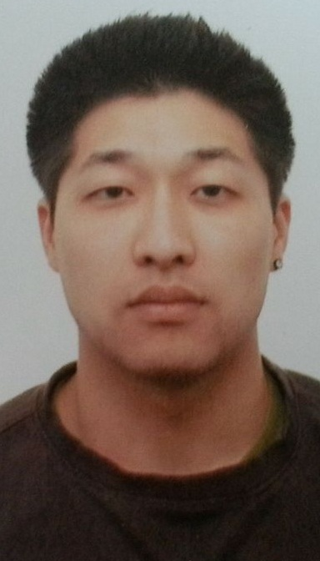
Christopher H. Kim 김선웅
Age | 29
Nationality | USA
Date Available  Objective  Skills  Visa Status | June 2013  To share my knowledge of the English language through persuasive, eloquent, and fun ways so students can enjoy and learn English together.  Languages: English and Korean  Computer knowledge: Excel, Works, and PowerPoint  Can play the Cello  F-4 (Currently in Korea)
Education | [ 2003-2007 ] California State University of San Bernardino  Major: Liberal Studies
Teaching Length | Tutoring 4 years
Professional experience | [ September 2012 - Feb 2013 ] ECC English Instructor  - Native teacher at ECC  - Taught Kindergarten phonics, writing, and math comprehension skills  - Taught Elementary students basic speaking, and writing skills  - Had 1-to-1 private classes with students on speaking emphasis  - Group studies using various English textbooks, storybooks, and newspapers.  [ July 2010- June 2011 ] Hanhwa Eco Metro Apartment Block#6 English Instructor  - Native teacher at the E.C.C (English Community Center)  - Taught Kindergarten phonics, and writing.  - Taught Elementary students basic speaking, and writing skills  - Adult conversation class  [ September 2008- November 2009 ] E Bo Young Talking Club  English Instructor  - Taught Speaking, Listening, Reading, and Writing through varieties  of lecture/workbooks.  - Taught pronunciation, and basic linguistics through debating  materials  .  - Handled from kindergarten to junior high school students.  - CNN news vocabulary and interpretation students can  understand through English.  [ December 2008 ] JES Island English Institute  English Instructor  - Taught Speaking, Listening, Reading, and Writing  - Handled from elementary school to junior high school students.  [ Summers/Fall 2005-07 ] Private Tutoring Los Angeles, CA USA  Tutor  - Tutoring Kids from Elementary to Jr. High in English and Math. Helping the students with their basic algebra, geometry, writing, vocabulary, and pronunciation.  [ Summer 2004 ] Excel Tutoring East LA, CA USA  Tutor  - Tutoring kids from 6 to 15 in English and Math. Making sure the kids understand their home work and helping them prepare for up-coming tests.  [ Jan- June 2004 ] Private Tutor Los Angeles, CA USA  Tutor  - Tutoring and helping students prepare for up-coming exams, job, and school interviews. Helping business men further advance their English skills in a professional manner for up-coming meetings and interviews.  [ Summer 2002-03 ] WPCA Church Torrance, CA USA  Cello Instructor  - Teaching children basic cello skills. Helping students prepare for upcoming concerts. Performing with students at concerts and church community activities.
References
Susie 010)3254-0730
김영석 010)4859-7905
Alan 010)6296-4673
송은범 011)1707-6841

