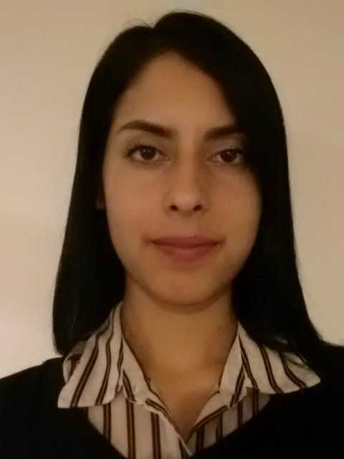

Christy Lauren Oropeza

OBJECTIVE
Seeking a position as a professional ESL teacher as a means to leverage my experience in the Humanities and Arts Department as an English major and to enlighten the minds of young children.

EDUCATION
2012 BA, English, University of California Riverside

JOB EXPERIENCE
David Barrett, Los Angeles, California 06/05 - 08/06
AVID Tutor/ Student Assistant

- Assisted teachers with photocopies, grading, phone calls, and filing of sensitive information.
- Provided guidance, support, and tutoring to students both individually and in groups with school related material.
- Had the experience to teach, learn, and participate in many school related activities / filed trips.

University of California Riverside Dining services, Riverside, California 2009/2012
Student Prep/ Junior Cook/ Coffee Shop Barista

- Exhibited the ability to learn new cooking, storing, and prepping techniques rapidly to accommodate the changes in the school's quarter system.
- Delivered exemplary customer service.
- Demonstrated flexibility and availability when requested to work over time.
- Earned multiple certificates due to "outstanding work performance" every quarter.

Kevin Lin, Rancho Cucamonga, California 08/12 – Present
Office Assistant/ Shipping Management

- Performed general office duties such as photocopying, scanning, faxing etc.
- Maintained spreadsheets and reports of monthly inventory.
- Filing and data entry of daily spending.
- In charge of designing company meeting reports for entire staff.
- Answered phone calls and directed them to appropriate department.
- Directed Phone calls to various shipping institutions/customers to keep track of shipments and have them shipped to the appropriate destination.
- Processed orders in a timely manner to have them shipped out that same day.
- Distributed and recorded mail/returned packages to appropriate handler.
- Daily input and retrieved payroll data for staff accurately.
---------------------------------------------------------------------------------------------------------------------
COMMUNITY / VOLUNTEER ACTIVITIES
Peace and Justice Summit at USC, Los Angeles, California June 1, 2007
  - Discussed issues of neighborhood violence while contributing possible solutions to better the living environment.
AIDS Walk Los Angeles, Los Angeles, California October 20, 2007
  - Gathered participants for the yearly event as a means to raise money for the cause.
ENGage Olympics, Los Angeles, California October 13, 2007
  - Volunteer opportunity that helped organize certain activities for senior citizens.
-------------------------------------------------------------------------------------------------------------------------------------------
SKILLS
- Proficient in Spanish and English / Currently learning Korean
- Computer and Type Writer Skills; Microsoft Word, Excel, Google Docs/Excel, Email, Fax, Scanner.
-------------------------------------------------------------------------------------------------------------------------------------------
EXTRACURRICULAR ACTIVITIES
Thomas A. Edison Middle School Newspaper
- Conducted surveys and interviews within the school’s students and faculty for the school’s newspaper.
Manual Arts High School Woodcraft Rangers Magazine Club
- Contributed Stories and Photographs to school’s monthly magazine.

Language Door
  - Registered for Weekly Korean Language Classes (February 2013-Present)

