Kobus Eksteen
Curriculum Vitae

22 Noeline Crescent
Eversdal
Durbanville
7550
South Africa
+27-21-919-1459 (Home)
+27-84-819-6137 (Cell)
010-6872-0660 (Korea cell)

kobusx10@gmail.com

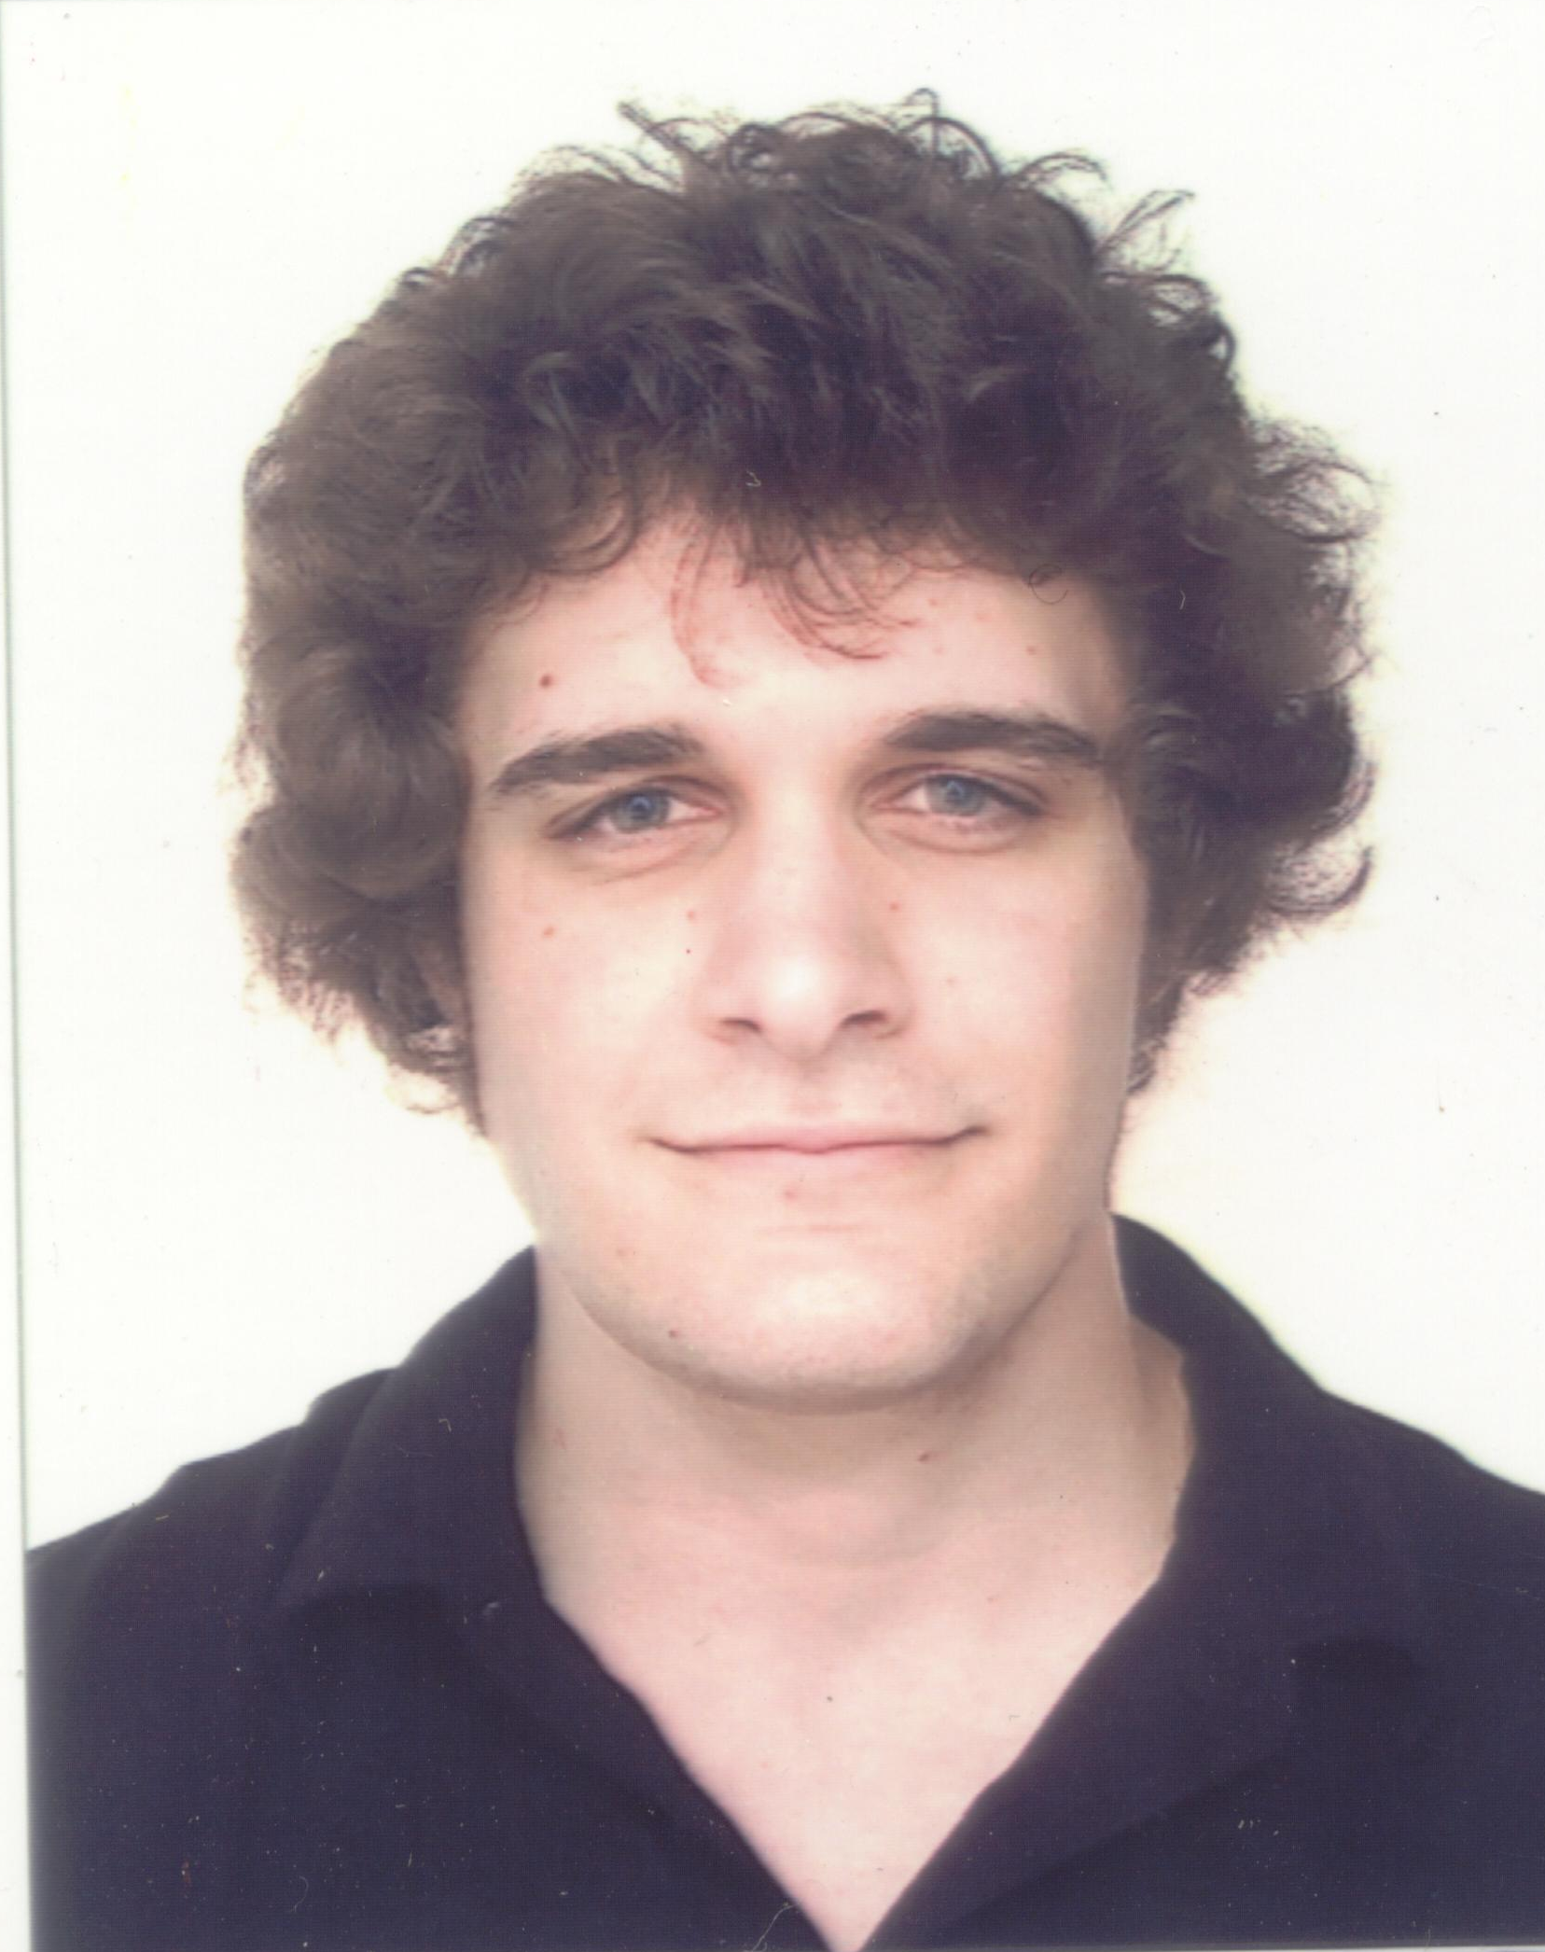
Personal details
Full Names: Kobus Eksteen
Nationality: South African
Current occupation: English Teacher
Health: Excellent
Education
- Tertiary education: Bachelor of Education degree
(2003-2006) Cape Peninsula University of Technology
Subjects: Main: English
Maths
Natural Sciences
Geography
Education/Educational Psychology
Other: Religious studies
History
Technology
Computer Literacy
Arts and Culture
- Other Education:
Computer Literacy course
Microsoft Office: Word, Excel, PowerPoint and Access (2003-2004)

Athletics Official course
A course that outlines the rules of athletics and the duties of an athletics official
Teaching Philosophy

I believe that any good ESL lesson is built on the lesson’s Target Language using an interactive and communicative approach.

I see humour and a relaxed classroom atmosphere to be essential in building students’ confidence, which will cut down the barriers many students in Korea face when leaning English.

I have found that a variety of fun, communicative activities, such as role plays, competitive and co-operative group learning activities are extremely effective in promoting English fluency amongst students.

It is important to give students the opportunity to practice what is being learned in order to internalize new and existing information. I have used content based instruction to great effect, where students have thoroughly enjoyed participating in activities while learning and using new language.

I always aim to involve every student in the class and give positive feedback to encourage student participation and confidence thus improving their English abilities.
Employment

- Seoul Daecheong Elementary School (June 2008 – June 2009)
  - Recently I was emplyed by the Gangnam District office of Education to teach at Daecheong Elementary School.
  - Here I was the only native-speaking English teacher and I taught without a co-teacher.
  - I taught grade 1 through 6.
  - I planned and taught 12 different lessons per week for 6 different grades.
  - I had to make all my teaching aids and materials on my own and I have become adept at developing different activities for varying levels.
  - I also taught English to Korean Teachers during vacation breaks.

- Gyeonggi English Village Teacher (March 2007 – March 2008)

  - I was a teacher and curriculum developer for the Special Programs and Middle school students.
  - I taught various Content Based Instruction lessons designed to elicit English through role playing and several fun activities.
  - I built students confidence and provided a fun experience with English while giving the students the opportunity to converse with many different foreigners in a friendly environment.
- I was chosen as one of the 3 teachers out of 85, responsible for teaching and testing a brand new high school curriculum.
- I was chosen for my ability to relate with older students.
- I have taught 4 Military Programs.

- Practical Teaching (2003-2006)

- Maths Lecturer assistant (2005)

- Hockey coach (2003-2005)

Interests

- I love to teach someone something new. It may be a new skill, sport or just conveying information.

- I have a lot of experience with computers and I can use countless programs, interfaces and fix almost any problem.

- Music has always kept me going and that is why I taught myself to play the guitar.

- I will try any sport that gets my heart racing like skateboarding, snowboarding or rollerblading.

References

Mr.Michael Bucknor Head teacher at Gyeonggi English Village
Former Principal
010 3144 4673
pajuevmike@yahoo.com

Mr.Dain Leathem Head teacher at Gyeonggi English Village
010 6240 3246
dainleathem@gmail.com

Mr.Yong Soo Cheon (Rick) Head Teacher at Gyeonggi English Village
011 344 5463
rickevkidz2005@yahoo.com

Ms.Charlotte Beckhurst Academic Coordinator Gangnam –UC Riverside International Education centre
010 6456 8310
charlottenatasha@gmail.com

Addresses/Contact information

Gyeonggi English Village 1779. Beopheung-ri, Tanhyeon-myeon
Paju City, Gyeonggi Province 413-780
http://english-village.gg.go.kr
(031) 956 2323

Gangnam- University of California Riverside International Education Centre
Fourth Floor, 8 Samsung-dong
Gangnam-gu, Seoul-si 135-090

Seoul Daecheong Elementary School
712 Irwon-dong, Gangnam-gu, Seoul 135-231
02-459-2152
http://www.daecheong.es.kr

