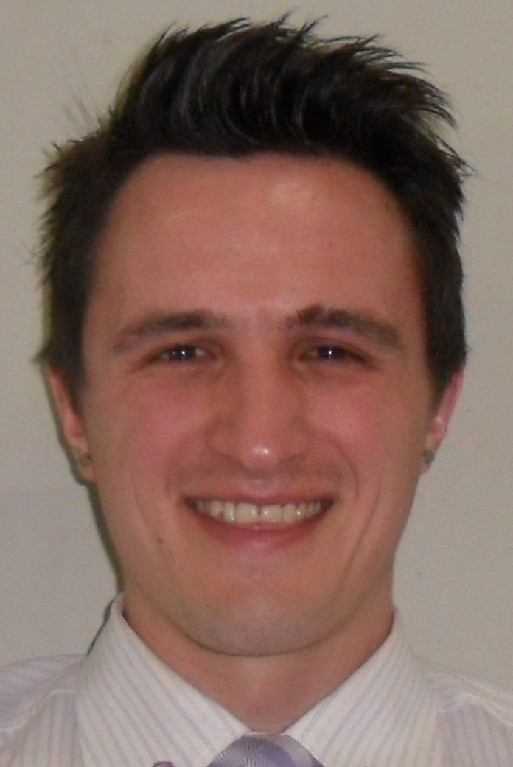

Conrad Odendaal (Resume Summary)
Permanent
23 Hilda Street, Chrismar, Bellville, South Africa
Objective | To obtain an educational position in South Korea.
Education | University of Stellenbosch, South Africa, Bachelor of Science in Sports Science, Double majors in Physiology and Biochemistry (February 2002 – December 2005)  University of Stellenbosch, South Africa, Honors degree in High Performance Sports Science, (February 2006 – December 2006)
Skills | Goal-oriented and driven individual with strong leadership capabilities and ability to work in unison with others. I am looking to better my skills and professional qualifications. Complete proficiency in two languages (English & Afrikaans), exposure to two others as well (Korean, Spanish, German, and French). Travel experience in 10 different countries
Employment/  Experience | Teacher, Cheongsol Elementary School, South Korea, Teaching Listening, Speaking and Writing classes to Middle School Students.  Teacher, Seong Ji Middle School, South Korea, Teaching Listening, Speaking and Writing classes to Middle School Students.  Teacher, Global Education Center, South Korea, Teaching Listening, Speaking and Writing classes to Elementary and Middle School Students.  Teacher Wonderland/WEL Language Project, South Korea, Teaching of English to Kindergarten and Elementary Students  People Well Ltd, London (UK), Manager on duty and Personal Trainer  Management of facilities, Member management and “Own Business” Management  USN Supplements South Africa, Sales Promoter and Lifestyle Advisor  Up selling products in pharmacies, Management of stock, Lifestyle advice to consumers |  | July 2012 - July 2013  April 2011 – April 2012  March 2010 - March 2011  September 2008-September 2009  May 2007–February 2008  January 2006-February 2007
Activities | Bellville High School Student Leaders Corpse, Part of student group to fulfill leadership roles in school. (2001)  Pieke Men’s Private Student Organization, University Stellenbosch, part of House Committee, had various portfolios and responsibilities to aid running 2000 members (2005)

Personal Profile

Qualifications : BSc Sport Science (University of Stellenbosch)
B Honors Sport Science & High Performance (University of Stellenbosch)
ITTT TESOL Certificate 100 Hours
ACSM Personal Training (Level 6) NQF (University of Stellenbosch)

I’m by nature a very energetic, open minded, resourceful and hard working person. I'm optimistic, have a good sense of humor and get on easily with people of all ages, in a group or one-on-one. My long term aim is to develop and enhance my experience and knowledge and to continually enhance my professional qualifications.

Points to be considered:

I have 4 years teaching experience in South Korea and also a 100 hour TESOL certificate.

I have spent 5 years at a University, receiving two degrees in Sciences.

I have also 6 years of traveling experience in Europe and South East Asia.

Every class I have taught in Korea, I have done so with little to no aid of a Korean speaking person (makes the job a lot harder).

Education and Qualifications

2001 - Bellville High School:
- Pass Matric with distinction
Subjects: English First Language HG
Afrikaans First Language HG
Biology HG
Science HG
Mathematics HG
Accounting HG

Sport: participated in various teams:
• Rugby (1st Team),
• Golf (1st Team, 8 Handicap),
• Squash (1st Team)
Received honors colors for golf and squash.

Extracurricular activities & other:
Drama (received honorary certificate)
Part of Student Council (Senior Council)

2002 - BSc Sport Science – First year completed
Courses : Biology 124 & 154
Physics 178
Chemistry B134 & 154
Mathematics 124(Bio)
Psychology 114 & 144
Computer literacy 178

2003 - BSc Sport Science – Second year completed
Courses : Physiology 278
Biochemistry 214 & 244
Genetics 214 & 244
Kinesiology 112 (Anatomy)
Kinesiology 142 (Sports management)
Kinesiology 152 (Sports history)
Kinesiology 182 (Sport Science) – various competitive sports covered: swimming, gymnastics, badminton, softball, team handball, tennis
Computer literacy 278

2004 - BSc Sport Science – Third year completed:
Courses : Biochemistry 314 & 344
Sport Science 222 (Sport Psychology)
Sport Science 232 (Motor Learning)
Sport Science 252 (Sport Physiology)
Sport Science 262 (Biomechanics)
Movement, Sport en Recreation 212
Movement, Sport en Recreation 222 (Disabled Bodies)
Movement, Sport en Recreation 242 (Sport Administration)
Movement, Sport en Recreation 282 – various competitive sports covered: rugby; cricket; hockey; tennis; athletics
Applied Kinesiology 312, 334 & 342 (Coaching specialization)
Computer literacy 378

2005 - BSc Sport Science – Fourth completed:
Courses: Physiology 378
Nutrition 378
Kinesiology 322 (Periodization)
Kinesiology 332 (Testing and Measurements)
Kinesiology 342 (Sport Psychology en -Sociology)
Kinesiology 372 (Ethics & Professional Teaching)
Applied Kinesiology 314, 352 & 362 (Fitness Industry)

- accredited ACSM Personal Training (Level 6) NQF from the University of Stellenbosch

- Various separate courses have been completed at the Department Sport Science of the University of Stellenbosch:
Swissball Training
Aqua Recuperation
Total Body Conditioning
Sportstrapping
Postural Analysis
Functional Training (by Sean Surmon, Msc Biokinetics)
EMT Emergency Care level 1
Rugby Coaching level 1
Hockey coaching level 1

- served on the House Committee of Pieke, the biggest men’s private hostel (house) at Stellenbosch University, September 2004 – August 2005, with responsibilities, i.e.
• Rugby representative for the house at Maties Rugby Club
• Organizing the Annual dance
• Spiritual Representative
• Organizing annual Beauty Contest (Miss Pieke)
• Building the Float for Carnival

2006 - Honnors BSc Sport Science (High/Peak Performance)
Courses: Exercise Physiology
Exercise Psychology
Motor Control
Kinantropometry
Biomechanics
Sports Physiology
Sports Psychology
Motor learning
NSCA High Performance & Training
Biostatistics & Research methods in Sport

- Pratical included season testing of various South-African Sports Teams, including the SA Women’s Cycling Team, SA Women’s Rugby Team, Maties’ Mens & Women’s Hockey Teams, Maties Men’s Cricket Team, Ajax Cape Town Full Junior Squad.
- Part of the personal training team responsible for the Maties Women’s Hockey 1st & 2nd teams weight training regime, where 80% of the women play for the National squad.

Finished studies at the University of Stellenbosch in November 2006

Computer Literacy

Attended Computer literacy 178, 278 & 378 classes from the University of Stellenbosch
Included Microsoft Word, PowerPoint, Excel and Advanced Excel amongst others.

Skills Summary

Personality wise – objective, hard-worker, determined, good humor, have ability to build relationships with all people.
Academic wise – knowledgeable, makes sure of technical information, quick-learner
Work wise – hard-worker, willing to learn, good at building proper working relationships with others

References

Mrs Jane Song [송정은] (Manager, Cheongsol Elementary School English Center, Bundang ) +8231 715 8455/6

Mrs Hyojong [임효종] (Head teacher and Co-teacher, Cheongsol Elementary School English Center, Bundang ) +8210 7399 6560

Mrs April Lee [이은옥] (Supervisor and Co-teacher, Seong Ji Middle School, Yongin ) +8210 2925 5151

Mr Teddy Woo [우태서] (Head Teacher, SGC, Seongnam) +8210 8753 0315

Ms Grace Lee [(Supervisor, WEL Language Project and Wonderland, Yeongtong, Suwon) +8231 302 0533

Anthony Mathurin (Bow Quarter Leisure Centre, Bow Church, London) +4479 0484 5737

Prof. ES Bressan (Professor at the Department Sport Science, University Stellenbosch, South Africa) +27 21 808 4722

Mr Albert Pretorius (Head of USN Western Cape, South Africa) +2782 771 4480

Dr Ralph Hamman 021 948 1871

