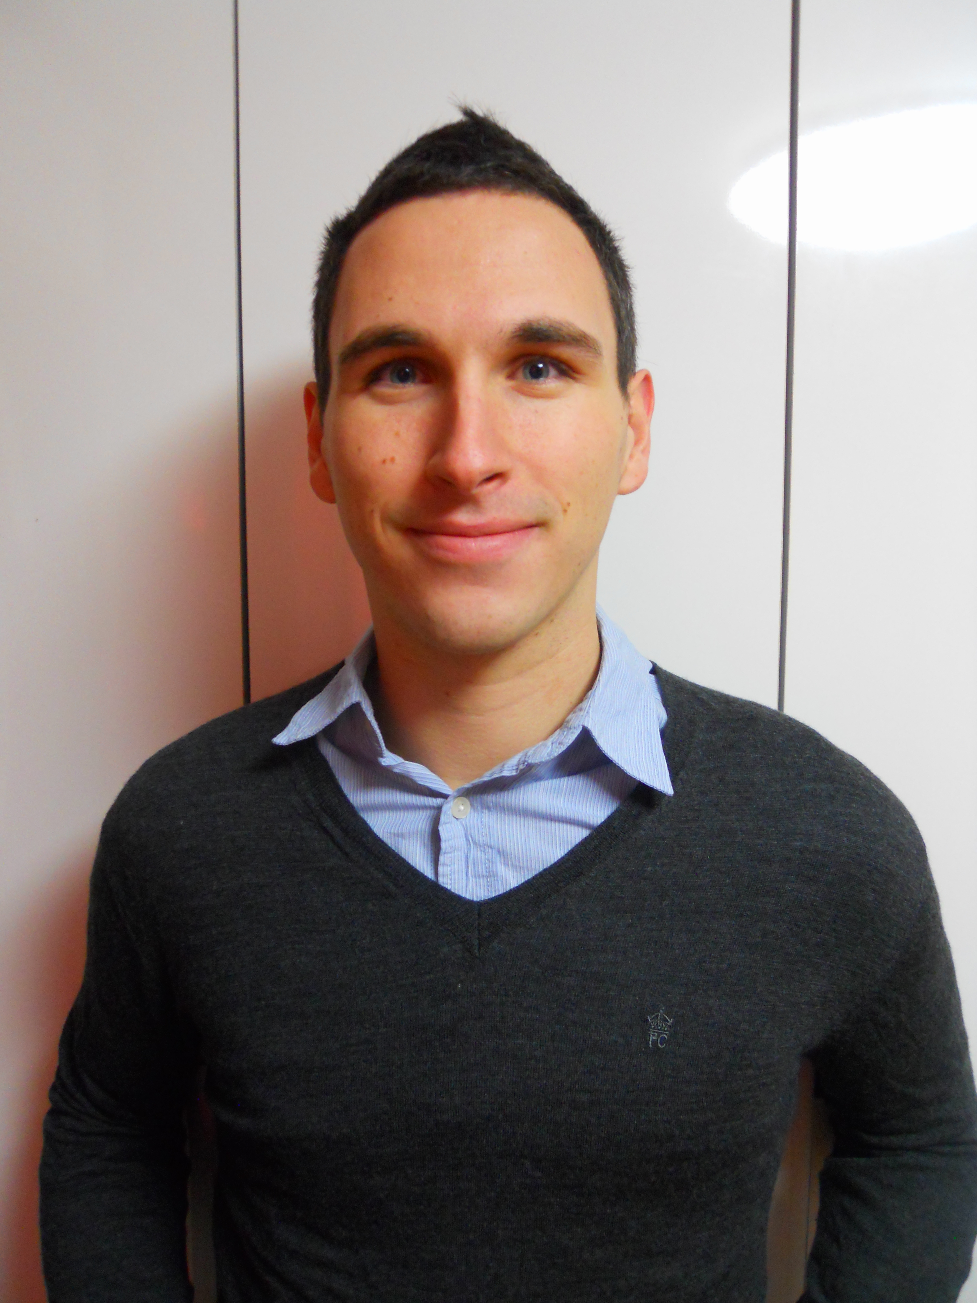
Craig Rayson

Personal Details

Birth: England, 28-Nov-1985
Citizenship: Canadian & U.K.
Mother Tongue: English
Marital Status: Single
Health: Excellent

Education

2004-2009 Windsor University Windsor, ON, Canada
Bachelor of Arts Honours
Major: Psychology
Minor: Biology

2000-2004 St. Anne High School Tecumseh, Ontario, Canada
Graduated with High School Diploma 2003

Experience
English Teacher July 13-August 13
Youngsan University – Busan, South Korea
Comprehensive ESL Teacher training program by Metropolitan Busan office of education
- Instructing 3 hour long classes for elementary school teachers in Busan.
- Creating syllabi, lesson plans and materials for multiple subjects weekly.
- Lessons created were designed to boost fluency and to teach and share teaching based concepts and strategies to be used in the classroom.
English Teacher March 11 – March 13
Gijang Middle School – Busan, South Korea
The native English teacher for middle school students, grades 1 to 3.
- Organizing weekly lesson plans and materials, including PowerPoint presentations and accompanying activity sheets.
- Conducting interviews/speaking tests for Gijang middle school and many others throughout Busan.
- Assisting the English department with extra English programs and with creating tests.
- Planning and demonstrating open class sessions
- Participating at annual summer and winter English camps.
- Participating in an English Immersion program conducted by the Haeundae board of education for Middle School students. (October-November, 2012)
English Teacher March 10 – February 11
EWAS – English With A Smile – Busan, South Korea
An English teacher for children ranging from the ages of 5-8.
- Organizing weekly lesson plans
- Grading daily homework
- Teaching phonics, science, math, social studies, grammar, etc.
- Creating tests monthly for material taught
- Writing progress reports
- Planning and demonstrating open class sessions

Housekeeper June 05 – February 10
Windsor Regional Hospital – Windsor, ON
A hospital Housekeeper with the responsibility of maintaining a sanitary environment for patients and staff.
- Sanitization of rooms
- Re-stocking supplies
- Safe handling of hazardous materials
- Required to work efficiently without supervision and to maintain the confidentiality of hospital/patient information.
Respite Worker September 07 – January 08
Family hired through Autism Services Inc – Windsor, ON
A respite worker, working with the family of a child with autism to provide the family with assistance and respite
- Create activities both fun and challenging for the child, such as visiting the library to select books to read, promoting language development.
- Ensure the safety of the child and other staff members
- Provide a report to the family of the child’s behavior and activity performance.
Support Worker June 07 – Aug. 07
Autism Services Inc – Windsor, ON
A Support Worker responsible for the care of children with Autism
- Creation and supervision of activities for the children
- Ensuring the safety of the children and other staff members
- Maintaining a daily log of progression, performance and behavior
- Promote language and learning skills of children with autism, specifically those with verbal limitations.

References

Cho Eun-Young
Head English teacher at Gi-Jang Middle School
Contact no: +8210 3849-8174
Email: prettychoe@hanmail.net

I am pleased to present my resume to you for a position at your language centre. I believe you will find me to be a dedicated educator who is well qualified to provide the motivation and direction students need to successfully learn.
The enclosed resume will testify to my career and solid commitment to providing students with excellence in education. As you will note I have earned a Bachelor’s degree in Psychology. While I do not possess an English degree or a master’s degree, I have learned a great deal on the job over the past 3 years, especially the last 2 teaching at a middle school in Gi-jang. My teaching style is direct and decisive, yet flexible in responding to constantly changing demands.
I have had the opportunity to teach a diverse group of students, ranging from Kindergarten, elementary school, middle school and even some adults while teaching at a language exchange café and at a University teaching Elementary school teachers for a month. This has provided me with the experience needed to become a well-rounded educator, enhancing my teaching techniques and instructional methods. I have developed communication, interpersonal, organizational, time management and leadership skills. Also, I have learned to be proficient in developing comprehensive lesson plans designed for individuals and the class as a whole.
One of my greatest strengths as an educator is cherishing the rewarding feeling given when a student enjoys and learns from my lessons. If I feel that my students have not learned from my lessons or enjoyed them, this motivates me to try harder to reach my students.
I have recently flown back to Korea and am currently residing in Busan. I have brought all my visa documents with me, including university transcripts, my degree and a new RCMP criminal background check. I am currently here on a tourist visa while seeking and securing my fourth contract in Korea.
I would feel privileged to secure a position at your school and would welcome the opportunity to discuss how my experience would best suit the needs of your students. I look forward to hearing from you at your earliest convenience.

Respectfully yours,

Craig Rayson

