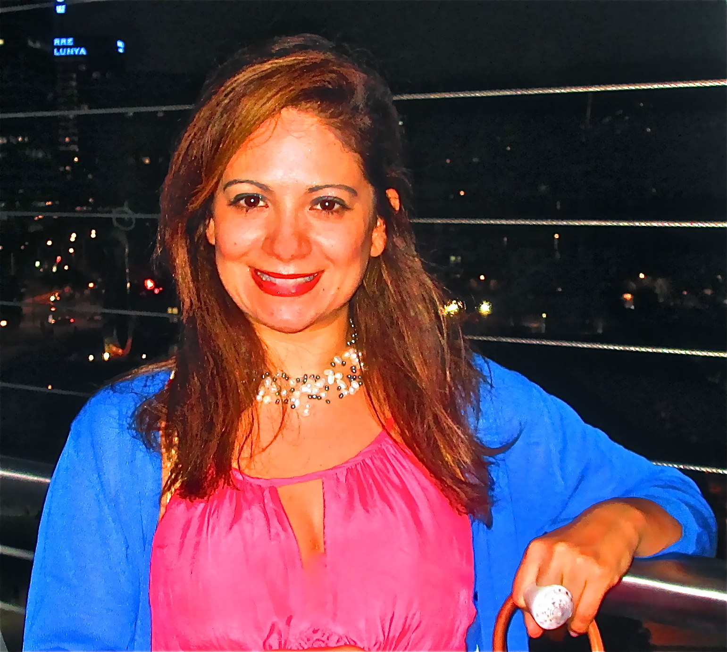

CRISTIE ROCK
Cel Phone: (010) 8407- 1977
E-mail: RochaCris.A@gmail.com
United States of America
Objective: To Obtain a Position as an ESL teacher in Seoul City
Summary of Qualifications
• Linguistic and Computer Proficiency:
Trilingual in English, Portuguese, Spanish, Int. French, Basic Korean
Education
• BA in International Business & Trade May 2008
• Florida Atlantic University, Boca Raton, FL

Experience

JLS Academy Aug 2012- Present
South Korea, Hanam City
ESL Teacher Full Time from Elementary to Middle School Level

Bank of America Corporate Jan 2011- Feb 2012
Fort Lauderdale, Florida
MCAT Position
Mortgage Treatment Options Loan Processor Assistant

E-Bo Young Talking Club Sept 09-Aug 2010
Byeongjeom Town, South Korea
ESL English Teacher from 1st to 6th Grade

Wonderland Private English Academy Jan-July 2009
in Icheon, South Korea
ESL English Teacher

Doam Public Elementary School March-July ‘09
in Icheon, South Korea

FAU Study Abroad to Costa Rica March 2008

• Studied International Economic Development of Latin America
& The Caribbean
• Visited Multinationals as well as local corporations: Dos Pinos,
La Nacion Newspaper, Café Britt, Baxter of Cartago, Hospira,
The US Embassy
• Assisted with translating during visits to local Costa Rican companies

Owner of Import & Export Business January 2002 - 2010
and Patent Holder

Global Arts & Enterprise Corporation, Delray Beach, FL

• Assisted in the design of new products, and patented them
• Established all business aspects including financial,
physical and intangible assets
• Customer Service, cash handling, all accounting

Market Research Internship May-June 2006
The Geo Group, Inc, World Headquarters, Boca Raton, FL

• Researched state operated mental health facilities, forensic hospitals,
VA nursing homes, SVP facilities and Prisons Across the
World for the process of RFP biddings and privatizing facilities
• Assisted HR department with establishing new
employment database in Central Florida

FAU Study Abroad to France June-August 2006

• Studied French, Art History and Archaeology in the South of France
• Traveled to Spain, Holland and Throughout Southern France

Cosmetic Sales Dec-June 2005
Bergdorf Goodman – Beauty Level, Manhattan, NY

Waitress/Hostess Position August- Dec 2005

Suite 225 Restaurant, Ocean Drive Lake Worth, Florida
• Worked as a Hostess and Waited Tables During Peak Hours (PT)
• Handled accounting and reservations
• Bartended a few nights a week

Esthetician Assistant Manager Summers 1997-2008
RJ Miller Spas, Nantucket Island, Massachusetts

• Assisted Doctor Francis Phelps with various skin resurfacing procedures
• Expanded client base through referrals, and follow up

Volunteer at Steubenville Florida Youth Conference Summer 2008
Lynn University in Boca Raton
• Helped Organize the Event for 2000 teenagers from around the US
• Participated in preparing youths to be Christian leaders in their parishes,
schools and the wider community

Volunteer To Teach Computer Classes for Adults Fall 2003
Our Lady Queen of Peace, Delray Beach, Florida
• Prepared Lesson Plans and Homework Practice Material
For Basic Computer Classes with emphasis on
God’s Principles and teachings
• Taught Classes in Portuguese to adults

Meditation Trainer (Yoga of the Breath) 2002- 2007

• Facilitated with meditation trainings in India, Brazil, France, London, Netherlands, Spain, Japan, China, Tibet, Philippines

School Sports – FAU 2003-2004

• Participated in Volleyball Intramurals for 2 semesters

Boca Raton High School Swimming Team 1994

