Curriculum Vitae/ Resumé:

Eric Oscar Wesch

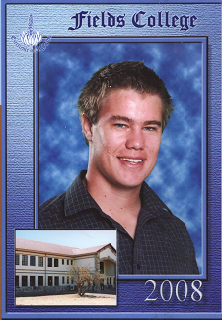

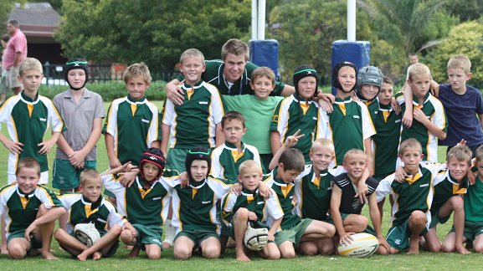As coach of victorious under 9 rugby team.

Application for a vacancy for 2010

1. Personal Details

Full name: Eric Oscar Wesch
Address: 41 Adelaar Street
Flamingo Park
Welkom, South Africa
59

Contact number: +2783-561-8636
Email: eowesch@yahoo.com
Place and date of
Birth: Bloemfontein; 1985/03/18
ID number: 8503185094088
Passport number: 445563247 (ZAF: Issued on 2/4/2004, expires on 1/4/2014)
Age: 24
Sex: Male
Marital status: Single
Nationality: South African
Home language: English
Other languages: Afrikaans

Health: Excellent
Availability: January 2010
Driver’s license: A1 and B

2. Contact Details

Email: eowesch@yahoo.com
Cell phone number: +27835618636

2. Education
2.1 Senior School

Matriculated: Ferdinand Postma High School in 2003
Certificate: Senior Certificate
Subjects and symbols: English 1st Language (Higher Grade) A
Afrikaans 1st Language (HG) B
Natural Science (HG) D
Mathematics (HG) D
Computer studies (HG) C
Technical Electronics (HG) C
Tourism (Standard Grade) B

2.2 Senior School Achievements

Deputy Chairman on the School Representative Council.
Chairman of School Sport Committee.
1st Team Rugby for 3 years (Represented local team at provincial trials)
Chess Open team for 3 years (Won the provincial title for those 3 years)
Provincial Chess Team in 2002

2.3 University Education

University: North-West University in Potchefstroom

Degree: Bachelor of Education (B.Ed)
Intermediate and Senior Phase
(January 2005 – July 2009)

Major: English

2nd Learning area: Technology

2.4 Department of Education Speech Competition 2006

Third overall in final of Departmental competition involving 400 students in May 2006.

  - Other Tertiary 2004

College: Vuzelela Tertiary College: Potchefstroom
Certificate: A+ Computer Certificate (One year)

Certificate: First Aid Level 1

3. Employment History

2007: Fields College
Rustenburg
Relief / Assistant Teacher for Grades 4-6
Extra-curricular Coached Under 9 Cricket and Soccer
Chess
Athletics (Shot put)

2008: Fields College
Rustenburg
Full time
Taught Gr. 4 (Age 10) Technology, Economic and Management Science (EMS) and Natural Science
Extra-curricular Coached Under 10 Cricket and Soccer
Chess
Athletics (Shot put)

2009: Monument Park Primary School
Pretoria
Full time
Taught Gr. 4 (age10) - Chess
Gr. 5 (age 11) - English
Gr. 6 (age 12) - English

Extra-curricular Coached under 10 boys (starting level) Cricket & Rugby.
Team won its division.
(Registered primary school coach and referee)
Chess
Athletics (Hurdles)

3. Other activities and interests

Fitness: I keep in shape by visiting the gym and jogging. I don’t smoke.
Sports: I am an avid rugby, football and cricket fan.
Culture: Reading and playing chess.
Religion: Evangelical.

4. Career development

4.1 COMPUTER CERTIFICATE 2004:
After completed my Matric (Grade 12) in Senior (High) School, I studied Computers at Vuzelela Tertiary College in 2004 and completed the internationally recognized A Plus Certificate.

4.2 FULL-TIME STUDY 4 YEAR DEGREE IN EDUCATION 2005+:
In 2005 I started full-time study of a 4-year Baccalaurius Education degree at North-West University in my former hometown of Potchefstroom (120km west of Johannesburg). I obtained A+ results during practical teaching evaluations at Vastrap Primary School (Rustenburg, September 2005) and Naudeville Primary School (Welkom, April 2006).

4.3 STUDENT TEACHER 2007-2008:
Good results in my first two years as a B.Ed. student assisted me to obtain a position as a Student Teacher at the prestigious FIELDS COLLEGE (primary and secondary school) in the city of Rustenburg on the SBT course (School Based Training) in 2007 and 2008. The SBT course of North-West University enables students to study while teaching full-time at a school. I did this to gain practical experience while earning a salary. In 2008 I taught grade 4 (ages 10-11) in Technology, EMS and Natural Sciences.

4.4 TEACHING IN PRETORIA 2009:
In 2009 I continued my career in Pretoria (the capital city of South Africa) at Monument Park Primary, rated one of the ten best primary schools in the city, teaching English and Technology. After a wonderful year at the school I decided to expand my experience and broaden my horizons by following the footsteps of my father and teach in Korea.

5. References

Ms. Olga Henchley
Senior Teacher, Fields College,
Rustenburg
+2714-533-0052 / +2772-768-6476

Mr. Salie Kritzinger
Principal, Monument Park Primary School,
Pretoria
+2782-8246-187

- Documents
B.Ed. Degree
Baccalaureus Educationis (B.Ed) Intermediate and Senior Phase.

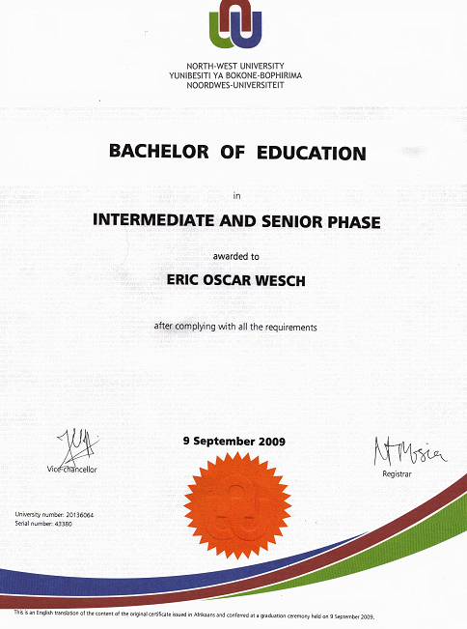

Passport and Identification Document

