CURRICULUM VITAE

CHRISTOPHER ROBERT WATSON

PERSONAL PROFILE

I am a passionate, dedicated and excited teacher looking for a full time teaching position. I consider myself a focused, motivated and intelligent individual with a hard-working nature and a drive to succeed in all endeavors.

Age: 26 years (born in 1983)
Availability: 4th January 2010
Desired Placement: Seoul
Nationality: South African
Race: Caucasian (White)
Marital Status: Single
Home Language: English
Other Languages: Afrikaans, Basic Xhosa
Phone number: +27413735589 (any time after 5pm Korea time)

EDUCATION

2006 - 2008: I sat and passed CFA level 1, 2, and 3 in December 2006, June 2007, and June 2008 respectively.

2002-2005: University of Cape Town
Bachelor of Business Science (2nd class Division 1 Honours) Actuarial Science (Quantitative Finance stream)

1997-2001: Grey High School, Port Elizabeth.
Matriculated with 5 A’s and 1 B.

1990-1996: Grey Junior School, Port Elizabeth
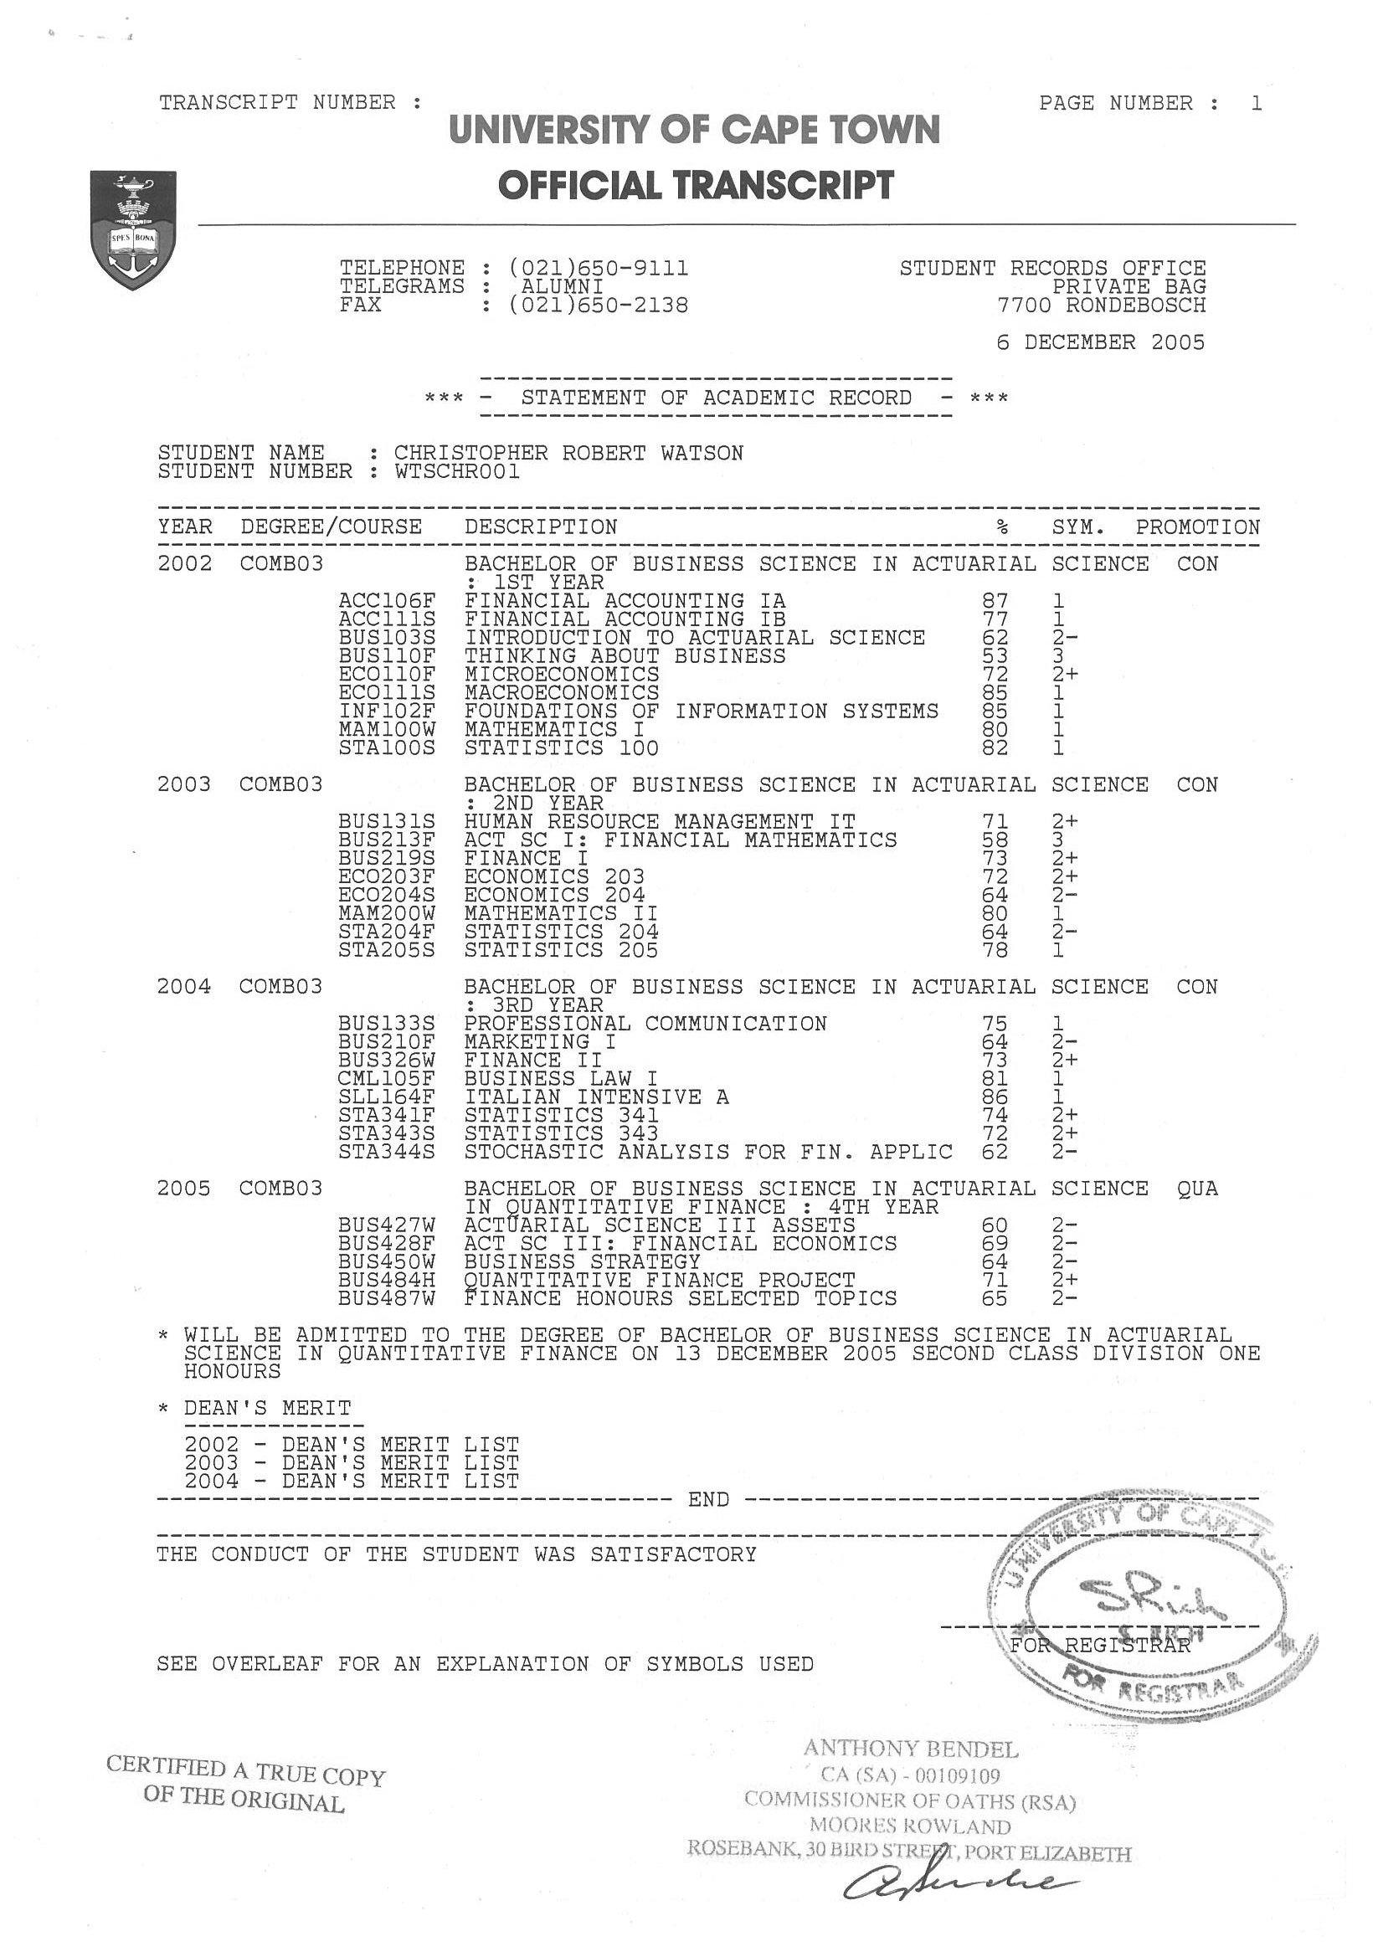
WORK EXPERIENCE

NONGTAKAI SUKSA SCHOOL (Thailand) – ENGLISH TEACHER

Nov ’09 – Dec ‘09
I was volunteering at a school in Khon Kaen province in Thailand. I was teaching students of poor backgrounds, who were between 12 and 18 years of age. I was focused on speaking and listening skills, while a Thai teacher was teaching the writing and reading sections. I really enjoyed being in the classroom and interacting with various people in the community.

CHOISUN (DYB) HAGWON (South Korea) – ENGLISH TEACHER

July ’08 – July ‘09
I worked as an English teacher in Daechi-dong, Gangnam-gu, Seoul. I worked at Choisun (DYB)’s main branch. I taught middle school students speaking and writing skills. We followed a broad curriculum, but I developed and used a lot of my own material.

I am surprised how much I enjoy teaching, I find it both challenging and rewarding. I put in a lot of effort into each class, and as a result I get a lot from the experience.

Reference: Mr Lee at Choisun DYB Institute.

PHILIPPOLIS HIGH SCHOOL (South Africa) – VOLUNTEER TEACHER

March’08
I taught English, Science and Mathematics at the Philippolis High School in the Free State, South Africa. I only volunteered for one month. In that month I took various classes during school term and also taught in a vacation program directed at the matrics (grade 12s). I found teaching a very challenging, yet rewarding experience.

ALLAN GRAY LTD (South Africa) – FIXED INTEREST TRADER

March ’06 – Feb’08
I was appointed as the sole Fixed Interest Trader in the four-person trading team that performed all the trading activities for Allan Gray Ltd, the largest privately owned asset manager in South Africa. AUM as at Dec’07 was approximately R250 billion.

The trading was order-driven buy-side trading with regular communication with the portfolio managers. Initially, I only traded fixed interest instruments (bonds and money markets). Later, I included foreign exchange trading and derivatives trading (equity futures and options) to my responsibilities.

Other tasks included reporting on events in the global debt and currency markets at daily morning meetings, allocating trades among clients, compliance, performance reviews, portfolio summaries and scenario analysis, ad-hoc research, and input into decision making. I also trained as back-up for equity trading and equity allocations.

Ah-hoc research includes reports on South African Bank preference shares (including valuations), hedging strategies for a specific client, bond lending and shorting in the SA market, equity futures rolls in the SA market (including a simple pricing model), pricing model for a commodity ETF in SA, and others.

References: Mr Stephen Mildenhall (Chief Investment Officer) and Mrs El-Rina du Preez (Trading Manager).
Telephone number: +27 214152300

PUBLIC SPEAKING, CULTURAL & SPORTING ACHIEVEMENTS

Public Speaking

- I have taken a course in Professional Communication at University of Cape Town (UCT), and achieved a first (75% +). I was awarded a certificate for this achievement.

Cultural Activities

- Musician – Guitarist. I have played the guitar for over twelve years. Music is one of my passions. I was professionally trained for three years by Dr. Howard Nock in Port Elizabeth. I have performed in various music groups for various reasons. In addition, I have recorded music at three different sessions, totaling six original tracks. Two of these tracks have received radio play on Highveld FM and Algoa FM in South Africa.
- Treatment Action Campaign (TAC) member 2004, 2005. The organization is aimed at helping HIV/AIDS victims receive medical attention as well as raising awareness of the virus. As a South African, the HIV/AIDS epidemic is one of my primary social concerns.
- Investsoc (Investment Society of UCT) member 2005. Through this society I have engaged in mock trading on the Johannesburg Securities Exchange (JSE), as well as attended business seminars and functions. In the Investor’s Games competition (a simulated trading game) I came in second place.
- RAG (A charitable U.C.T. student development organization)
I was a depot manager in 2005 for the Sax Appeal fund-raising event. This involved gathering a group of friends together, with an assignment of first-year students, and selling magazines in Cape Town’s early morning traffic in an attempt to raise money for various RAG projects and charities.

Sporting Activities

- Squash
- Soccer / football
- Hockey
- Golf

