Curriculum Vitae/Resume of: Prudence Adelaide Alexander

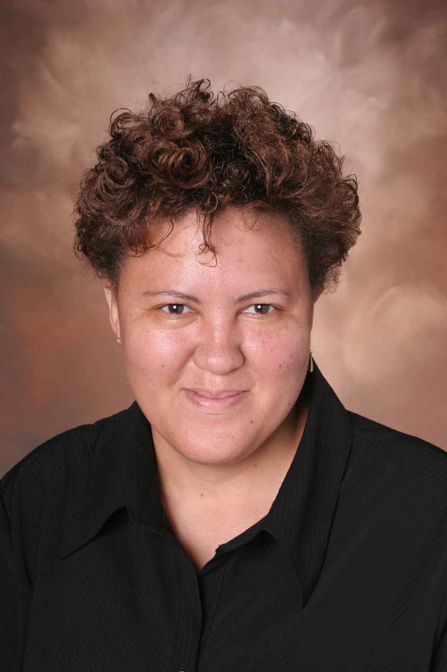
First names: Prudence Adelaide| Last name: Alexander | Age:41
Can start from: 2010-May-12
South African

Gender: Female

Marital Status: Single

Email address :
p1alexander@yahoo.com or alexanderp3@gmail.com

Address: 51 Plateau Drive, Claremont, Johannesburg, 2092, Republic of South Africa.

27-11-474-4593 or 27-82-921-4998 (South Africa) 010 2269 4998 (South Korea)

OBJECTIVES:
I would like to secure a teaching job within Korea
I would also like to continue to further my career experiences, working within a stimulating and challenging environment that would enable me to use skills that have been highly developed throughout my current and previous positions as an educator .I would like to continue to contribute to the Republic of South Korea (South Korea’s) economy that is fast becoming an economic force on the international markets.

EDUCATION/QUALIFICATIONS

Diploma in Education (DE III)
Graduated: 1991 Rand College of Education

Majors / Subjects : History, Mathematics, English, Education
Degree: BA (HUMANITIES)
Graduated 1998 Randse Afrikaanse Univ. (renamed University of Johannesburg)

Majors / Subjects:: History, Education, Mathematics, English

Diploma :Web Design

Graduated: 2004 Boston Business College

Subjects: Frontpage 2000, Business English

Diploma :Project Management
Graduated: 2006 Boston Business College Business Management

Subjects: Project Management, Business English various computer
programs

WORK EXPERIENCE:

Name of Institution/Employer - Duration - Subject(s) Taught /Duties

Eldocrest Primary School | 1990-1998 | MATHEMATICS, ENGLISH 1st & 2ND LANGUAGE  TECHNOLOGY EDUCATION, MUSIC EDUCATION
Parkhurst Primary School | 1999-2000 | (1999) : Mathematics, Health Education. English, Geography  General Science, Religious Instruction  (2000) : Mathematics, Religious Studies, Technology.
St Barnabas College | 2001-2005 | Mathematics (Gr 7,8.9), Remedial Mathematics (Gr 7, 8, 9, 10 )  History (Gr 9,10,11,12) History and Social Sciences (Gr 7-8)  :Computer Studies (Gr 7, 8, 10), Life Orientation (Gr 11)  : Technology (Gr 7,8,9)
Parktown High School for Girls | 2005-2007 | I was the Gauteng Department of Education (GDE) District 10 Information Technology and CAT Cluster Leader  Years as Cluster leader (2006 and 2007)  SUBJECTS TAUGHT : Computer Literacy: Grade 8 and 9  Computer Applications Technology (CAT) (Gr 10 and 11)  I was engaged in further training in CAT for grades 11-12 – Gauteng Dept of Education (GDE) requirement  Mathematics (Gr 8 and 9 ) I was engaged in further training in Mathematics Literacy (GR 10)  Life Orientation: Grade 11 and 12
Samkoe Middle School (South Korea) | 2008 | ESL: educator: English Conversation and Writing. Trained contestants for the English Golden Bell competition.

Woonsan Elelmentary School
(South Korea) 2009 ESL: educator and trainer
of the Contestants for the
English Golden Bell and
Speech competitions
Extra English classes.

ADDITIONAL VOLUNTEER WORK IN SOUTH KOREA:

Employer - Duration - Responsibilities
Hwasweong Osan Ed. Office 2009-2010 Lecturer: On the Job Training
South Korea Group Leader
Website Committee Member
Newsletter Committee
Member

INTERNATIONAL EXPERIENCE

County - Duration - Activities
Republic of South Korea 01 March 2008 – May 2010 ESL Teacher
(2 contracts)

MY SKILLS:
- I am a person who is loyal and trustworthy.
- I am a good communicator
- I have good leadership and organizational abilities.
- I am computer literate-I have certificates to prove my qualifications esp since I’ve taught computer studies as well.
- I see myself as a very successful person in my professional as well as my private life.

