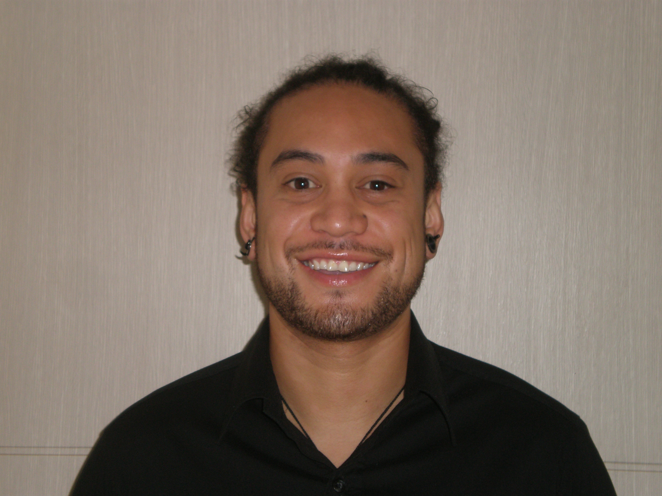
David Griffith Robati
Gyeongi-do, Goyang-si,
Ilsan dong gu, Janghang dong,
778 Bonchi, Bobo County 1cha 259 ho
Ilsan, South Korea
T 010-2345-4765
E david.robati@gmail.com

EDUCATION
2001 – 2005 BCA (Double major in Accountancy and Commercial Law)
Victoria University of Wellington, New Zealand

WORK EXPERIENCE
Aug 2009 - present James English Academy
Ilsan, South Korea
ESL Teacher
- Taught kids from grades 2 through to 10
- Classes of up to 10 children
- Taught Listening, Reading, Writing, Speaking and Phonics
- Responsible for all own lesson planning
- Responsible for preparing level testing examinations and reports

Apr 2006 - Feb 2008 GEC (Global Education Center)
Incheon, Seogu, South Korea
ESL Public School Teacher
- Taught grade levels from 3 to 6
- Organized and facilitated ESL summer camps
- Created dynamic lesson plans for 35 plus students
- Developed positive relationships with both co-workers and students
- Created fun activities for gifted students through an English club

RELATED EXPERIENCE
2006 – 2008 English Square
Youth Centre, Seogu, Incheon, South Korea
ESL Volunteer
- Participating in ESL festivals and performances
- Volunteered in helping with community service

July 1996 - January 2000 Mana Swimco
Wellington, NZ
Learn to Swim Instructor
- Taught toddlers and young children how to swim ages (2-10)
- Taught basic water confidence
- Promotion of water safety to youngsters
- Classes of up to 6 children
- 4 classes per day for 40 minutes each
- Volunteered as coaching support at swim meets
- Supported children when separated from their parents

1998 – 2000 Discovery School
Basketball Coach
- Coach of Elementary School Basketball team

2008-2009 G.B. Landscapes LTD
Wellington, N.Z.
Landscaper
- Landscaper for both residential and commercial properties

Apr. 1999-June 2005 N.Z. Post
Wellington, N.Z.
Mailroom Supervisor
- Management of the mailroom for private boxes with a staff of four
- In charge of team meetings and training
- Customer service and clerical duties

SKILLS / INTERESTS
- Strong communication and interpersonal skills
- Good time management
- Trustworthy, confident person with the ability to take the initiative
- Experience with Microsoft office tools
- Extensive knowledge of Cook Island Maori language
- Familiar with Korean, and Japanese

- Strong interest in Music, and the Arts
- Health and Well-being
- Travelling and meeting new people
- Experiencing new cultures and languages

REFERENCES
Vicky Hong
James English Academy
010 2866 9791

Julian Lee
Global Education Center
010 3256 2333

Guy Morris
Director, G.B. Morris Landscapes
+64 (21) 976 091

