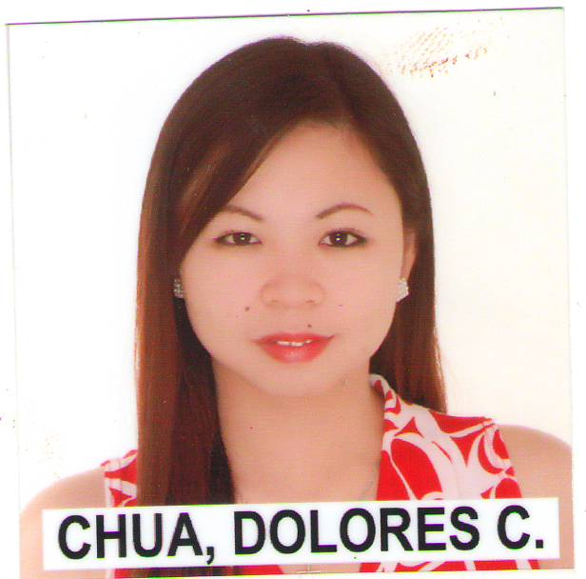
CHUA, DOLORES CELEMEN
Kyonggi-do Ansan-si Sangrok-gu Bonodong 714-12
01063890829
doloreschua@yahoo.com

OBJECTIVE
To gain experience and meet new people. A job which I can contribute to the improvement of an individual.

COMPETENCIES

- Sufficient knowledge and abilities in written communication.
- A patient listener who fully focuses on speakers and understands some accents.
- Strong skills in time management, prioritizing tasks, and meeting deadlines.

EXPERIENCE HIGHLIGHTS

Communication and People skills:

- Consistently maintain a positive attitude and enjoy helping people.
- Articulate and very effective working with people of different backgrounds and temperaments.
- Accurately record, remember, and verbally communicate detailed information.
- Cooperatively work with others to produce and deliver required work
Organization and Time Management:

- A problem solver quickly grasps complex situations and turns them into manageable tasks
- Produce quality work even when under extreme time pressure and deadlines.
- Proven ability to understand and follow complex instructions to successful conclusions.

Technical Skills:

- Has knowledge in Microsoft Word, Power Point, Excel.

WORKING HISTORY

E.J.O. COMPANY ( Franchise of Chowking, Sta. Rosa, Laguna)
Served as a crew member of this restaurant chain from 2004 of July to
2005 of April.

PERSONAL DATA

Birthday : October 19, 1987
Age : 23 years old
Height : 5’3
Weight : 50 kgs
Nationality : Filipino
Religion : Christian
Language Spoken : English and Tagalog

EDUCATION AND CERTIFICATIONS

Elementary: Laguna Resettlement Community School 1994-2000
Valedictorian

Secondary: San Pedro Relocation Center
National High School 2000-2004
Secretary (over-all school organization)

College: Calamba Doctors’ College
Bachelor of Science in Nursing 2005-2009

*Nursing Board Examination Passer last June 2009

OTHER SKILLS

A band member of our church: can play drums, guitar, base and keyboard.

Can sing as well.

Youth leader of our church for 4 years.

Joined in school competitions, such as dancing and others.

Participated in school and health center volunteers.

Character References:

Park Chando - Electrical Engineer - 01190357974
Leah Chua _ English Teacher - 01063890829
Gina - Institute Owner - 0178549679

