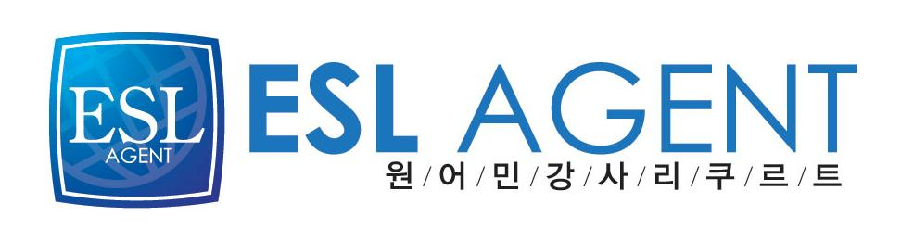
이에스엘 에이전트
김민수대리
02-2675-0582
017-569-6666
CURRICULUM VITAE

CONTACT INFORMATION

Name: Damien Horgan.

EDUCATION

Second level:
C.B.S.
Doneraile,
Co. Cork.
Ireland.

Third level:
National University of Ireland,
Maynooth,
Co. Kildare.
Ireland.

University of Edinburgh.
Edinburgh,
Scotland.

QUALIFICATIONS

Second Level:

Leaving Certificate.
Results:

- English: B (Higher)
- Mathematics: A (Lower)
- French: C (Higher)
- Physics: C (Higher)
- Geography: B (Higher)
- Economics: B (Lower)
- Irish: C (Lower)

Third Level:

General Science Degree in Mathematics, Experimental Physics and Mathematical Physics.

I.C.M. Diploma in eCommerce and web- technologies.

City & Guilds (level 2) in web-design and databases.

PGCE (Secondary Education in Mathematics).

WORK EXPERIENCE

Nov. ’00- March ’04:

Spring Nurseries,
Richardstown,
Doneraile,
Co. Cork.
Ireland.
003532224451

April ’04-June ’04:and
July '05- Sept ‘06:

Presentation Convent,
Doneraile,
Co. Cork.
Ireland.
003532224512
Work details:
Presentation Convent is an Elementary school. I taught every subject there, including English, Science, Mathematics and Art.

I have also tutored middle and high school students in Mathematics and Physics.

May 2008-Present
Junior Lab School
경기 용인시
기흥구 마복동
331-1 리딩프라자 304 호

Current job description:
I have been teaching a wide range of students( age 7 to 16) with various levels of ability. I am involved in all aspects of their English Education, particularly conversational English but also in grammar, phonics, listening and writing skills.
For some of my older, higher level students I have devised my own programme to teach conversational English, placing emphasis on aspects I feel are important e.g. word and sentence stress and in particular sentence structure. I feel my methods are successful in helping students acquire more fluent speech.
In addition to my work at my academy I also teach two adults. Their level is quite high so it is mainly conversational English I teach

