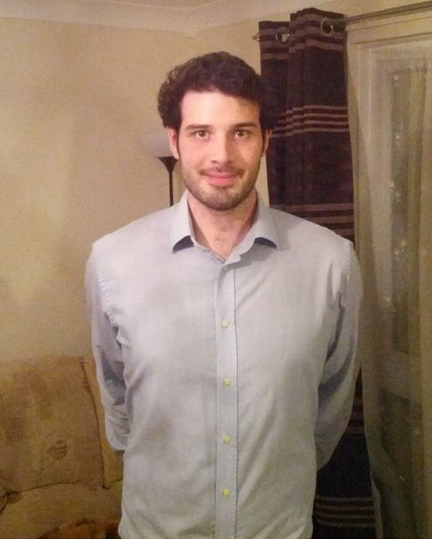

Daniel Hammant
2 Nursery End
Barnstaple
Devon
EX31 1RA
United Kingdom

Phone: +447500876934
Skype: dan.hammant
Email: danhammant@gmail.com

Date of birth: 22/03/1989
Nationality: British

PERSONAL PROFILE

I am a motivated, confident, enthusiastic, and outgoing individual with the ambition of teaching English in Korea. I have always prided myself on my ability to read, write and speak English at an advanced level and, because of this, I feel that I would be effective at teaching the language to others. Throughout my various jobs I have learned what it means to be a professional co-worker and employee: having what it takes to work under pressure; the ability to use my initiative; an eye for solving problems; and the motivation to help others.

EDUCATION

140 Hour I-to-I TEFL Course (July 2012 – October 2012) [Accredited by ODLQC]
Modules included: Classroom course (20hrs), Teaching course (60hrs), Grammar Awareness (20hrs), Teaching Young Learners (10hrs), Teaching Large Classes (10hrs), Teaching with Limited Resources (10hrs), Teaching One-to-One (10hrs).

BA (Hons), University of the West of England, Bristol (September 2008 – July 2011)
Major: Film Studies
Minor: Creative Writing
Level Attained: 2:1

WORK EXPERIENCE

Sales Advisor – Currys, Barnstaple (March 2012 - Present)
Responsibilities include: Teaching about technology to those who aren't technologically-minded, finding out what's right for the customer, helping to train new staff.

Student Ambassador - University of the West of England, Bristol (March 2009 – July 2011)
Responsibilities include: Teaching prospective students and parents about the benefits of studying at the university, showing people around campus, answering questions.

RELEVANT SKILLS

Communication: Throughout all of my previous employment, communication has been key;
whether it be building rapport, answering any questions or queries in a clear and concise manner, or using my knowledge to effectively demonstrate to
others.

Over the three years in which I studied at university my course demanded that I wrote academic essays and exams, which enabled me to demonstrate my strong written communication skills. Furthermore, I also had to conduct a number of presentations in seminars; something that strengthened my ability to talk in front of a large number of people.

Inter-personal: When working in sales it is important that one always conveys themselves in
a positive manner, even if a customer is being difficult, and this is certainly a
characteristic I pertain.

As mentioned previously, one of the responsibilities of my current job is to
teach those who aren't technologically-minded about technology. To be able
do this, one needs to have a large amount of patience and this is something I
have.

Organisational: I have effectively demonstrated strong organisational skills by multi-tasking in order to meet coursework deadlines at university and successfully pass my course.

Film Studies itself involves a large amount of analytical work which has developed my research skills and my ability to pay attention to detail.

Team Work: Regular group work in seminars at university has enabled me to improve my listening and negotiation skills while also furthering my ability to debate critically structured arguments.

In working as a Student Ambassador, it is very important to maintain a team-work outlook. Because Ambassadors are split into groups, it is necessary to have constant communication with each other so that there is always someone in the right place to help visitors.

References

Available upon request.

