Daniel Miller
781 Eupnaeri
Uljin-eup, Gyeong-buk
767-805
South Korea
Phone: 010-5804-4567 Korea: USA 714-243-8813
kasain@hotmail.com Skype: Daniel.Miller8
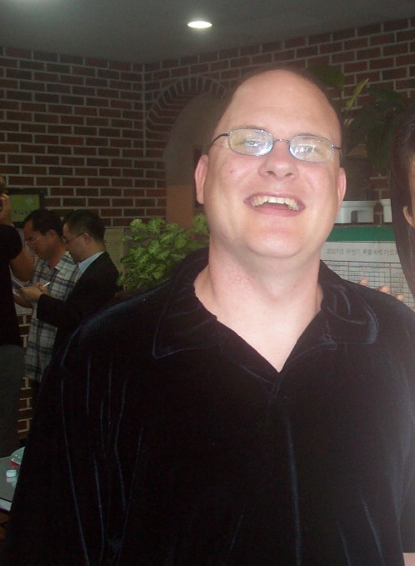
Objective: Seeking a challenging position providing an opportunity to utilize my education and experience and help people improve their quality of life and teach English.. I recently became aware of the opportunities of teaching English around the world. I want to take advantage of this opportunity. I would like to teach in S Korea, Taiwan, Russia, Japan or China. While I may not be CELTA certified now, I don’t mind enrolling in a program before my start date or do a program concurrently. My contract ends December 17th, so I am looking for a new adventure.
Education
California State University Fullerton
Dates Attended: 1/2002-2004
Bachelor of Science, Human Services, Mental Drug and Community Tracks.
Experience
12/08 – 12/09
Uljin High School, S Korea
I taught English conversation and topics. I helped with test prepping and vocabulary comprehension. I taught sixteen – eighteen year old students. I made all my own lessons and topics. I really enjoyed teaching this grade level.

12/07 – 12/08
James Foreign Language Institute
Located in Gumi, Korea
I teach children and adults English. I have made manuals for popular books such as Side By Side for adults, and Gogo and Hooray children books. I do make Cd’s and some PowerPoint presentations. With adults I use The Korean Times and Orange County Newspaper for events going on around the world. I try to not just teach memorization, but how to apply knowledge learned.

