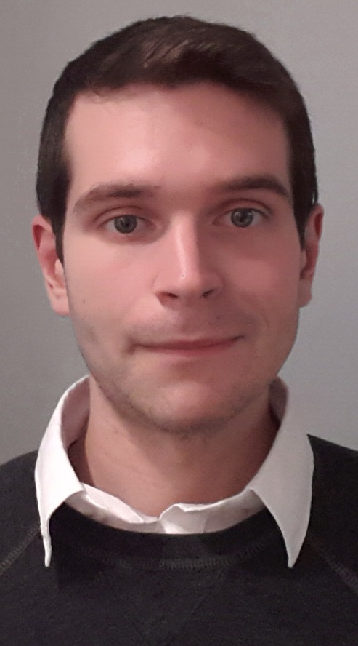

Darragh Liam Feran

3517 Grey Ave
Montreal, Quebec

I am interested in applying for a position teaching English to adult students. I am a graduate of Concordia University’s Creative Writing program and have experience teaching English in Korea in small private language institutes. During my time teaching, I was assigned students of different levels and ages, and therefore learned to tailor lessons and language appropriately. In addition to teaching the standard curriculum, I was also given the opportunity to help advanced students prepare for various standardized tests.
Most of my professional teaching experience is with children, and while I found it extremely rewarding, I am now looking to teach more mature students. I believe I possess a strong and intuitive command of English grammar and syntax, and enjoy assisting my Korean acquaintances with their pursuit of English.
그리고 저는 한국어를 할 줄 압니다. 저는 처음에 한국에 왔을때 “안녕하세요”나 감사합니다” 같은 말밖에 한국어를 몰랐는데 열심히 공부했고 자주 연습을 해서 지금 한국말을 꽤 잘 합니다. 한국어를 배우는 동안 좋은 한국인 친구들을 만났고 진심으로 한국문화에 대해서 관심을 가졌습니다. 그래서 저는 한국말을 계속 공부하려고 합니다. 제가 한국말을 잘 할 수 있으면 한국회사 생활은 더 쉽고 편해질 것같습니다. 그리고 마지막으로 제 글을 읽어주셔서 감사합니다.
In summation, I believe my command of English and my general interest in languages make me well suited to teaching English to adult students. I ask that you please consider my application, and I would like to thank you for your time.

Sincerely,

Darragh Liam Feran
Darragh Liam Feran

Current Address
3517 Grey Ave
Montreal, Quebec, H4A 3N5

514-754-5046
d_feran@hotmail.com

Experience
June 2012- June 2013 English Teacher
7 Step English (Goeup Dong), Yangju-si, South Korea
- Taught primarily elementary and middle school students from a progressive, structured curriculum
- Assisted in the implementation of a monthly speech contest
- Wrote supplemental scripts and materials
- Prepared students for the TOSEL and the TOEIC standardized tests

January 2012-May2012 English Teacher
LMH English Academy, Yongin-si, South Korea
- Taught primarily middle and high school students from a curriculum based on Seoul National University's TEPS standardized college entrance exam
- Assisted my employer prepare for the TEPS test
- Developed scripts for a conversation-based curriculum

Education
  - Concordia University, Montreal, Quebec
  - B.A. Creative Writing, Graduated with Distinction, 2011

  - Dawson College, Montreal, Quebec
  - D.E.C. Pure and Applied Science, 2009

Interests and Skills
- Intermediate French language skills
- Low-intermediate Korean language skills

Publications
- “The Resolution,” The Void (9.2)

