Darryn Flett
Mobile: 01028222453 E-Mail darrynflett@hotmail.com

Date of Birth 12.04.81 Nationality British Visa Status F2

PERSONAL PROFILE

I am a professional business trainer and English language instructor. I have over five years teaching experience, spent mostly in Korea and London, but also on various volunteer projects around the Asia Pacific region. I am UK business graduate who has worked and travelled to over 50 countries. I am currently studying towards an MA in TESOL, I am CELTA certified.

MAJOR ACHIEVEMENTS

- I have trained Vice President’s and groups of engineers of Samsung.
- I have successfully planned and delivered intensive training course for flight attendants of a number of multinational airliners.
- I successfully completed 3, 1 year contracts teaching in Suwon, South Korea, fully planning and teaching all lessons to a variety of age groups and abilities. As well as teacher management and curriculum development responsibilities.
- I was a business trainer in London, teaching top level management for world renowned companies such as Coca Cola, Novartis, LG, ABN and Bank Italia amongst others.
- I successfully taught a course of Business English to employees of international manufacturing company in Daegu, South Korea.
- I achieved a 2:1 Honours degree in Business Studies from The Robert Gordon University.
- I secured one of only 8 placement positions (out of 300 students) with Shell, where I received the maximum spot prize of one month’s salary for outstanding achievement.
- I was awarded first prizes in Management Studies and Physical Education at high school.

HIGHER EDUCATION – UNIVERSITY

The Robert Gordon University, Aberdeen, UK 1999-2003, BA (Honours) Business Studies 2:1.
.
My 25,000 word honours thesis was an analysis of the implementation and operational issues surrounding the UK Government’s new integrated policy initiative, The United Kingdom Emissions Trading Scheme.

Regent’s College, Oxford – 2002 CELTA Certificate
Training and assessment in: Planning and teaching effective lessons. Analysis and assessment of individuals’ needs. Observation and analysis of experienced EFL teachers. Teaching English to business people, and children.

SECONDARY EDUCATION

Buckie Community High School 1993 1999

5 Highers - Management Studies A First Prize, Physical Education B First Prize,
Secretarial Studies B Second Prize, English A, Mathematics B.

EMPLOYMENT

Ehwa American Language School, Feb 2010 – December 2010.

I am the senior language instructor teaching middle school students. I have Curriculum development, book writing and teacher training responsibilities.

Myung Dang Elementary School, After School Program, Nov 2009 – September 2010

I am currently working teaching elementary students in Suwon.

Daekyo Corp After School Program Manager, Suwon/Yongin, South Korea Jan 2009 – June 2009

I developed and carried out level placement tests, produced curriculum materials and delivered fun and enjoyable lessons for a wide variety of abilities at a number of elementary schools in the area.

Freelance Language Trainer, Suwon, South Korea June 2008 – January 2009

I was the personal tutor of a Vice President’s of Samsung’s Semiconductor division for 10 months. I have also planned and delivered lessons to groups of the company’s engineers.

I successfully planned and delivered intensive training courses for flight attendants. I also worked with middle and high school students helping them prepare for upcoming exams and university entrance tests.

I also worked in a number of local schools during this time, focussing on middle school students listening and speaking abilities.

Pacific Canada Academy, Suwon, South Korea June 2007 – June 2008

I completed a one year contract teaching a wide range of ages and abilities, mainly elementary students in an after school program. I was involved in curriculum development, placement interviews and liaising with the parents.
Canning International, London, England – February 2007 – June 2007

I was a professional business trainer responsible for teaching groups of top level management employees from world renowned companies like Coca Cola, Novartis, LG, ABN and Bank Italia amongst others.

Comax Latex, Daegu, South Korea – November 2006 – December 2006

I was employed to assist the CEO of this international manufacturing company with the business’ English related activities as well as teaching him and some members of his staff conversational skills.

Bandi English School, Suwon, South Korea - August 2005 to August 2006

I was the senior English teacher at Bandi English School. I planned and taught lessons to a wide range of students from young children to businessmen. Duties included placement interviews, student evaluations and parent counselling. I also played a role in curricular development and teacher training.

October 2004 – May 2005 Senior Accounts Assistant

Baker Hughes and Capita Health Solutions I was involved in the processing of invoices as well as creating complex excel databases for engineering planning and budgetary exercises.

September 2003 – September 2004

I travelled and worked around the world for a year. In Sydney I had a senior accounts assistant position at Macquarie Bank where I was involved with planning and budgetary exercises. In Fiji, Vietnam, Cambodia and India I also volunteered at local schools to gain valuable teaching experience.

Shell UK Exploration and Production - June 2001 to September 2002

This industrial placement was split between working within the Northern Business Unit’s busy Finance team and supporting a group of Asset Analysts. I performed a variety of tasks ranging from the preparation of monthly accruals, to the regular creation of SAP master data and budget, planning and project controls exercises. I was also the editor of Expro’s monthly newsletter Northern Lights which had more than 1500 subscribers, this task required me to work using my own initiative setting out tight plans and deadlines, as well as liasing with senior management and external organisations. For the completion of this project I was awarded a special one month’s salary spot bonus. I also taught foreign students conversational English.

ACTIVITIES AND INTERESTS

I play, coach and watch football on a regular basis. I have a strong passion for travelling. I am also learning Korean in which I have now mastered the basics in conversation and writing. I am also a published travel writer and journalist.

SKILLS PROFILE

Teaching: I have taught all age groups and abilities both professionally and voluntarily, from large classes to personal one on ones. I have developed a wide range of materials, I feel comfortable and confident of my abilities in all class room situations.

Communication: I have excellent communication skills and posses the ability to relate to all levels of social and commercial contacts in both business and society.

Team Work: I have experience working within both large and small teams that have helped develop a wide range of planning, organising and time management skills.

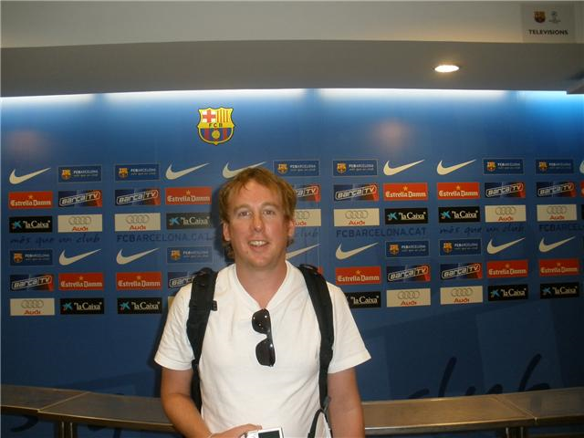

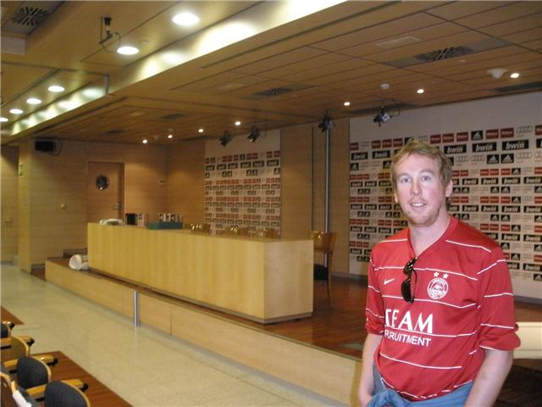

These pictures are from the Real Madrid and Barcelona football stadiums in Spain.

