258-5 Itaewon Dong, YONGSAN-gu seoul SOUTH KOREA.
Telephone: 010-2660-4558 E-mail: davichris80@gmail.com
david morgan
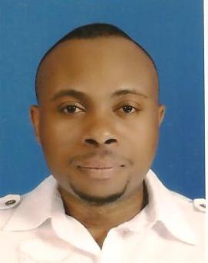
Personal Information
Date of Birth
1st NOVEMBER 1976

Nationality
SOUTH AFRICAN
Place of Birth
JOHANNESBURG
Marital Status
SINGLE
Language
ENGLISH

PROFESSIONAL OBJECTIVE
Dedicated to creating a positive learning environment to help students improve their English abilities and explore their creativity.

EDUCATION
Education Diploma in Literature and Linguistics – Majoring in English
Education Diploma – Teaching High School – Art and Design 2000- 2002
Sussex University, England
Bachelor of Vocational Studies majoring Industrial Art 1996- 2000
Sussex University, England

WORK EXPERIENCE
Company employee- exports and trade – Korea 2006-2008
I have been responsible for setting up schedules for pick-up and cargo transport,
Negotiating bulk purchases, and researching product availability
English Teacher
I have taught young children of kindergarten and elementary school age, as well as
adult company classes.

Teacher - Fine Arts
Rainbow International School, Kampala –Uganda 2005-2006

I was responsible for the development of the curriculum. I taught High School children Art theory and practical experience in charcoal and pencil drawing, painting, clay modeling, wood carving, decoupage, collage, and sculpture. I also organized outings to museums and art galleries.

I created comprehensive classroom social studies learning resources, encouraging students to take home, use and learn the new material. I managed classes of 25 students at a time in guided research and community project regarding health, hygiene and social behavior.

Teacher - English Literature and Fine Arts
St. Stephen College, Kampala, Uganda 2003-2005

I taught English to classes of 40 High School students. Topics explored included
Grammar, Syntax, Etymology, Writing and Debate. We explored modern and classic authors of Africa and Europe. I used creative methods and resources to successfully guide students in learning grammar, spelling and writing.

I like to motivate students in ascertaining their inner strengths and abilities and discovering what truly inspires them through guided discussions and field trips.

Other Attributes:
Accomplished Artist with proficient skills in painting
Music composer, arranger, and signer. Composed and performed the theme music for a popular TV series.

