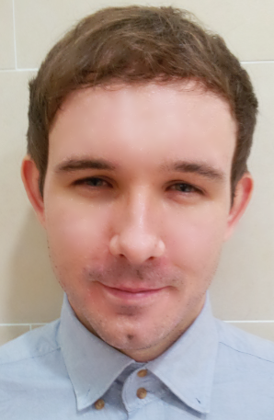

Resume

Name: David Gallagher
Date of birth: 14/05/1985
Martial Status: Single
Nationality: Ireland

Education
2003 - 2006 BA of English Literature and Philosophy, University of College Cork.

Work experience
Position: English Teacher
Company: Nova English Academy
Date: November 2012 to Present
Responsibilities:
- Responsible for teaching all age groups (kindergarten, elementary school,
middle school, high school and adults).
- Making various documents each month: homework lists for parents and students, monthly tests for each class, and newsletter pages for each student (which included photos and comments).
- Choosing books and materials for each class before each semester.
- Making games, flashcards, and other fun material to teach the kindergarten and elementary students in a fun and lively way.
Reason for leaving: To move to Seoul.

Position: English Teacher
Company: Avalon English
Date: February 2011 to February 2012
Responsibilities:
- Responsible for conducting classes of six to sixteen elementary students.
- Preparing lesson plans and class material.
- Working with Korean co-teacher to ensure the needs of students are being fulfilled.
- Teaching advanced classes, such as Toefl writing, Toefl reading and debate.
- Assisting students with their presentation skills.
Reason for leaving: To have a new experience.

Position: Business Account Manager.
Company: Dell Computers.
Date: January 2008 to January 2009 and December 2006 to September 2007
Responsibilities:
- Built and maintained business relationships with large companies.
- Discussed detailed I.T. solutions with my clients in a friendly and precise manner.
- Assisted those less experienced than me in their transition from Business Sales to Business Account Manager.
- Benefited from several in-house training programmes, in which I was required to give presentation in front of my colleagues and management.
Reason for Leaving: To travel.
.
Skills:
Communication skills: Very good written and oral communication skills.

Computer skills: Extremely experienced and comfortable with using Microsoft Word and Excel, as well as using the internet and various multi-media applications.

Interests:
Reading and writing: Have a great interest in all types of literature, especially novels.

Korean language and culture: Since arriving in Korea I have made an effort to learn Korean. As a result, I have achieved level three in TOPIK (Test of Proficiency in Korean).

To whom it may concern,

I am writing you because I am currently seeking a teaching position in Seoul, and I am hoping your company can help me secure a position in a good, reliable school. I am currently living in Onyang, Korea, and I can be contacted using the above contact information.

I arrived in Korea in February 2011. I worked for Avalon English for one year, teaching elementary school students. In Avalon I taught various subjects, including Toefl speaking and writing, and debate classes. It was the perfect introduction to teaching for me, because Avalon taught me a lot about class management and about various teaching styles.

Since November 2012 I have been working in Nova English Academy in Onyang. In Nova, I have had the pleasure of teaching all age groups from kindergarten to adults. I have had much more responsibility in Nova, such as choosing books for upcoming semesters and creating my own material for kindergarten and adult classes. This added responsibility has helped me improve a lot as a teacher.

Since I arrived in Korea I have really enjoyed working with children and learning about Korean culture. I have a joint major in English and Philosophy, and I am sure this is a benefit, especially when teaching students with a high level of English. My personality really fits well with teaching young kids. I have a kind and fun personality, and this is what helps me create an enjoyable and comfortable class environment.
I have been studying Korean since I came to Korea. I have reached level three in Topik (Test of Proficiency in Korean). Learning Korean, meeting new people and teaching English to children has made my life in Korea very enjoyable.

.
Sincerely,
David.

