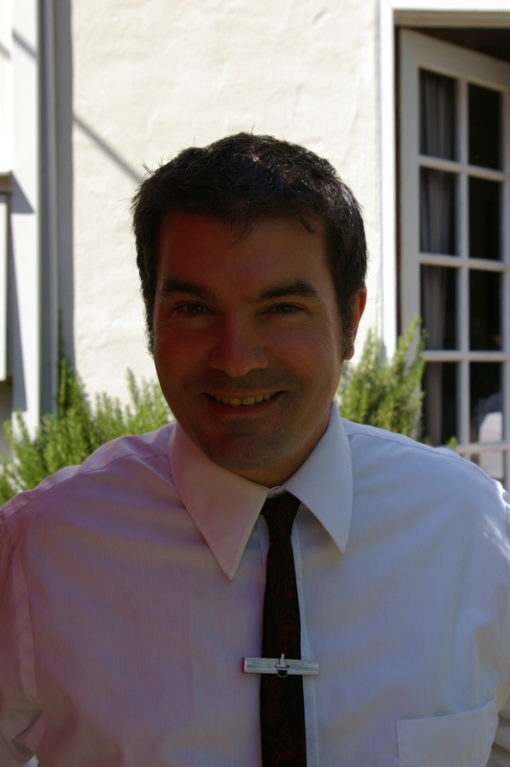
David Smith

EDUCATION and TRAINING:

- July 2009: Teaching English as a Foreign Language (TEFL) 100 Hours Certificate
- March 2009: California Teaching Credential #130055299
- June 1996: San Francisco State University, San Francisco, CA,Bachelor of Arts, summa cum laude, Anthropology

EMPLOYMENT HISTORY:

July 2012-present
Combustion Junction: Estacada, OR: Inventory Manager
RESPONSIBILITIES: Kept track and organized inventory for a vintage motorcycle restoration company; minor consulting work on a Land Speed Record Norton motorcycle attempt.

February 2011- February 2012
Jizan Economic City – Polytechnic University, Saudi Arabia: English as a Foreign Language Teacher – Information Technology Teacher
RESPONSIBILITIES: Developed culturally sensitive, educational curriculum for ESL and IT for approximately eight hundred adult students; hired as an ESL and IT teacher promoted within four months to Department Head counseling students and teachers, as well as writing and administering tests and finals.

August 2009- August 2010
Namsung High School, South Korea: English as a Foreign Language Teacher
RESPONSIBILITIES: Developed culturally sensitive, educational curriculum for approximately nine hundred adolescent students; monitored students’ academic progress; counseled students as needed; facilitated class discussions; completed 85 hours of training; provided on-going consultation to colleagues.

August 2008-February 2009
United States Department of Homeland Security, Sacramento, CA: Transportation Security Officer
RESPONSIBILITIES: Screened airline passengers for potential security threats; gathered security related intelligence; utilized security risk detection equipment; educated the public on security procedures and regulations; completed on-going training in safety and evacuation techniques.

August 2007- August 2008
Varsity Theatre, Davis, CA: General Manager
RESPONSIBILITIES: Managed daily operations of the independent film theatre; projectionist building and taking apart films; supervised and managed ten staff members; ensured compliance with state and federal mandates and; maintained employment work schedule calendars.

July 2006 - August 2007
Reading Entertainment International, Tower Arts Theatre, Sacramento, CA: General Manager
RESPONSIBILITIES: Managed daily operations of the independent film theatre with monthly revenue of approximately one hundred thousand dollars; developed and implemented cost efficient strategies which resulted in a decrease of monthly liabilities by fifteen percent; supervised and managed twenty staff members; ensured compliance with state and federal mandates and; maintained employment work schedule calendars.

November 1996 – August 2004
California Journal and State Net, Sacramento, CA: Programmer/Publications Manager
RESPONSIBILITIES: Directed all data gathering including voting records; supported legislation for an election reporting project; utilized a variety of programming languages including Perl, JavaScript, and html; standardized legislative bill data by programming reusable templates to be used across the United States; provided editorial input to the California Journal (weekly legislative publication); conducted on-going technical training for employees; interviewed legislative staff and; conducted research using qualitative tools and methods.

October 2002 – August 2004
University California Davis, California National Primate Center, Davis, CA: Assistant Animal Technician/Security
RESPONSIBILITIES: Cleaned and fed approximately 5,000 primates; provided night security.
OTHER:
FBI Clearance with Apostille Completed May 30, 2013
San Francisco State University Diploma Apostille on July 9, 2013
http://www.linkedin.com/in/davesmith500
References available up request

