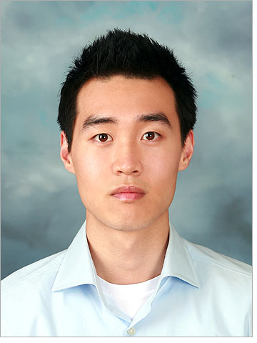

David P. Sohn

Objective:
To obtain a teaching position which utilizes my education and experience and promotes a creative and positive environment.
Education/Certification:
University of Guelph, ON
Bachelor of Arts, 2011
Coursework Concentration:
• Principles of Learning
• Cognitive Psychology
• Developmental Psychology
• Social Psychology
• Organizational Psychology
Oxford Seminars, ON
•100-hour TESOL/TESL/TEFL Certificate, 2011
Experience:
Avalon English 3/2012 - 3/2013
English Teacher
• Teach six separate classes daily, ranging from 2-15 students in attendance
• Teach students grades K-6 essential Reading, Writing, Listening, Speaking skills
• Introduce the curriculum outlined in the monthly syllabus
• Create effective lesson plans and activities daily
• Communicate with co-teachers as needed to discuss students’ progress or concerns
Martingrove Collegiate Institute 12/2011 – 1/2012
Volunteer Assistant Coach
• Assist with a variety of volleyball drills and conditioning methods
• Focus on fundamentally passing, setting, hitting, blocking, serving, and defense

