EDUCATION
New York University, Stern School of Business - New York, NY
BS in Finance & Accounting, May 1997; GPA: 3.3
Trustee Scholar 1995-97; Dean’s List 1995
EXPERIENCE
4/09 – Present Gyeongseo Elementary School, Incheon – After School Teacher
- Instructed English language learning in eight after school classes from grades 1 to 6
- Drilled phonics and taught basic vocabulary using the Up & Away Phonics book series
- Introduced grammar concepts in a systematic way using the Grammar Club book series
- Taught speech writing and presentation for upper grades using the Speaking Juice book series
- Instituted a stamp incentive program and conducted a market day to motivate and encourage students
- Assigned homework and thoroughly checked and reviewed answers to ensure full understanding
- Developed power point presentations, customized tests and quizzes as well as
- Created daily lesson plans to use as a guide for teaching and for smooth transition of topics
- Wrote detailed progress reports for each student on a bi-monthly basis

10/08 – 4/09 Korean Christian International School, Iksan – English Hagwon Teacher
- Performed the daily duties of an English teacher for 5 kindergarten & 10 elementary level hagwon classes
- Encouraged over 200 students to enjoy the process of speaking and mastering the English language
- Orchestrated each 30-minute class with a carefully developed, activity-filled lesson plan
- Instructed English conversation for hagwon grades 1-6 using the Let’s Go and English Time book series
- Assessed phonics skills for upper level hagwon grades using the Letters & Sounds 2 book series
- Evaluated writing and composition skills for upper level hagwon grades using Write Time For Kids
- Created and conducted speaking tests inspired by vocabulary and themes in the text books
- Developed reading and comprehension skills using the Paths to Adventure reading program
- Corrected daily homework assignments, taught grammar, drilled vocabulary, evaluated penmanship, graded book tests, read literature in the library, held spelling bees and recorded academic progress
- Taught math for kindergarten using the Button Bear, Numbers Skills and Arithmetic 1 book series
- Instructed English conversation for kindergarten using the Super Tots and Magic Time book series
- Presented poetry to kindergarteners using the Preschool Poems & Finger Plays book
- Escorted classes on weekly outings to cultural and educational institutions throughout the city of Iksan
- Achieved dramatic improvements in academic performance of students in the lowest percentile resulting from parent-teacher cooperation and leveraging of students’ strengths
7/98 – 10/08 Access, Bond, Custom, Delta Employment Agencies, New York – Lead Word Processing Operator
- Performed responsibilities and duties of lead operator at over 20 different law firms and financial institutions including: Mayer Brown, Bernstein Litowitz, Dewey Ballantine, Chadbourne Parke, Fried Frank, Greenberg Traurig, Hughes Hubbard, Le Beouf Lamb, Paul Hastings, Orrick Herrington, Weil Gotshal Manges
- Supervised and trained new permanent and temporary employees on the use of in-house word processing templates, styles and general office procedures
- Financial document production including price volume charts, organizational charts, PowerPoint slide presentations; advanced Excel charts and graphs; as well as incorporating documents from the entire Microsoft Office Suite into either a master Word or PowerPoint document

OTHER SKILLS
- Computer: Microsoft Office – Word, Excel, PowerPoint (advanced features)
- Languages: French, Spanish
- Recreation: Baduk, Janggi (Chinese chess), Ping Pong, Tennis, Singing
- Travel: Africa, Asia, Australia, Europe, North America, South America
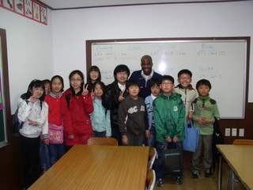 |  | 
`
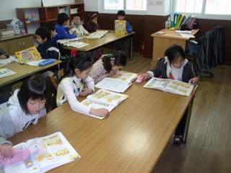 |  | 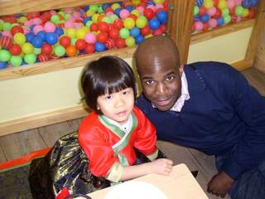
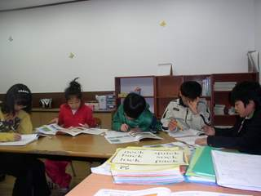 |  | 