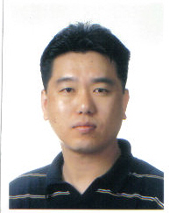

David I. Park
Seoul Si, Seocho Ku,
Bang Bae 1 Dong 904-13 #302

C.P.: 016) 880-4199
p880d@hanmail.net

I am currently looking for a part, full time teaching or administrative position that will allow me to use my skills and knowledge to the best of my abilities.

WORK EXPERIENCE

July 2007 to present, Andrew Language Academy

May 2005 to present, Teaching English privately

Registered with the Ministry of Education

July 2003 to March 2005, Acting Principal, Part Owner, ACE Language School.

Created the school and its core curriculum.

Duties include parental counseling, teaching, marketing and supervising the instructors.

July 2002 to March 2003, 60 hours per week, Academic Director, ALS Ewha (Youngdungpo) Seoul.

I was the Academic Director in charge of the Youngdungpo Branch. My responsibilities were to create and implement the curriculum as well as take care of the Instructors.

EDUCATION
West Coast University, Los Angeles, BA in Business, 1997

Devry University, Los Angeles, 4 Semesters, Business Major, 1992 to1994.
Santa Monica City College, Los Angeles. 1990 to 1992.
University of Maryland, Okinawa, Japan. 2 Semesters, 1989.
National University, San Mateo, 1 Semester, 1987.

West Coast University, Los Angeles, enrolled 1987
Beverly Hills High School, Class of 1986.
OTHER INFORMATION
I understand and speak Korean fluently as well as have knowledge of Spanish.

