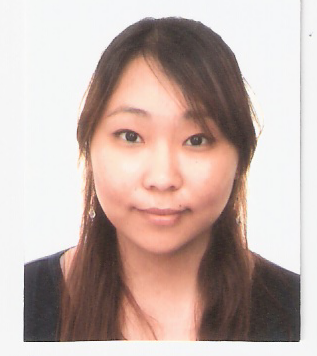 Dawn Jeong
daeun0807@hotmail.com
mobile: 010-4333-0807

OBJECTIVE: To participate in industry of full-time job where I can interact with others.

EDUCATION:
2003-2008 University of British Columbia
5 Bachelor of Arts Degree (Asian Studies)

2007 Summer Korea University
4 International Summer Program

2000 - 2003 Prince of Wales Secondary School
3 Graduated grade 12

1997-2000 MacKenzie Middle School
2 Graduated grade 9

1995- 1997 Standford Elementary School
1 Graduated grade 7

WORK/VOLUNTEER EXPERIENCE:
Sept 2008- Sept 2010 Muwon Middle School
1 Native English teacher

Jan 2008- Jan 2010 Tutor
1 Grade 12-Tutoring grade 12 English
2 Grade 4 – Tutoring grade 4 English

May 2007- August 2007 Interpreter
1 Interpreted documents from Korean – English
2 Interpreted video clip interviews from English- Korean

June 2007 – August 2007 English Teacher (private institute)
1 Taught elementary level children conversation class

February 2006 – December 2006 Symcor
1 Remote Keying Department (item data processor)

June 2002- January 2006 Customer Service Representative (Cashier)
1 Assist as cashier
2 Assist in packaging items
3Assist in washing and drying clothing items

May 2005- August 2005 Customer Service Representative (Waitress)
1 Assist as cashier
2 Assist as serving food
3 Assist as preparing for take-outs

September 2003- December 2003 Customer Service Representative (Cashier)
1 Assist as cashier
2 Assist in cleaning

September 2001-April 2003 Tutoring
1 Grade 10 - taught math, help in homework
2 Grade 5 - help in homework and reading
3 Grade 2 – Taught English

September 2003- December 2003 Volunteering (Care Center)
1 Helped old folks to walk down the halls
2 Assist decorations at certain festivals
3 Assist meal preparations

AWARDS AND ACHEIVEMENTS:
2002-2003 1 Academic Honor Roll
(Prince of Wales High School)

2006 2 TESOL certificate

SKILLS AND QUALIFICATIONS:
- Fast learner- Good communication skills, Excellent organization skills
- Basic knowledge of computers (HTML, Excel, and Power Point)
- Fluent in English and Korean - speak, read, and write
- Chinese - attended Mandarin School, can speak simple conversation.
- Japanese - 3 years studying in high school, 1 year at college can write, can speak simple conversation.

REFERENCES: Available upon request

