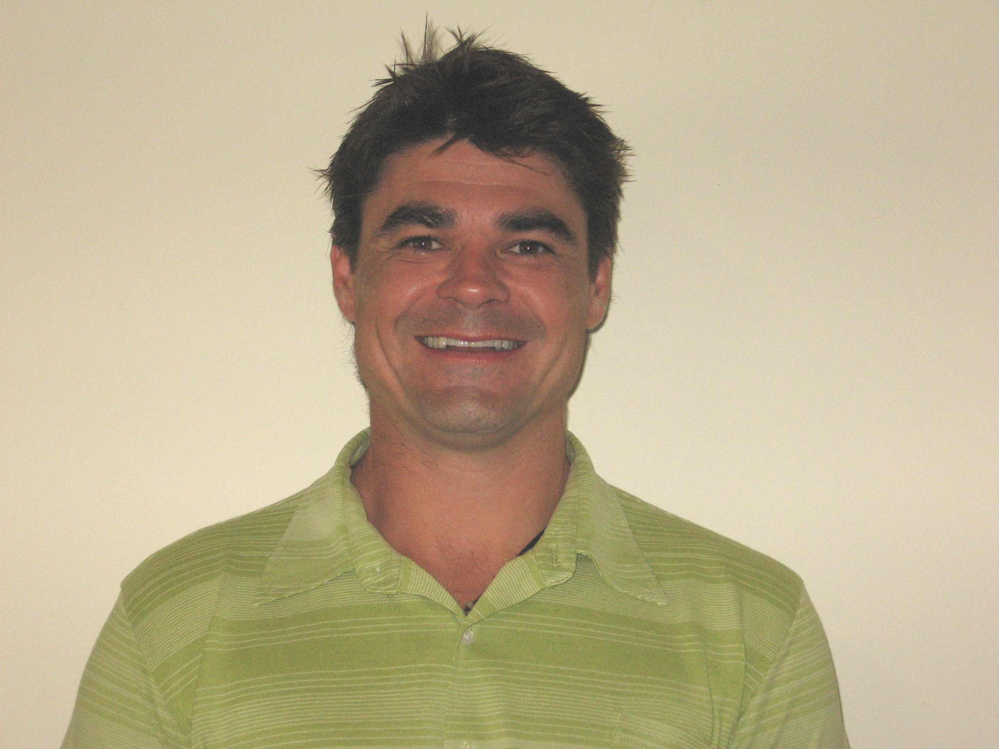

Dean Wilson

PERSONAL DETAILS

Full Name: Dean Andrew Wilson
Address: PO Box 227. Balingup Post Office. Western Australia.
Phone (Home): (08) 9764 1456 Phone (Mobile/Cell): 040 747 0900
Email: yeahgday@hotmail.com
Licenses: HR & R-E Classes: (Car, Truck, Motorcycle)

DEMONSTRATED WORKSKILLS & ABILITIES PERSONAL QUALITIES

- Well developed written and verbal communication skills • Honest / Fair
- Effective organisational and time management skills • Hard worker
- Outstanding problem solving skills • Reliable
- Work well alone or in a team environment • Adaptable / Flexible
- Computer competent • Good sense of humour

EDUCATION AND TRAINING___________________________________________

2001 – 2004 EDITH COWAN UNIVERSITY – Bunbury. Western Australia.
Graduate - BACHELOR OF ARTS – (Major: Writing and Media. Minor: Sociology and Anthropology).

2005 – 2006 REGIONAL COLLEGE OF TAFE – Busselton. WA.
Graduate - CERTIFICATE III IN COMMUNITY SERVICES (YOUTH WORK) in conjunction with 12 MONTH TRAINEESHIP at South West Community Drug Service Team
Relevant Training Conferences Attended: (Presented at *)

- 2-day Ministerial Council for Youth Suicide Prevention workshop
- 2-day Clinical Supervision Workshop – Adelaide
- 3-day Australasian Professional Society on Alcohol and
Other Drugs Symposium (APSAD) – Melbourne *
- 2-day “Beyond the Boundaries” – Working With Families
- 5-day AOD Key Stakeholders Conference (Feb 2007) *

1987 - 1991 CARLISLE REGIONAL COLLEGE OF TAFE – Carlisle. WA.
Graduate - AUTOMOTIVE ELECTRICAL FITTER
4 Year Apprenticeship -
Northside Automotive & Marine Electrics. Balcatta. WA.

EMPLOYMENT HISTORY

July 2007 – July 2008 MAPO WONDERLAND Seoul, Korea
FOREIGN ENGLISH TEACHER – Kindergarten / Elementary
Duties:
- Teaching of English language (Target students’ ages: 4 to 15).
- Development of educational programs and materials
- Curriculum design and implementation
- Indoor and outdoor classroom activities for/with students
- Grading and assessing / evaluating students
- Student counseling
- Attending teacher’s / parent’s meetings and workshops
- Other related activities, such as lunch service, field trips,
birthday party and class preparation etc.
- Monthly Lesson Plan preparation where required

April 2005 – April 2007 COMMUNITY SERVICES YOUTH WORKER / COUNSELLOR.
St. John of God / South West Community Drug Service Team
Duties:
- Alcohol and other drug counseling: Working with people of all ages (including Noongar / Aboriginal) on a one to one basis.
- Provide community services and resources information.
- Plan, conduct and evaluate programs / workshops for young people, covering: employment training, education, self development, accommodation, welfare and counseling through such programmes as Youth Peer Education.
- Provide support to people, particularly the young experiencing difficulties such as family problems, unemployment, illness, drug use or homelessness.
- Arrange food parcels, shelter or clothing.
- Arrange referral of clients to appropriate specialists or community agencies
- Liaise with teachers, social and welfare workers, local authorities, health professionals, refuge workers, parents and in some instances, police.
- Community Development
- Mentor clients and trainees
- Present programmes at conferences.

Jan 2004 – Sept 2006 TEACHER / SESSIONAL TUTOR (Casual Contract).
Bunbury Regional Prison (Department of Justice).
Duties:
- Teach prisoners – Certificate of General Education for Adults (Accredited course).
  - Teach, facilitate learning, access and mentor students in accordance with relevant curriculum and / or training package requirements.
  - Planning, preparation (of classes) and marking of work.
  - Provide specialist assistance to facilitate students’ learning.
  - Participation in the conduct of training needs analysis and skills audits.
- Tutor prisoners – (Some through an Indigenous Tutorial Assistance Scheme):
  - Work professionally one to one and in groups with Curtin University Students.
  - Provide culturally appropriate academic support to Curtin Indigenous Students in tertiary studies.
  - Liaise with ITAS staff regularly re: student issues.

Sept 2004 –- Dec 2004 EMPLOYMENT SKILLS CONSULTANT / TUTOR. (C/Contract)
Bunbury Regional Prison (Department of Justice).
Duties:
- Tutor - Indigenous prisoners (Indigenous University Orientation Course) – through the Aboriginal Tutorial Assistance Scheme.
- Implement Indigenous Pre-employment Program:
  - Impart knowledge and information concerning employability skills.
  - Execute Interactive Assisted Career Guidance program.
  - Develop resumes / job application letters.
  - Organise guest speakers and conduct mock interviews.

2002 – 2004 TINA’S TASTY THAI TREATS Restaurant (P/T whilst studying)
Cashier / kitchen hand / occasional cook.

GUILD INFORMATION OFFICER - (Casual whilst studying)
Advocate on behalf of students - ECU, Bunbury, WA.

2000 – 2001 JOURNALIST / PHOTOGRAPHER - (Casual Contract)
Donnybrook - Balingup Herald. Balingup WA.

1999 - 2000 SUPERVISOR AT ‘SOUTHERN COMFORT’ – (F/T Contract) Overseeing / building a heritage stone bed and breakfast building. Balingup, WA.

WORK EXPERIENCE & VOLUNTEER WORK ______________

2008 Photographer: ROKON Indie Music Magazine – South Korea
2007 Mentor: AMP-SW – Young person with a disability.
2006 Scholarship Recipient – Healthway / Australian Health Promotion Association Graduate
2005-07 Committee Member of Community Organisations: Bunbury Local Drug Action Group & In Town Centre, Bunbury. WA.
2004 Volunteer, literacy and numeracy tutor (after school homework) – primary school children - Milligan House, Bunbury WA.
2003 Co-Editor of Montage University magazine – ECU. Bunbury. WA.
2002 Mentor: University mentoring program – ECU Bunbury. WA.
1994 - Current Blood Donor.
1993 - Current Collector - Annual Heart, Cancer and Arthritis Doorknock Appeal.

HOBBIES & INTERESTS___________________________________________

Photography 1998 - Creative Photography Course – Sydney. NSW.
Art 2003 - Oil Painting with John Garde (Renowned Artist) Bunbury.
Cooking 1998 - Malaysian and Indonesian Cooking Course – Sydney
Surfing 1985 - Jr. Male Champion - Blowholes Classic. Carnarvon. WA.
Football 1992-94 Football Carnival (WAAFL) Representative - Melbourne

REFEREES AVAILABLE UPON REQUEST

