Resume
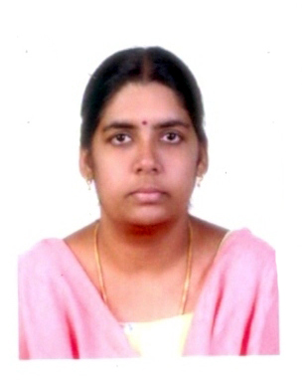

Deepa Velmurugan
Geo-Buk house, IInd Floor,
Room No-203, Ma-dong, Iksan,
Jeollabuk-do, South Korea – 570 752
Email: deepaambi@yahoo.co.in

Having 6 years of experience in teaching professionally in College and School environment. Expertise with various teaching methodologies that would help children to learn teaching with interest and enthusiasm. Also a good learner to adapt to learn and utilize new technological teaching techniques. Have experience in teaching different age groups which requires different methodologies of teaching as per age group. Have also given guidance and assistance to students, in times of difficulties in subjects. Have a creative attitude and thus have adapted various new learning techniques which made the class interesting for students. Expertise in teaching subject namely Computer Science, Commerce, Accounts and English of all grades.

Objective:

To use my skills and experience and thereby to promote a positive atmosphere, and higher quality education among children. Seeking a challenging and responsible position to use my abilities and experience effectively and efficiently for children and I also have acquisition for learning and developing new skills.

Achievements and skills:

- Have excellent communication skill to deliver and present learning effectively
- Can create an enthusiastic environment and make learning a happy journey among children
- Have creative and imaginative blend which helps in delivering lessons in a practical and interesting manner among children
- Have a caring attitude to attend to children's needs and concerns in time.
- Have a strong desire to work with children

Software Proficiency:

      - Operating System :- Windows2000/XP, Ms Dos
      - Language :- C,C++,HTML
      - Package :- Visual Basic6.0,MS-Office,Oracle,Tally 9
      - Certificate Course :- C,C++

Education:

      - Master of Science (Information Science & Management)- Nehru Memorial
College, Puthanampatti, Affiliated to Bharathidasan University, Trichy, Tamil
Nadu, Inida. - 2003
      - Bachelor of Commerce (B.Com)-Sri Saradha college for women, Salem,
Affiliated to Periyar University, salem, Tamil Nadu, India. - 2001

Work History:

School Teacher,
Indian Matriculation School, Belukurichi, India. June 2006- July 2009

Responsibilities:

As school Teacher I took the responsibility of teaching theoretical lessons, practical sessions of lessons taught, coordinating games and fun activities among children. . I took the responsibility of taking story telling sessions for children and there by helped the children to increase their vocabulary and creative thinking. I took the responsibility of teaching and executing children's projects from conception to completion. I took care and educated of age from 1-8.I was responsible for not only making lesson plans but also for managing the whole class allotted to me. I planned and organized variety of activities both for individuals and group activities namely playing, dancing, singing and games which helped children to bring out their talents and improve their skills. I took care of each child individually and attended their problems in lessons and also coordinated with their parents to communicate about their children.

College Lecturer,
Nehru Memorial College, Puthanampatti, India. June 2003 – May 2006

Responsibilities:

As college lecturer I took the responsibility of teaching commerce, Accountancy and Computer science. For completing the curriculums of the students and handed all type of teaching work in accordance with the role. Accomplished educator with demonstrated ability to teach, motivate and direct students while maintaining high interest and achievement. Articulate communicator able to effectively interact with diverse populations of students at a verity of academic levels. Consistently maintain excellent relations with students, parents, faculty and administrators. Self-motivated with strong planning, organizational and leadership skills.

Languages Known:

English, Tamil

