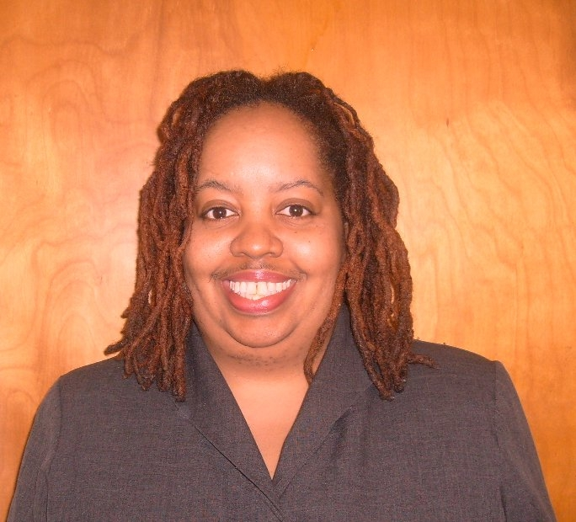
Deirdre Vachon Weary
Permanent address: 19666 Dequindre Detroit MI USA 48234
Email address: deirdreweary@yahoo.com
Phone: 1-313- 685-3708

Profile:
US Citizenship
Native English Speaker
Birth Date: 04/17/1969
BS Degree in Microbiology - Michigan State University
TEFL/ TESOL Certificate - Oxford Seminars

Experience:

TEFL:
May 2008-May 2009
International Communication Center, Daejeon, South Korea,
English Teacher

- Taught English from basic to advance levels to children in global house village.

- Developed age appropriate curriculum materials for activity lesson plans for dance, drama, math, science, zoology, speech, Earth, space, and food English immersion classrooms.

- Participated in open house presentations for parents, community and media.

- Administrative duties included but not limited to student assessment by a series of placement tests, midterms, final exams and report cards.

- Served as a resource to new and less experienced instructors in
developing their teaching skills and as a resource on the English
language and American culture to all instructors who are not native
speakers or who are less familiar with American culture.

Corporate Training:
March 2007-Feb 2008
Allied Waste Services, Inc., Pontiac, MI, USA
Program Coordinator
- Developed training materials for a corporate safety program. Trained CDL Drivers and management staff to use digital cameras to enforce company safety and environmental policies.

References
Available upon request

