To whom may concern

My name is Don Suh. I am a recent graduate of Georgia State University and I'm planning on going to law school in the United States. However, I will not be starting law school until the Fall of
2009. Between now and then, I would love to teach English in Korea.

So you want to know a little about me? Well, I am 28 years old and currently living in Atlanta, Georgia. I was born in South Korea and my family moved to the states when I was 14 months old. Since then, I have lived in six states including Texas, North Carolina, Georgia, California, Oregon, and Washington. I am now a U.S. citizen with a bachelor's degree in finance. I speak very good conversational Korean and I can write and speak English at a very high level. Although my teaching experience is limited to tutoring fellow college students and extended family members, I have often received compliments on my teaching ability. I enjoy teaching very much. I have had professors, family members, and students tell me that I would make an excellent teacher or counselor. If you want to know a little bit more about what kind of person I am, please visit...

http://www.mypersonality.info/personality-types/infp/

If you are interested, please contact me with details regarding the teaching positions available. Thank you for your time.
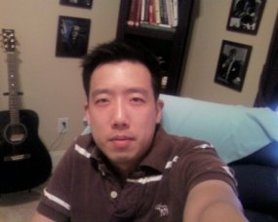
Donald Suh
2547 Stone Manor Drive
Buford, GA 30519
(404) 751 – 8900
Don.Suh @ Gmail.com

Objective

An entry-level position as an accountant/financial analyst.

Education

Bachelor of Business Administration in Finance
• Georgia State University, Atlanta, Georgia
• Degree Awarded August 15, 2008
• Business G.P.A. of 3.39, Georgia State G.P.A. of 3.32
• Faculty Scholar, Semester Honors

Relevant Courses

• FI 3300 Corporation Finance
• ACCT 4210 Cost Accounting
• FI 4000 Fundamentals of Valuation • ACCT 2101 Financial Accounting
• FI 4020 Financial Analysis
• ACCT 2102 Managerial Accounting
• FI 4300 Adv. Corporate Finance
• FI 4420 The Financial System

Involvement

Atlanta Habitat For Humanity
• Provided assistance on Saturdays as a construction worker on home builds.

References

• Available on request.

