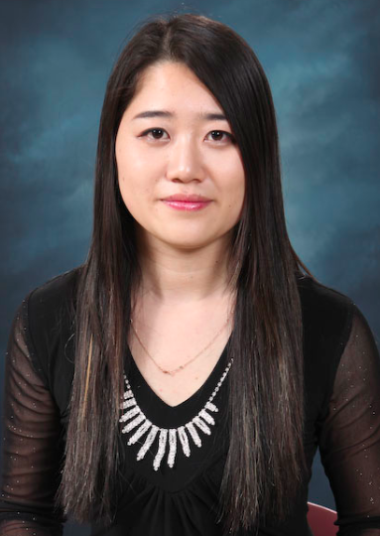
Full Name: Kogay Stella Sergeevna
Date Of Birth: 11.12.1989
Contact Email: stella_hgu@yahoo.com
Cell Phone Number: 010 5571 8789

(F4 Visa Holder.)

EDUCATION: Successfully completed special English courses at CADA (Central Asia Development Agency);
Graduated State Moscow Art School (2001-2004);
Graduated Russian University - MHU (Modern University of Humanities) Major: Marketing.
Graduated Korean (Christian) University – HGU (Handong Global University) Majors: Global Management and United States & International Law.
EXPERIENCE: 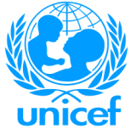 UNICEF (United Nations International Children’s Emergency Fund).
 Non-Governmental Organization PSI (Population Services International).
Korean-Russian Trading Company “CHARIS”.
“GnB Language Academy”.
“Daniel Language Academy”.
Private tutoring (Elementary, Middle, Adult)
English camps
Baby sitter

LANGUAGES: English – Fluent
Russian – Fluent
Korean – Good
Tajik – Good
Iran – Good
PERSONALITY: I am an easy-going, talkative, kind, active person. I am responsible, creative, and ambitious. I love communicating with people and can easily get along with them, especially with kids. I enjoy making friends. My hobbies are: design, music, and search interesting information especially about technology.
I love studying and doing researches.

My life credo is “Everything is possible with God”.

