John Ahn, PE
johnahnse@naver.com / Seoul 010-8344-0150
practicality is a necessity!

June 17, 2009

Re: ESL Teaching Job Application

Dear Sir/Madam:

I am looking for a position that my experiences and skills may be efficiently utilized in the English teaching community in Korea. Combined with my early education in Korea, college education/work/business experiences in the main stream in California enabled me to be fluent in both languages. My goal in this job search is to readjust myself in my home country for the first couple of years of living back in my home country. Further afterwards, I wish to start a small architectural design office in a remote rural area.

My professional experience of supervising engineers/draft persons/construction crews and coordination with clients/other consultants/governmental agencies may further benefit in hiring/managing teaching staffs, guiding advanced business related English practice and/or filling in unexpected absences of staffs.

I understand that English is becoming must-use global language and recognize importance of practical ESL education. Please review my qualification for the most suitable available position and don’t hesitate to contact me with any questions.

Truly,

John Ahn, PE

Attachment: 1 page of Resume

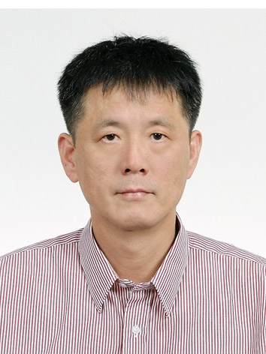

RESUME OF JOHN AHN
Contact: johnahnse@naver.com / Seoul 010-8344-0150
practicality is a necessity!

Objective:

To work as an ESL instructor and/or a manager

Education:
- 1982-1985 AA in Architecture at East Los Angeles College, GPA 3.8
- 1985-1989 BS in Architectural Engineering at California Polytechnic State University, GPA 3.4
- 1990-1992 Attended graduate courses in Structural Engineering at San Jose State University
Experience:
- 1983-1985 Part time draft person, 20 hours per week, Masonry Institute of America
- 1986-1987 Assistant to professor in concrete testing lab for architecture major students
- 1985-1988 Intern at structural engineering design offices for each summer and winter break
- 1989-2008 Junior/project/senior/lead/principal engineer at LTK Associates, CLA Engineers,
BFL Engineers, The Bentley Company & John Ahn Structural Engineering, all in the San Francisco Bay Area
Certification & Award:

- Professional Engineer licensed in California and State of Washington, since 1994
- California Engineer-in-training Examination passed in 1989
- Scholarship Award $3,000 in 1985 at East Los Angeles College graduate ceremony

Ability & Capacity:

- Recruiting/managing teaching staffs
- Supporting business-related English learning, letter writing, conversation and other needs
- Guiding with USA universities admission, application, SAT and other preparation
- Filling in staff absence, emergency leave or other unexpected cancellation
- Any other English and math/science teaching possible

Preference:

- Shorter contract
- Housing or living allowance
- Moving cost allowance, from Seoul if needed
- No need of air-travel reimbursement
- Working in smaller cities
- Assistance for USA citizen stay extension, if needed

