1374 Cottage pl. Windsor, Ontario, Canada | Phone 519-962-8997  E-mail philmiron@gmail.com
Phillip M. Miron
Objectivea | Teacher of English as a Second Language
Education  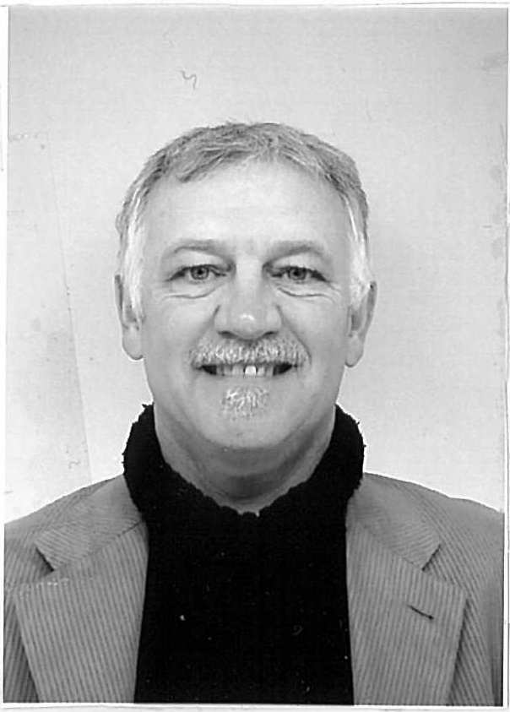 | 1976- 1993. Bachelor of Arts. Psychology Major. University of Windsor, Ontario.  .
1978. Ambulance and Emergency Care. St. Clair College.
2004.Teacher of English as a Second Language (TESL) No Boundaries Language Centre.
 | French, basic Japanese, fluent English.
Work experience | May/1994- Oct/2007 Casino Windsor, Windsor, Ontario  Shuttle Bus Driver. Valet Parking Attendant. Hotel Doorman. Cafeteria Worked for Sarnia General Hospital in the emergency department as an ambulance attendant 1980 – 1988..
Volunteer experience | Helped Sudanese refugees with basic conversation classes. Assisted with local red cross first aid courses. Assisted with elementary school gymnasium classes.
Hobbies | Walking, cycling, singing, guitar.
Summary of qualifications | Caring, dedicated and committed to being a teacher of English, I will make a positive difference to your students. I will bring energy to the class and make it fun. I will develop a personal manner of teaching that will engage the student in a meaningful way.

