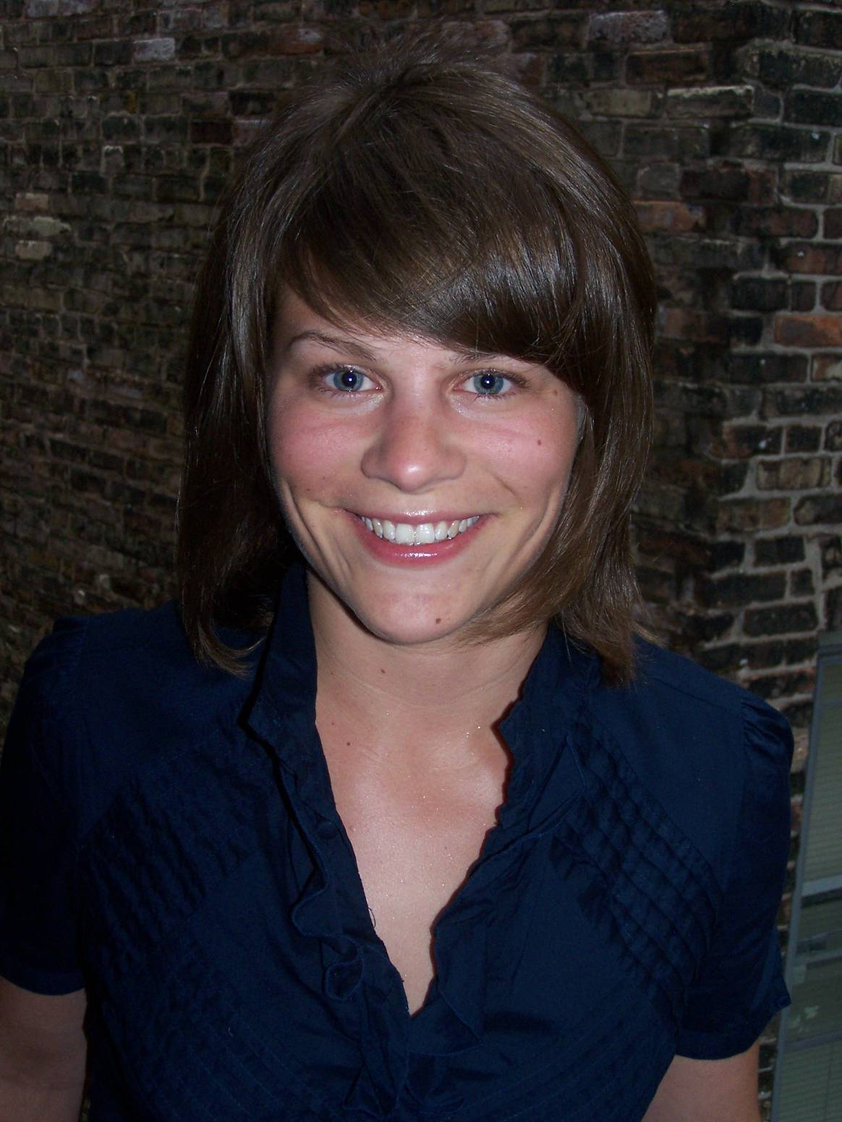
Elissa Ecker
e-mail: elissaecker@yahoo.com
2515 N. Stowell Ave., Milwaukee, WI 53211
Phone: (320) 224-2975

PERSONAL DETAILS
Birth: U.S.A. 01/31/1984
Citizenship: American
Mother Tongue: English
Health: Excellent

EDUCATION
University of Wisconsin- Milwaukee 2002-2006 Milwaukee, WI, U.S.A.
- Bachelor of Fine Arts- Painting and Drawing
- Art History and Criticism minor

Santa Reparata School of Art 2006/Summer
Florence, Italy
- Intense study of Italian Art History

TESOL/TEFL TRAINING
Oxford Seminars 2009 Milwaukee, WI, U.S.A
- Oxford Seminars TESOL/TEFL Certification

EXPERIENCE
Server, Milwaukee Ale House, Milwaukee WI 2004-present
- Exceptional service skills in the fast paced culinary industry
- Train/mentor new staff to provide excellent customer service

Freelance Fine Artist, Milwaukee WI 2002- present
- Design and create original pieces of art to fulfill patrons needs
- Proficient in oil/acrylic paint, watercolor, chalk pastels, color pencil

RELEVANT SKILLS AND EXPERIENCE
Travel Experience: England, Belgium, Germany, Italy, Switzerland, Thailand
Interests: painting/drawing, running, reading, travel

REFERENCES
Available upon request

