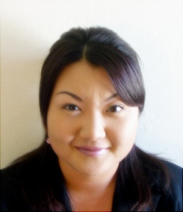
34834 Lilac St. Union City, CA. 94587 USA
E-mail: estella4u@hotmail.com
Date of Birth: 1980, February 11th
Phone: 1-510-919-8001
Esther Hyunjung Park
Objective | Seeking a full time job teaching or translating English in Korea.
Experience | Sep. 2005-present Regis Corp. San Francisco, CA  Area Training/education Manager  - Technical training/educating for employees.  - Managed working schedule for employees at each stores.  - Oversee sales and production of all stores in the area.  - Managed inventory for each stores in the area.  - Managed/maintained customer relationships.  - Pre-train and post-train new employees.
Dec. 2004-Sep.2005 Regis Corp. San Francisco, CA
Shift-Manager/Stylist
- In charge of hiring and training new employees.
- Performed hair styling services to customers, specializing in color, hair treatment and perm
- Maintained customer relationships
2003-2005 Private tutor San Francisco, CA
Private Tutor
- Taught English to students in language exchange programs, including TOEIC, TOEFL, writing, and conversations.
1996-1999 Cabello Elementary school Union City, CA
Tutoring Teacher
- Help students with their homework
- Teach English/Math to students
Education | -2005, Dec. Certified At HSA with Supercuts.  -2003, Sep. Graduated from Hayward College of Cosmetology.  -1997, Aug. Graduated from James Logan High school.  -1994, Jun. Graduated from Rogers Middle school.
Skills | - Bilingual in the languages of Korean and English..  - Certified with Cosmetology license.  - Certified for piercing/waxing.  - Certified for nail-art design.
Interests | -Taught Korean to 1.5 and 2.0 Korean generations at church as community service (5 years).  -Currently a citizen of USA.  -Awarded 3rd place in fashion and 2nd place overall from Hair style & Fashion Extravaganza.
References | Available upon request.

