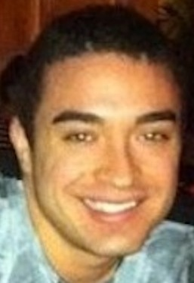

EVAN LEVINE

OBJECTIVE: Seeking a position to teach English internationally.

EDUCATION: DePaul University, Chicago, Illinois
Major: Public Relations & Advertising
Minor: Hospitality Leadership
GPA 3.0/4.0
Date of degree: June 2013

EXPERIENCE: Rockit Ranch Productions, Chicago, Illinois 2/12 – 6/12
Marketing Intern
. Assisted with numerous company events: Fashion Shows, Club Nights, and Private Parties to B List celebrities.
. Managed social outreach via Twitter.
. Encouraged the promotion of four venues: Rockit Bar and Grill, Rockit Burger Bar, Ay Chiwowa!, and The Underground.

The Friendship Circle, Newport Beach, California 6/11-9/11
Social Media Intern
. Developed the company’s social media sites: Facebook, Twitter, and company homepage.
. Coordinated events for teenagers with disabilities
. Participated in company events and acted as a liaison for the Orange County branch.

Cynthia's on the Water, Newport Beach, California 12/08 – 9/08 Server/Shift Lead
. Interacted with restaurant clientele while managing servers.
. Maintained cohesion while working in a busy environment.
. Ran inventory checks and income review for the restaurant.

SKILLS: Advanced in most IT programs including Microsoft Word, Outlook, Access, SPSS, Excel, PowerPoint. Effective face-to-face interpersonal communication skills.

ACTIVITIES: DePaul Epicurean 9/11-6/13
- Event planner for DePaul hospitality club with a focus on food & beverage and hospitality operations.

Marva Program 6/12-8/13
- Voluntary enlistment in the IDF (Israel Defense Force) for non-Israelis’ to undergo basic training and community service.

Sigma Chi Eta 9/08-5/09
- Honors Communication Society at Santa Barbara City College.

The Friendship Circle 9/05-9/09
- Volunteered as a mentor to an autistic teenager. Honored for my services
by Actor Jon Voight and Governor Arnold Schwarzenegger.

