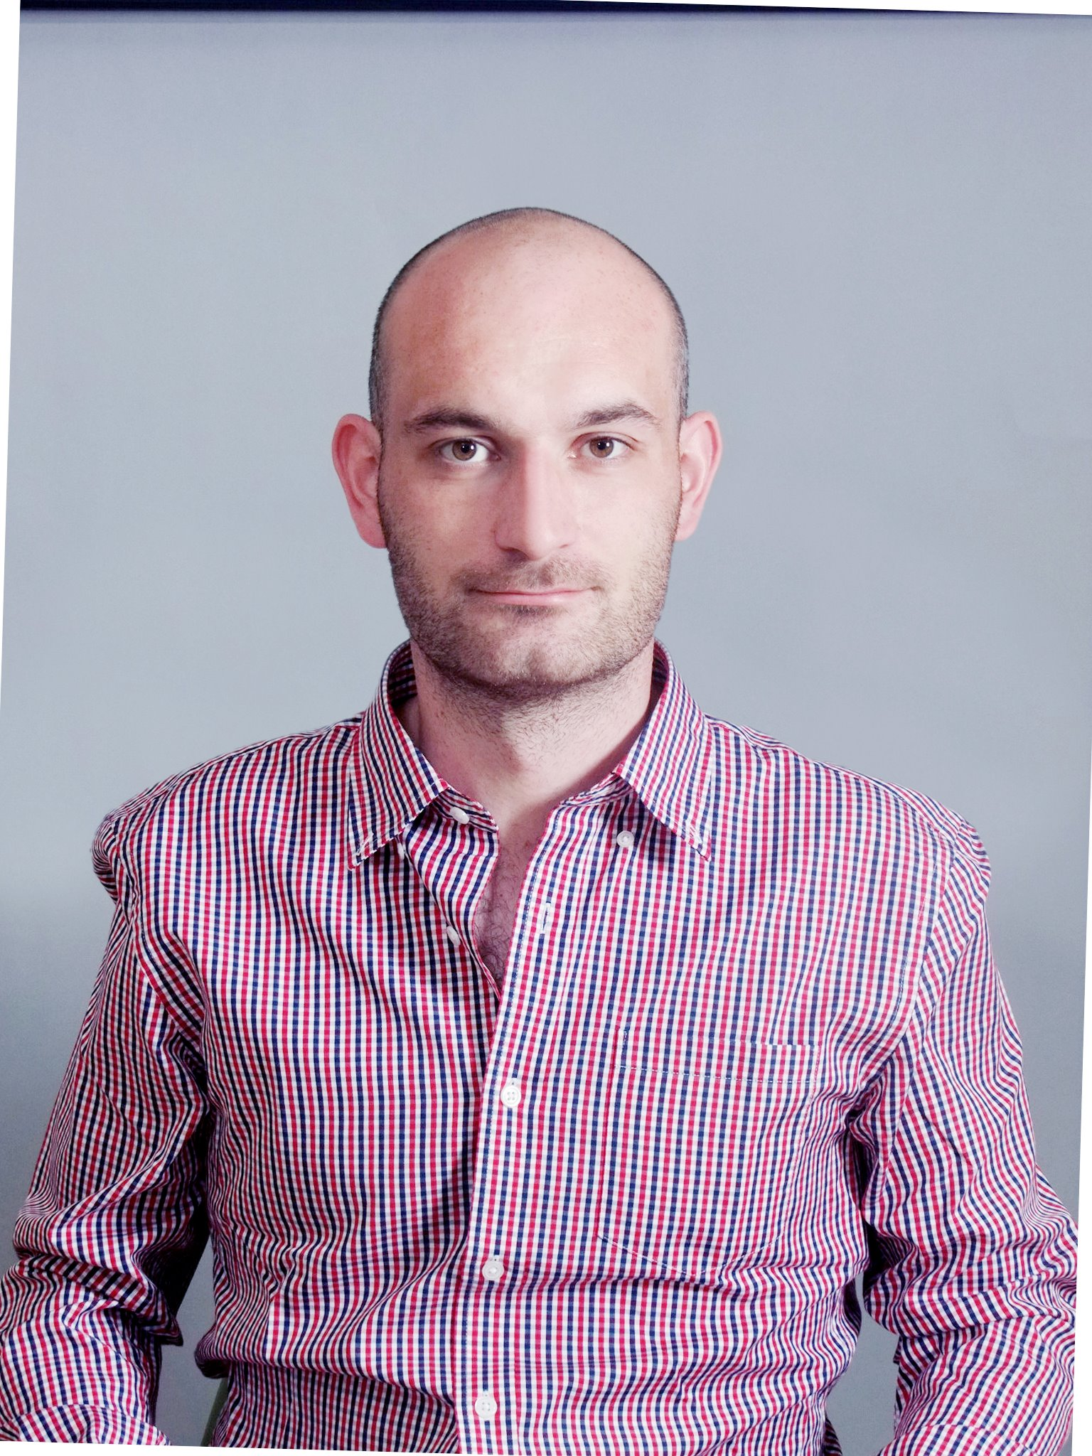

Fergal McGee

Home Address
경기도 성남시
분당구
야탑동
320-5번지 101호
Tel: 010 5157 6648
Email: fergalmcgee@gmail.com
DOB: 08th February 1983

Education and Qualifications
2005 – 2006 Bachelor of Science (Honours) in Computing in Computer Service Management - Letterkenny Institute of Technology
Result: 2:2 Honours
Subjects Studied: Distributed Systems (java), Strategic IT Management, Systems Design, IT Service Management, Data Communications, Project (java 2 Micro Edition).

2004 – 2005 Bachelor of Science in Computing in Information Technology Support – Letterkenny Institute of Technology – result: Merit 2
Subjects Studied: Computer Networks, Computer Organization, Computer Service Management, Project (java), Software Development (C++), E-commerce (html, asp, database connectivity).

2002 – 2004 Higher National Certificate in Information Technology Support – Letterkenny Institute of Technology – result: Merit 1
Subjects Studied: Computer Applications , Computer Systems, Operating Systems, Software Development (c), Interpersonal Communications, Computer Networks, Training & Support , Mathematics, Databases, Multimedia.

Employment History
Mar 2011 – Mar 2013 English Teacher, Simseok Elementary School
Teaching science, drama and extensive reading to elementary students through English. Duties included, creating lesson plans, creating and conducting tests, evaluations, performances, experiments, vocabulary tests, morning broadcasts, English camps and festivals.

Dec 2008 – Feb 2011 English Teacher, Oh Sung Sik English Academy
Teaching English grammar, writing, reading, speaking, pronunciation, and listening skills to elementary and middle school students. Duties also include conducting tests, writing evaluations and preparing lessons.

Feb 2007 – Nov 2008 Systems Engineer, CBE Software
Installation and configuration of Hardware/Software at customer sites.
Providing Customers with training on CBE Software packages.
Providing Customers with support service (office and on-site).

Oct 2004 – Dec 2004 Christmas Sales Assistant, Argos Letterkenny
Working in Stock room, Issuing products to customers, dealing with customer queries.

Jan 2003 – Jun 2003 Lab Attendant\Technician, Letterkenny Institute of Technology
Checking all equipment within labs on a weekly basis, Resolving problems with lab computers (hardware and software), Ensure the safe and secure operation of area, Dealing with student queries.

2001 – 2002 Shop Assistant, Asda Superstores, Glasgow
Dealing with customer queries, Operating Tills, Distributing stock on shelves.

1999 – 2001 Shop Assistant, Superdrug Stores, Glasgow
Operating Tills, Dealing with stock takes, Distributing stock on shelves, dealing with customer queries, working in warehouse.

Hobbies and Interests
I enjoy sport and exercising on a regular basis. In particular I enjoy soccer and pool. At college in Glasgow I played for my college soccer team and play for a team in Korea. I have a great interest in computers and enjoy most aspects. I find teaching and working with children very enjoyable and rewarding. I also like listening to music and socializing.

Skills Profile
Team working Developed through group project and research at college as well as through teaching and leisure activities.

Communication: Can speak and write clearly and make presentations to target audiences. Also I have had 4 years experience teaching elementary and middle school students. I can speak and write Korean at a basic level.

Teaching Experienced teacher who can create and execute fun and educating lessons while maintaining structure and control of a class.

Course related skills: The following is a list of applications and programming languages knowledge that was obtained at college:

Programming Languages:
Java JSP
Html SQL

Applications: Microsoft Office including Word, PowerPoint, Access, Excel etc...
Authorware Dreamweaver
Java 2 ME Wireless Toolkit Fireworks
Rational Rose Windows Administration
Red Hat UNIX Sony Vegas Pro

Additional Information
I have a full driving licence.

Referees
Dr Vincent Murphy Andrew Kim
Head of School of Science Senior Teacher
Letterkenny IT Sim-seok Elementary School
Tel. +353 (0)749164110 Tel. +82 (0)10 8804 7356

